For three days in September 2010 the streets of Maputo, the capital ofMozambique, were filled with thousands of striking workers protesting rising food prices. Mozambique, a former Portuguese colony, is one of the most impoverished nations in the world, ranked 175th out of 179 countries on the United Nations Human Development Index. Seventy percent of the population of 23 million survives beneath the poverty hne and an estimated 54 percent are unemployed. The statutory minimum wage is US$37 a month; annual per capita income is only $807. The riots and strikes, organized primarily by text messaging, were prompted by a 30 percent increase in the price of bread. In the course of the riots, 13 people were killed, including a 6-year-old girl and a 12-year-old boy, and more than 400 wounded when police opened fire on demonstrators.
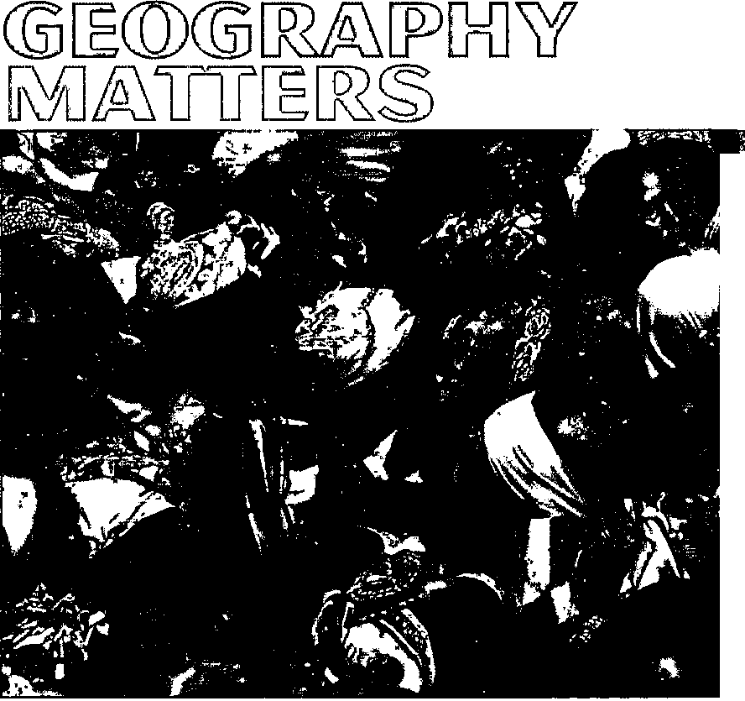The problem of food shortages and rising food prices in Mozambique and in many other places is a reflection of the increasing geographic interdependence of the world. The situation is partly the result of increasing food consumption in other parts of the world, especially in booming China and India, where many have stopped grovnng their own food and have the cash to buy a lot more of it. Increasing meat consumption has helped drive up demand for feed grain, and this in turn has driven up the price of grain everywhere. Speculators in international commodity markets have joined the fi'ay, fiirther accelerating price rises. Another key
1
Explain how the study of geography has become essential for understanding a world that is more complex, interdependent, and changing faster than ever before.
Identify four examples of how places influence inhabitants' lives.
Distinguish the differences among major map projections and describe their relative strengths and weaknesses.
Explain how geographers use geographic information systems (GIS) to merge and analyze data.
Summarize the five concepts that are key to spatial analysis and describe how they help geographers to analyze relationships between peoples and places.
Describe the importance of distance in shaping human activity.
Summarize the three concepts that are key to regional analysis and explain how they help geographers analyze relationships between peoples and places.
Two men attempt to brace the front gate as hundreds of mothers of malnourished children try to
push into a therapeutic feeding center in Maradi, Niger.
linkage concerns energy prices: High oil prices push up fertilizer prices, as well as the cost of transporting food fi-om farm to market. The popularity of biofiiels as an alternative to hydrocarbons is straining food supplies, especially in the United States, where generous federal subsidies for ethanol have lured farmers away from growing crops for food. Compounding all this is climate change. Harvests in many countries have been seriously disrupted by extreme weather. In 2009-2010, there were prolonged droughts in Argentina, China, and the Sahel region of Africa; catastrophic floods in India, Indonesia, Pakistan, Sri Lanka, and Thailand; and a record-breaking heat wave that affected China, North Africa, Europe, and the United States along with parts of Canada, Russia, South Korea, and Japan.
Geographers learn by finding out where things are and why they are there. Human geography is about recognizing and understanding the interdependence among places and regions, vnthout losing sight of the uniqueness of each specific place. Places are specific geographic settings vnth distinctive physical, social, and cultural attributes. Regions are territories that encompass many places, all or most of which share attributes different from the attributes of places elsewhere. Maps are also important tools for introducing geographers' ideas about the way diat places and regions are made and altered, a
4 HUMAN GEOGRAPHY Places and Regions in Global Context
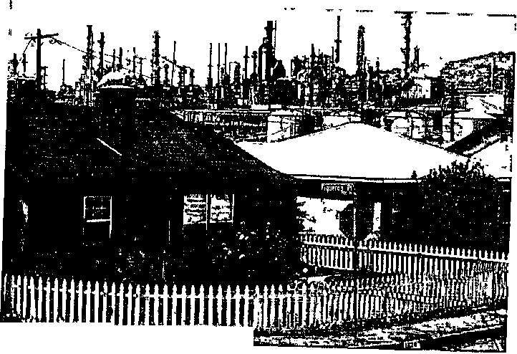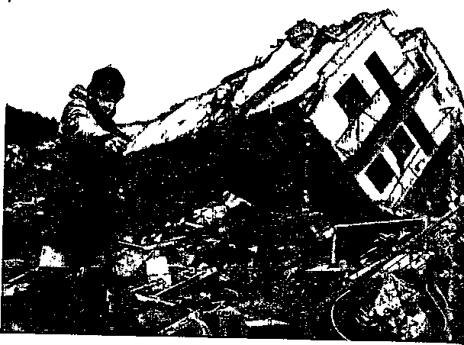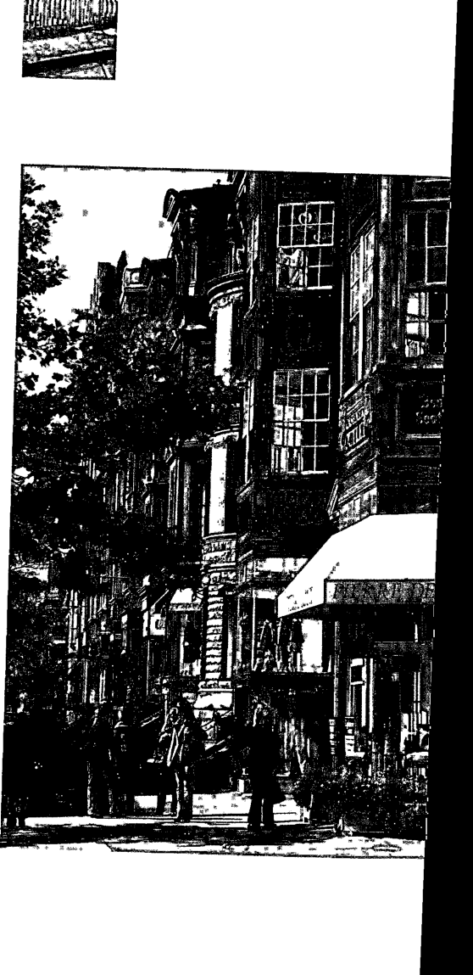
CHAPTER 1 Geography Matters
FIGURE 1.2 Quality of Life A petroche cal plant adjacent to a housing developmerJ Wilmington, California. I
FIGURE 1.1 Flood victims A resident of Onagawa, Japan stands next to a building destroyed by a tsunami on March 26, 2011. Although major disasters are covered widely in the media, only a minority of Americans are able to understand them in geographic context.
FIGURE 1.3 Central city neighborhood Newbury Stree shopping street In Boston.
WHY GEOGRAPHY MATTERS
The importance of pography as a subject of study is becoming more widely recognized as people everywhere struggle to understand a world that is increasingly characterized by instant global communications, rapidly changing international relationships, unexpected local changes, and growing evidence of environmental degradation. Many more schools now require courses in geography than just a decade ago, and the College Board has added the subject to its Advanced Placement program. Meanwhile, many employers are coming to realize the value of employees with expertise in geographical analysis and an understanding of the uniqueness, influence, and interdependence of places. Through an appreciation of the diversity and variety of the world's peoples and places, geography provides real opportunities not only to contribute to local, national, and global development but also to understand and promote multicultural, international, and feminist perspectives on the world.
Most people want to understand the intrinsic nature of the world in which we live. Geography enables us to understand where we are both literally and figuratively. Geography provides knowledge of Earth's physical and human systems and of the interdependency of Hving things and physical environments. That knowledge, in turn, provides a basis for people to cooperate in the best interests of our planet. Geography also captures the imagination: It stimulates curiosity about the world and the world's diverse inhabitants and places. By obtaining a better understanding of the world, people can overcome closed-mindedness, prejudice, and discrimination.
WHY PLACES MATTER
An appreciation of the diversity and variety of peoples and places is a theme that runs through all of human geography, the study of the spatial organizationof human activity and of people's relationships with their environments. This theme is inherently interesting to nearly all of us. National Geographic magazine has become a venerable institution by bringing us monthly updates of the seemingly endless variety of landscapes and communities around the world. More than 5 million households, representing about 19 million regular readers, subscribe to this magazine for its intriguing descriptions and striking photographs. Millions more read it occasionaUy in offices, lobbies, waiting rooms, or online.
Yet many Americans often seem content to confine their interest in geography to the pages of glossy magazines, to television doc- umentanes, or to one-week packaged vacations. It has become part of the conventional wisdom-both in the United States and around the world—that many Americans have little real appreciation or understanding of people and places beyond their own daily routines. This is perhaps putting it too mildly. Surveys have revealed widespread ignorance among a high proportion of Americans, not only of the fundamentals of the world's geography but also of the
APPLY YOUR KNOWLEDGE List three reasons why a corporate employer would feel it is important for prospective employees to have some knowledge of geography, b
diversity and variety within the United States itself. One Gallup poll found that 70 percent of young adults in the United States could not find their own country on a map of the world. In surveys of young adults in Canada, France, Germany, Great Britain, Italy, Japan, Mexico, Sweden, and the United States, Americans come m next to last in terms of geographic literacy.' Neither wars nor natural disasters appear to have compelled majorities of young Americans to absorb knowledge about international places in the news (Figure l.I).
Also striking is Americans' ignorance ofhow the United States fits into the wider world. Majorities overestimate the total size of the U.S. population and fail to understand how much larger the population of China is. Three-quarters of young adults in the United States believe English is the most commonly spoken native language in the world, rather than Mandarin Chinese. This lack of geographical knowledge carries over to people's perceptions of the United States and its role in the world. A poll in 2010 found, for example, that most Americans believe that the United States spends more than 15 percent of its budget on aid to poor countries; the actual figure has consistently been less than 0.2 percent of the country's gross national income, putting it last among rich industrial nations. So although most people in the United States are fascinated by different places, relatively few have a systematic knowledge of them. Fewer still understand how different places came to be the way they are or why places matter in the broader scheme of things. This lack of understanding is important because geographic knowledge can take us far beyond a simple glimpse of the inherently interesting variety of peoples and places.
^per ASW, 2002 Global Geographic Literacy Survey. Washington DC- National Geo^phic-Roper ASW, 2002; Roper Public Affairs, 2006 Gbbal Geographic Literacy Survey. Washington, DC: National Geographic Education 1'oundation-Roper Public AiFairs, 2006.
The Influence of Places
Places are dynamic, with changing properties and fluid boundaries that are the product of the interplay of a wide variety of environmental and human factors. This dynamism and complexity is what makes places so fascinating for readers oiNational Geographic. It is also what makes places so important in shaping people's lives and m influencing the pace and direction of change. Places provide the settings for people's daily lives and their social relations (patterns of interaction among family members, at work, in social fife, in leisure activities, and in poHtical activity). It is in these settings that people earn who and what they are, how they are expected to think and behave, and what life is likely to hold for them.
Places exert a strong influence, for better or worse, on people's physical weU-bemg, opportunities, and lifestyle choices. Living in a small town dommated by petrochemical industries, for example means a higher probability of being exposed to air and water pollution, having a limited range of job opportunities, and having a relatively narrow range of hfestyle options because of a lack of amenities such as theatres, speciafized stores and restaurants, and recreational facilities (Figure 1.2). Living in a central neighborhood of a large metropofitan area, on the other hand, usuaUy means having a wider range ofjob opportunities and a greater choice of lifestyle options because of tiie variety of amenities accessible within a short istance ( igure 1,3). But it also means, among other things, livine;
with a relatively high exposure to crime.
The Meaning of Places
Places also contribute to people's collective memory and become powerful emotional and cultural symbols. Consider the evocative power for most Ameri(;ans of places like Times Square in New York; the Mall in Washington, D.C.; Hollywood Boulevard in Los Angeles; and Graceland in Memphis. And for many people ordinary places have special meaning: a childhood neighborhood'
a college campus, a baseball stadium, or a family vacation spot' This layering of meanings reflects the way that places are sodally

constructed—given different meanings by different groups for different purposes. Places exist and are constructed by their inhabitants from a subjective point of view.
The meanings given to a place may be so strong that they become a central part of the identity of the people experiencing them. Your identity is the sense that you make of yourself through your subjective feelings based on your everyday experiences and social relations. Your ovra neighborhood, for example, is probably heavily laden w^ith personal meaning and sentiment for you. But your neighborhood may wrell be viewed very differendy, perhaps unsym- pathetically, by outsiders. This distincdon is useful in considering the importance of understanding spaces and places from the viewpoint of the insider—the person who normally lives in and uses a particular place—as well as from the viewpoint of outsiders (Including geographers).
Finally, places are the sites of innovation and change, of resistance and conflict (Figure 1.4). The unique characteristics of specific places can provide the preconditions for new agricultural practices (such as the development of seed agriculture and the use of plow and draft animals that sparked the first agricultural revolution in the Middle East in prehistoric times—see Chapter 8); new modes of economic organization (such as the high-tech revolution that began in Silicon Valley in the late twentieth century); new cultural practices (the punk movement that began in disadvantaged British housing projects, for instance); and new hfestyles (for example, the hippie lifestyle that began in San Francisco in the late 1960s). It is in specific locales that important events happen, and it is from them that significant changes spread.
Nevertheless, the influence of places is by no means limited to the occasional innovative change. Because of their distinctive characteristics, places always modify and sometimes resist the imprint of even the broadest economic, cultural, and political trends. Consider, for example, the way that a global cultural trend- rock 'n' roll—-was modified in Jamaica to produce reggae. And how in Iran and North Korea rock 'n' roll has been resisted by the authorities, with the result that it has acquired an altogether different kind of value and meaning for the citizens of those countries. Similarly, Indian communities in London developed Bhangra— a "world beat" composite of traditional Punjabi music, Mumbai (Bombay) movie scores, and Western disco. Cross-fertilization with local music cultures in New York and Los Angeles has produced Bhangra rap.
To consider a different illustration, think of the ways some communities have declared themselves "nuclear-free" zones: places where nuclear weapons and nuclear reactors are unwelcome or even banned by local laws. By establishing such zones, individual communities are seeking to challenge trends toward using nuclear energy and maintaining nuclear arms. They are, to borrow a phrase, "thinking globally and acting locally." Similarly, some communities have established "GM-free" zones, taking a stance against genetically modified crops and food. In adopting such strategies, they hope to influence thinking in other communities so that eventually their challenge could result in a reversal of established trends.
In summary, places are settings for social interaction that, among other things,
- structure the daily routines of people's economic and social life;
B provide both opportunities and constraints in terms of people's long-term social well-being;
- provide a context in which everyday, commonsense knowledge and experience are gathered;
- provide a setting for processes of sociahzation; and
H provide an arena for contesting social norms.
APPLY YOUR KNOWLEDGE Explain how and why
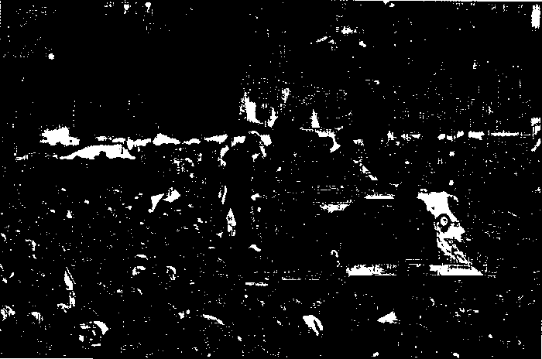a particular place has mattered to you. How might others' experience or perception of that same place differ from yours? How does your place influence your health or job prospects? ■
6 HUMAN GEOGRAPHY Places and Regions in Global Context
FIGURE 1.4 Tahrir Square, Cairo, Egypt
Egyptian anti-government demonstrators flood Cairo's landmark Tahrir Square on February 11,
2011, the 18th day of protests against President Hosni Mubarak, who subsequently resigned.

STUDYING HUMAN GEOGRAPHY
The study of geography involves the study of Earth as created by natural forces and modified by human action. This, of course, covers an enormous amount of subject matter. There are two main branches of geography: physical and human. Physical geography deals with Earth's natural processes and their outcomes. It is concerned, for example, with climate, weather patterns, landforms, soil formation, and plant and animal ecology. Human geography deals with the spatial organization of human activities and with people's relationships to their environments. This involves looking at natural physical environments insofar as they influence, and are influenced by, human activity. To that end, the study of human geography must cover a wide variety of phenomena. These include, for example, agricultural production and food security, population change, the ecology of human diseases, resource management, environmental pollution, regional planning, and the symbolism of places and landscapes.
Regional geography combines elements of both physical and human geography. Regional geography is concerned vnth the way that unique combinations of environmental and human factors produce territories with distinctive landscapes and cultural attributes. The concept of region is used by geographers to apply to larger-sized territories that encompass many places, all or most of which have similar attributes distinct from the attributes of other places.
What is distinctive about the study of human geography is not so much the phenomena that are studied as the way they are approached. The contribution of human geography is to reveal how and why geographical relationships are important, in relation to a wide spectrum of natural, social, economic, political, and cultural phenomena. Thus, for example, human geographers are interested not only in patterns of agricultural production but also in the geographical relationships and inter- dependencies that are both causes and effects of such patterns. To put it in concrete terms, geographers are interested not only in what specialized agricultural subregions (for example, the dairy farming area of Judand, Derunark) are like but also in the role of subregions such as Jutland in national and international agro-food systems (their interdependence with producers, distributors, and consumers in other places and regions—see Chapter 8).
Geography is very much an applied discipline as well as a means of understanding the world. Geographers employed in business, industry, and government are able to use geographic theories and techniques to understand and solve a wide variety of specific problems. A great deal of the research undertaken by geography professors has an applied focus (see Box 1.1, "Geography Matters: Geographers at Work").

THE BASIC TOOLS AND METHODS OF HUMAN GEOGRAPHERS
In general terms, the basic tools employed in geography are similar to those in other disciplines. Like other social scientists, human geographers usually begin with observation. Information must be collected and data recorded. This can involve many different methods and tools. Fieldwork (surveying, asking
CHAPTER 1 Geography Matters 7
questions, using scientific instruments to measure and record things), laboratory experiments, and archival searches all are used by human geographers to gather information about geographical relationships. Geographers also use remote sensing, the collection of information about parts of Earth's surface by means of aerial photography or satellite imagery designed to record data on visible, infrared, and microwave sensor systems (Figure 1.5 see page 9). For example, agricultural productivity can be monitored by remotely sensed images of crops, and energy efficiency can be monitored by remotely sensed levels of heat loss from buildings.
Once data have been obtained through some form of observation, the next important step is to portray and describe them through visualization or representation. This can involve a variety of tools, including written descriptions, charts, diagrams, tables, mathematical formulas, and maps. Visualization and representation are important activities because they allow large amounts of information to be explored, summarized, and presented to others. They are nearly always a first step in the analysis of geographical relationships, and they are important in conveying the findings and conclusions of geographic research.
At the heart of geographic research, as with other kinds of research, is the analysis of data. The objective of analysis, whether of quantitative or quahtative data, is to discover patterns and establish relationships so that hypotheses can be established and models can be buUt. Models, in this sense, are abstractions of reality that help explain the real world. They require tools that allow us to generalize about things. Once again, we find that geographers are like other social scientists in that they utilize a wide range of analytical tools, including conceptual and linguistic devices, maps, charts, and mathematical equations.
In many ways, therefore, the tools and methods of human geographers are parallel to those used in other sciences, especially the social sciences. In addition, geographers increasingly use some of the tools and methods of the humanities—interpretive analysis and inductive reasoning, for example—together with ethnographic research (the systematic recording of human cultures) and textual analysis. The most distinctive tools in the geographer's kit bag are maps and geographic information systems (GIS).
Maps
Maps not only describe data but also serve as important sources of data and tools for analysis. Because of their central importance to geographers, they can also be objects of study in their own right. Geographic information systems involve an organized set of computer hardware, software, and spatially coded data that is designed to capture, store, update, manipulate, and display geographically referenced information.
Maps are representations of the world. They are usually two- dimensional graphic representations that use lines and symbols to convey information or ideas about spatial relationships. Maps express particular interpretations of the world, and they affec how we understand the world and how we see ourselves in rela tion to others. As such, all maps are "social products." In gen eral, maps reflect the power of the people who draw them up. Jus
constructed—^yen different meanings by different groups for different purposes. Places exist and are constructed by their inhabitants from a subjective point of view.
The meanings given to a place may be so strong that they become a central part of the identity of the people experiencing them. Your identity is the sense that you make of yourself through your bjective feelings based on your everyday experiences and social elations. Your own neighborhood, for example, is probably heav- ly laden with personal meaning and sentiment for you. But your ighborhood may well be viewed very differently, perhaps unsym- pathetically, by outsiders. This distinction is useful in considering he importance of understanding spaces and places from the view- oint of the insider—the person who normally lives in and uses a articular place—a^well as from the viewpoint of outsiders (includ- ng geographers).
Finally, places are the sites of innovation and change, of re- istance and conflict (Figure 1.4). The unique characteristics of pecific places can provide the preconditions for new agricultural ractices (such as the development of seed agriculture and the use f plow and draft animals that sparked the first agricultural revolu- ion in the Middle East in prehistoric times—see Chapter 8); new nodes of economic organization (such as the high-tech revolution liat began in Silicon Valley in the late twentieth century); new cul- ural practices (the punk movement that began in disadvantaged ritish housing projects, for instance); and new lifestyles (for ex- mple, the hippie lifestyle that began in San Francisco in the late 1960s). It is in specific locales that important events happen, and it s from them that significant changes spread.
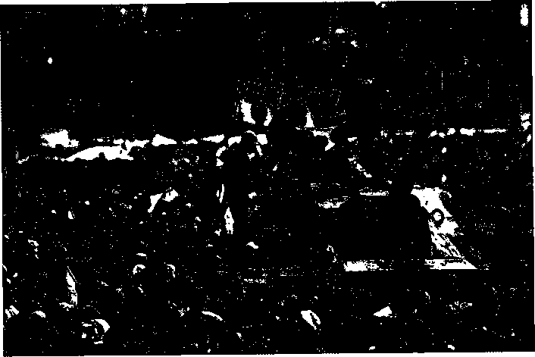Nevertheless, the influence of places is by no means limited :o the occasional innovative change. Because of their distinctive ;haracteristics, places always modify and sometimes resist the mprint of even the broadest economic, cultural, and political rends. Consider, for example, the way that a global cultural trend— ock 'n' roll—was modified in Jamaica to produce reggae. And how n Iran and North Korea rock 'n' roll has been resisted by the au- horities, with the result that it has acquired an altogether different kind of value and meaning for the citizens of those countries. Similarly, Indian communities in London developed Bhangra— a "world beat" composite of traditional Punjabi music, Mumbai (Bombay) movie scores, and Western disco. Cross-fertilization with local music cultures in New York and Los Angeles has produced Bhangra rap.
FIGURE 1.4 Tahrir Square, Cairo, Egypt Egyptian anti-government demonstrators flood Cairo's landmark Tahrir Square on February 11, 2011, the 18th day of protests against President Hosni Mubarak, who subsequently resigned.
6 HUMAN GEOGRAPHY Places and Regions in Global Context
To consider a different illustration, think of the ways some communities have declared themselves "nuclear-free" zones: places where nuclear weapons and nuclear reactors are unwelcome or even banned by local laws. By establishing such zones, individual communities are seeking to challenge trends toward using nuclear energy and maintaining nuclear arms. They are, to borrow a phrase, "thinking globally and acting locally." Similarly, some communities have established "GM-free" zones, taking a stance against genetically modified crops and food. In adopting such strategies, they ' hope to influence thinking in other communities so that eventually their challenge could result in a reversal of established trends.
In summary, places are settings for social interaction that, among other things,
- structure the daily routines of people's economic and social life;
- provide both opportunities and constraints in terms of people's long-term social well-being;
- provide a context in which everyday, commonsense knowledge and experience are gathered;
- provide a setting for processes of socialization; and
- provide an arena for contesting social norms.
APPLY YOUR KNOWLEDGE Explain how and why
a particular place has nnattered to you. How might others' experience or perception of that same place differ from yours? How does your place influence your health or job prospects? ■

STUDYING HUMAN GEOGRAPHY
The study of geography involves the study of Earth as created by natural forces and modified by human action. This, of course, covers an enormous amount of subject matter. There are two main branches of geography: physical and human. Physical geography deals vnth Earth's natural processes and their outcomes. It is concerned, for example, with climate, weather patterns, landforms, soil formation, and plant and animal ecology. Human geography deals with the spatial organization of human activities and with people's relationships to their envirormients. This involves looking at natural physical environments insofar as they influence, and are influenced by, human activity. To that end, the study of human geography must cover a wide variety of phenomena. These include, for example, agricultural production and food security, population change, the ecology of human diseases, resource management, enviroimjental pollution, regional planning, and the symbolism of places and landscapes.
Regional geography combines elements of both physical and human geography. Regional geography is concerned with the way that unique combinations of environmental and human factors produce territories with distinctive landscapes and cultural attributes. The concept of region is used by geographers to apply to larger-sized territories that encompass many places, all or most of which have similar attributes distinct from the attributes of other places.
What is distinctive about the study of human geography is not so much the phenomena that are studied as the way they are approached. The contribution of human geography is to reveal how and why geographical relationships are important, in relation to a wide spectrum of natural, social, economic, political, and cultural phenomena. Thus, for example, human geographers are interested not only in patterns of agricultural production but also in the geographical relationships and inter- dependencies that are both causes and effects of such patterns. T o put it in concrete terms, geographers are interested not only in what specialized agricultural subregions (for example, the dairy farming area of Jutland, Denmark) are like but also in the role of subregions such as Jutland in national and international agro-food systems (their interdependence with producers, distributors, and consumers in other places and regions—see Chapter 8).
Geography is very much an applied discipline as well as a means of understanding the world. Geographers employed in business, industry, and government are able to use geographic theories and techniques to understand and solve a wide variety of specific problems. A great deal of the research undertaken by geography professors has an applied focus (see Box 1.1, "Geography Matters: Geographers at Work").

THE BASIC TOOLS AND METHODS OF HUMAN GEOGRAPHERS
In general terms, the basic tools employed in geography are similar to those in other disciplines. Like other social scientists, human geographers usually begin with observation. Information must be collected and data recorded. This can involve many different methods and tools. Fieldwork (surveying, asking questions, using scientific instruments to measure and record things), laboratory experiments, and archival searches all are used by human geographers to gather information about geographical relationships. Geographers also use remote sensing, the collection of information about parts of Earth's surface by means of aerial photography or satellite imagery designed to record data on visible, infrared, and microwave sensor systems (Figure 1.5 see page 9). For example, agricultural productivity can be monitored by remotely sensed images of crops, and energy efficiency can be monitored by remotely sensed levels of heat loss from buildings.
Once data have been obtained through some form of observation, the next important step is to portray and describe them through visualization or representation. This can involve a variety of tools, including written descriptions, charts, diagrams, tables, mathematical formulas, and maps. Visualization and representation are important activities because they allow large amounts of information to be explored, summarized, and presented to others. They are nearly always a first step in the analysis of geographical relationships, and they are important in conveying the findings and conclusions of geographic research.
At the heart of geographic research, as with other kinds of research, is the analysis of data. The objective of analysis, whether of quantitative or quafitative data, is to discover patterns and estabfish relationships so that hypotheses can be estabhshed and models can be built. Models, in this sense, are abstractions of reahty that help explain the real world. They require tools that allow us to generalize about things. Once again, we find that geographers are like other social scientists in that they utilize a vwde range of analytical tools, including conceptual and linguistic devices, maps, charts, and mathematical equations.
In many ways, therefore, the tools and methods of human geographers are parallel to those used in other sciences, especially the social sciences. In addition, geographers increasingly use some of the tools and methods of the humanities—interpretive analysis and inductive reasoning, for example—together with ethnographic research (the systematic recording of human cultures) and textual analysis. The most distinctive tools in the geographer's kit bag are maps and geographic information systems (GIS).
Maps
Maps not only describe data but also serve as important sources of data and tools for analysis. Because of their central importance to geographers, they can also be objects of study in their own right. Geographic information systems involve an organized set of computer hardware, software, and spatially coded data that is designed to capture, store, update, manipulate, and display geographically referenced information.
Maps are representations of the world. They are usually two- dimensional graphic representations that use lines and symbols to convey information or ideas about spatial relationships. Maps express particular interpretations of the world, and they affect how we understand the world and how we see ourselves in relation to others. As such, all maps are "social products." In general, maps reflect the power of the people who draw them up. Just
CHAPTER 1 Geography Matters 7

GEOGRAPHY MATTERS

Geographers at Work
Urban and Regional Planning. Urban and regional planning adopts a systematic, creative approach to address and resolve physical, social, and economic concerns of neighborhoods, cities, suburbs, metropolitan areas, and larger regions. Planners work directly on preserving and enhancing the quality of life in communities, protecting the environment, promoting equitable economic opportunity, and managing growth and change of all kinds. Planning has roots in engineering, law, architecture, social welfare, and government, but geography, because of its focus on the interdependence of peoples and places, offers the best preparation for specialized professional training in urban and regional planning.
Economic Development. An ability to understand the interdependence of places and to analyze the unique economic, environmental, cultural, and political attributes of specific regions enables geographers to contribute effectively to strategies and policies aimed at economic development. Geographers are involved in applied research and policy formulation concerning economic development all over the globe, addressing the problems not only of individual places and regions but also of the entire world economy.
Security. Geographers' knowledge and understanding of geopolitics, political geography, demographics, medical geography, and cultural geography, together with an appreciation of the interdependent relationships among local, regional, and global systems, provide a sound basis for work in many areas of security. Knowing how places and regions "work" also means knowing about their vulnerability to potential security risks.
Landsat satellite images ar both visible and invisible to cover, soils, and built envi the processed image. This Baltimore, Maryland Area.

FIGURE 1.5 Remote
as well as unique source lems and processes. Exa urban encroachment onl
Spaceimaging.com; top right photo
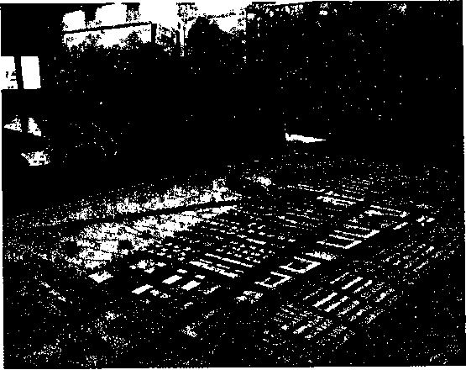
FIGURE 1 .A Urban and Regional Planning Planning professionals examine a model of Scharnhauser Park, a new town near Stuttgart, Germany.
including things on a rr map"—can be empowerii what they omit, and ho reflects the experiencei tions of their authors. T
Career options for geography majors are diverse, challenging, and exciting. Most geography graduates are able to find careers in which they have the opportunity to make a positive contribution to the world through their analytical skills. These careers include cartography, geographic information systems (GIS), laboratory analysis, private consulting, urban and regional planning, international development, teaching, and management in private industry. Because of the broad nature of the field, these careers engage every aspect of human activity on every scale from the local to the global. The following examples reflect this diversity:
B International Affairs. Knowledge and understanding of regional histories and geographies, along with their ability to analyze the interdependence of places and regions, enables geographers to effectively contribute to discussions of international policy. Work within governmental agencies, corporations, and nonprofit institutions in shaping international strategies is especially important in the context of accelerating globalization.
a Location of Public Facilities. Geographers use specialized techniques to analyze the location patterns of particular population groups, to analyze transportation networks, and to analyze patterns of geographic accessibility to sites. Such analysis enables geographers to determine the most effective locations for new public facilities, such as clinics, emergency rooms, social centers for the elderly, and shelters for the homeless.
a Marketing and Location of Industry. Similar techniques are used to determine the most efficient, or most profitable, locations for new factories, stores, and offices. Geographical research is also used to analyze the changing geography of supply and demand, allowing industry to determine whether, and where, to relocate. Basic techniques of geographic analysis are also used in geodemographic research, an important aspect of marketing.
a Geography and the Law. Geographical analysis is increasingly involved in resolving complex social and environmental issues. One important example is the issue of property development and the implications of environmental hazards such as flooding, coastal erosion, toxic-waste dumps, and earthquake fault zones for policies, codes, and regulations. Another is the issue of drawing up geographical boundaries for political units in ways that ensure equal representation by population size and racial and political composition—even as populations are changing between one election and another.
■ Disease Ecology. By analyzing social and environmental aspects of human diseases, geographers are able to shed light on the causes of disease, to predict the spread of particular outbreaks, and to suggest ways in which the incidence of disease might be controlled.
CHAPTER 1 Geography Matters 9

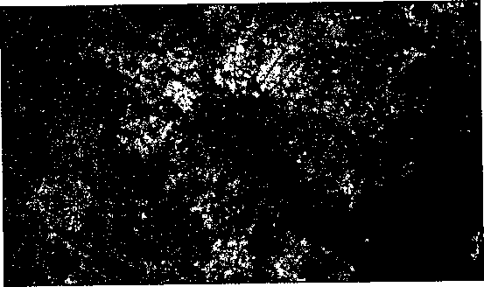

Landsat satellite images are digital images captured from spectral bands both visible and invisible to the human eye. Different kinds of vegetation cover, soils, and built environments are reflected by different colors in the processed image. This Landsat image is of the Washington, DC and Baltimore, Maryland Area.
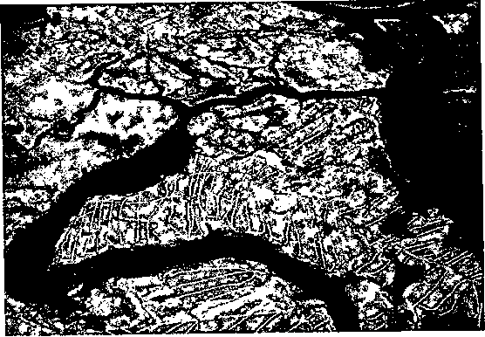

Aerial photographs can be helpful in explaining what would otherwise require expensive surveys and detailed cartography. They are especially useful in working with multidisciplinary teams. This example shows the lower Connecticut river near the town of Old Lyme. The photograph was taken during the Connecticut River Marsh Restoration Project.
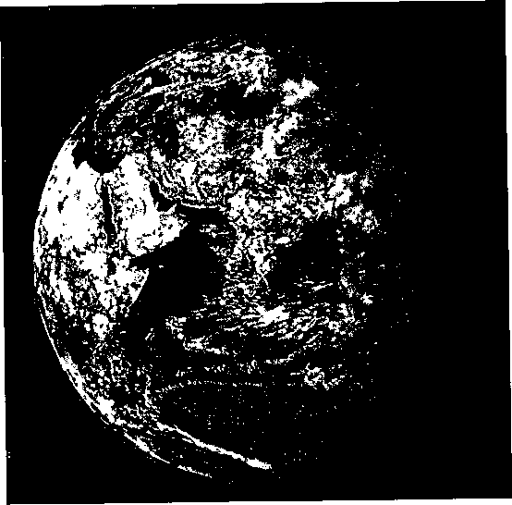
FIGURE 1.5 Remotely sensed innages Remotely sensed images can provide new ways of seeing the world, as well as unique sources of data on all sorts of environmental conditions. Such images can help explain problems and processes. Examples of such applications include studies of the deforestation of the Amazon rain forest, urban encroachment onto farmland, water pollution, and bottlenecks in highway systems. (Source.-Top left photo courtesy of
Spaceimaging.com; top right photo courtesy Joel Sartore www.joelsartore.com.)
Using a collection of satellite-based observations, scientists and visualizers stitched together months of observations of the land surface, oceans, sea ice, and clouds into a seamless, true-color mosaic of every square kilometer (0.386 square mile) of the planet. Much of the information contained in this image came from a single remote-sensing device—NASA's Moderate Resolution Imaging Spectroradiometer, or MODIS—flying more than 700 km above the Earth on board the Terra satellite.

including things on a map—literally "putting something on the map"—can be empowering. The design ofmaps—what they include, what they omit, and how their content is portrayed—inevitably reflects the experiences, priorities, interpretations, and intentions of their authors. The most widely understood and accepted jjjaps—"normal" maps—reflect the view of the world that is dominant in universities and government agencies.
Maps that are designed to represent the form of Earth's surface and to show permanent (or at least long-standing) features such as buildings, highways, field boundaries, and political boundaries

YlSUALIZmC GEgGRAPHY

Geography and Consumer Preferences
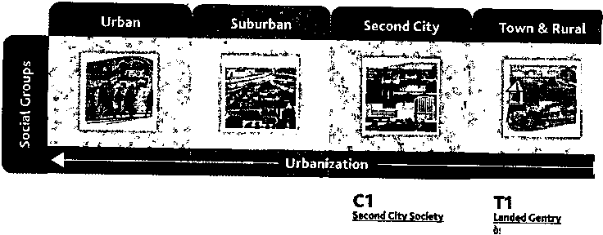
TABLE 1 .A A Socio-spatial Classification of Consumer Groups
U1
Urban Uptown
04 Young Digerati 07 Money StBraftw 16 Boheml»i Mix"' 2&«Thfl Cos|Tq>oli?ares 29 Ameffcan Dreams
SI
Elite Suburbs
- Upper Crust
  - Blue Blood Estates
    - Movers & Shakers 06, Wnner's Ci'rele
10 Second City Elite
- Br!teUtes.U'lClty
- Upward,a<Mjnd
i Country Squires 09 Big Rsh. SmaU Pwid 11 Cod's CoQntfy 20 F%t<TradtFamnies 25 Country Casuals
T2
Country Canrfort
23 Greenbelt Sports
28 Traditional Times
- New Homestesdors
- BI^SKyramibcs
37 Maybeay-vifl©
S2
06 E}fficul^e Suites ''14 New ^mpty Nests 15 Pools & Patios 17 BeltwajfBoomerS IS Klds&CuMe-SaCs 19 Home Sweet Hdme
i
C2
CrtvCwtOT
24 tip-a^^Comers 27 Mu'dlrtu'^MafUgerff : 34 W-hceP-cfctt Fences
Source: Nielsen PRIZM 2010. PRIZM is a trademark or registered trademark of The Nielsen Company (US), LLC.
Low
j81 Cray Power 22>}n£tnfitient{8ts 30 'ixAuthan Spr«M
■
S4
ijracjuribqr^ 44 hTsA « *1' <
^ Arnr(fcanr>Ch>ni(4S'
Market research consultants, using statistical methods similar to those
used by urban social geographers, are able to identify the geogra-
phy of different types of households according to their distinctive
consumption patterns and preferences as well as their socioeconomic
and demographic attributes and their typical residential settings. The
best-known and most comprehensive classification of households in
the United States is the Nielsen PRIZM segmentation system. Block-
level data from the U.S. Census of population is merged with house-
hold demographic and lifestyle data from list-based records for over
120 million households, along with detailed profiles of more than
890,000 households from sources such as R. L. Polk & Co's new-car
buyers and Experian Simmons National Consumer Study which pro-
vides measures of consumer buying behavior and lifestyle descrip-
tors. The PRIZM® segmentation system from Nielsen crunches data
into fourteen major socio-geographic groups: Urban
Uptown, Midtown Mix, Urban Cores, Elite Suburbs, The
Affluentials, Middleburbs, Inner Suburbs, Second City
Society, City Centers, Micro-City Blues, Landed Gentry,
Country Comfort, Middle America, and Rustic Living.
Each of these, in turn, is subdivided, giving a total of
66 distinctive market segments, based on characteristics
such as income, education, occupation, and home value.
The following examples illustrate the kind of market
segmentation that is possible. One of the most affluent
segments is Young Digerati. This relatively wealthy seg-
ment is part of the Urban Uptown social group and en-
joyed an estimated median household income of $91,104
in 2010. Young Digerati are tech-sawy and tend to live in
fashionable neighborhoods on the urban fringe. Highly
educated and ethnically mixed, these communities are
typically filled with trendy apartments and condos, fitness
clubs and clothing boutiques, casual restaurants, and all
types of bars—from juice to coffee to microbrew. Their
distinctive consumer preferences include water skiing,
Audi A3 cars, the Economist magazine, and the Indepen-
dent Film Channel.
American Dreams is also part of the Urban Uptown
social group, however this segment demonstrates how
ethnically diverse the United States has become: Just
under half the residents are Hispanic, Asian, or African
American, and one in ten speaks a language other than
English. These middle-aged immigrants and their children
live in upper-middle-class comfort. The estimated me-
dian household income of the American Dreams neigh-
borhoods is $58,517 and residents tend to buy Lexus IS
vehicles, shop at Old Navy, listen to motivational tapes,
read Black Enterprise magazine, and watch TeleFutura.
Bedrock America belongs to the Rustic Living social
group and is made up of economically challenged fami-
lies (an estimated median household income $28,978 )
in small, isolated towns located throughout America's
heartland. With modest educations, sprawling families.
and service jobs, many of these residents struggle to make ends meet. One quarter live in mobile homes. One in three have not finished high school. Dodge Ram Flex Fuel is the favorite choice for those purchasing new vehicles; fishing and hunting are preferred pastimes in Bedrock America, and residents tend to order from Avon, read Parents Magazine, and watch The Young and the Restless.
Figures 1 .B and 1 .C show the location of these three PRIZM segments in the New York City, New York, and Seattle, Washington, metro area. All sorts of marketers and market researchers use geode- mographic data such as these (often at a much more detailed level) not only to identify and find potential consumers of houses and apartments, cars, consumer goods, and magazines but also to help make location decisions about stores, restaurants, gas stations, and supermarkets.
Source; Nielsen MyBestSegments 2010 (www.mybestsegments.com)

THE WORLD

South Beach, Miami Beach
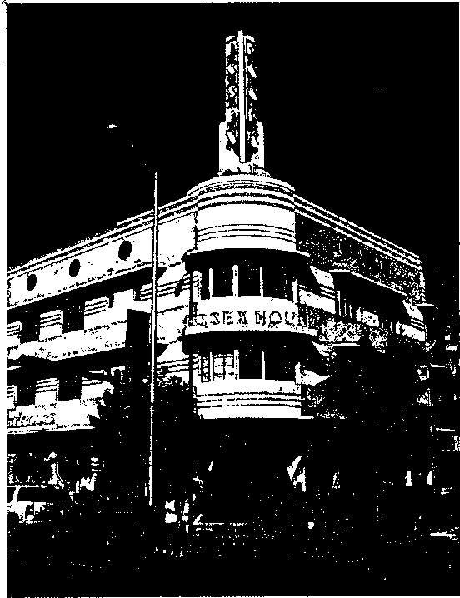
FIGURE 1.D South Beach Architecture Characteristic elements of buildings in the Art Deco district of South Beach include building forms based on geometric shapes, with sharp angles and/or curved corners; "eyebrows" above windows; jutting towers, ziggurat rooflines, glass-block windows, porthole windows, deck railings, racing stripes, and chevron decorations; the use of the modern materials like chrome, plastic, and aluminium; distinctive signage and lettering with exaggerated or multiline details; and neon lighting.
Meanwhile, as metropolitan Miami absorbed increasing numbers of immigrants from Cuba and Latin America, South Beach was infiltrated by drug dealers and the associated crime and vice. Wealthy households moved out, leaving behind less affluent households, such as the retirees on fixed incomes. For a while. South Beach acquired the nickname of "God's Waiting Room." By the
South Beach provides a vibrant illustration of a place that embodies the layered legacy of successive waves of development and change, in just over 100 years, South Beach has gone from a coconut plantation to a speculative development of modest single-family residences; a booming resort and retirement district; a run-down district infiltrated by crime and vice; and a renovated district on the National Register of Historic Places. Its latest incarnation is as an exclusive residential enclave—an international destination district and celebrity haunt, in the process, it has changed from a segregated Anglo American community to a predominantly Jewish community to a multiethnic, cosmopolitan population, the setting for an unabashedly vulgar hedonism. Elements of all of these changes are visible in the landscapes of the district today.
Construction of a small oceanfront residential district began in 1913. A year later, Carl G. Fisher, a successful entrepreneur who made millions selling a business to Union Carbide, began to invest in property development and infrastructure improvements (including a vital road bridge to the mainland). South Beach steadily filled up in the 1920s in a real estate boom supercharged by the palatial homes built by several prominent millionaires. The boom coincided with the blossoming of stylish Modern architecture inspired by the Paris Exhibition of 1925. The new styles reflected a fascination with the streamlined design and comfort features of mass transportation of the era, especially transatlantic ocean liners, luxury automobiles, and passenger trains. Property development and redevelopment continued even during the Great Depression of the 1930s, creating a distinctive district of hotels and residences— about 800 l^ildings in 1 square mile—in what later became known as Art Deco styles (Figure 1 .D).
After World War II, South Beach became a glamorous destir>a- tion district, a seasonal haven for wealthy northerners. The arrival of retirees from the Northeast and Midwest brought a new dimension of ethnic diversity to the city. Jewish retirees were drawn to Miami Beach but had to contend with segregation ordinances that restricted them to the area south of Fifth Street, the southern tip of South Beach. Civil rights activism, combined with the sheer weight of increasing numbers, overcame segregation by the 1960s, and within a few years Jews had come to dominate the entire city of Miami Beach. In South Beach, synagogues, Yiddish theatres, kosher restaurants, and delicatessens proliferated. While there were some upscale hotels and residences, the district was dominated by modest, deteriorating, low-rise buildings populated by retirees on small, fixed incomes.
mid-1970s. South Beach was down-at-heel, no longer attracting many new retirees and on the cusp of irretrievable deterioration. It was saved by the activism of conservationists, who secured a square-mile portion of South Beach as the Miami Beach Art Deco District on the National Register of Historic Places. Conservationists promoted the idea of renovating the buildings by applying a palette of pastel hues—flamingo and bubblegum pink, peach, periwinkle, purple, aqua, and lavender blue—on what had previously been whitewashed surfaces. Hotels and restaurants also began to invest in classic Art Deco neon lighting that provides an exotic nightscape. The makeover was enough to attract new investment, new visitors, and new residents. The combination of distinctive architecture and wide stretches of soft, almost-white sandy beaches, together with the subtropical light, made South Beach an attractive location for photo shoots. Many of the large New York-based modeling agencies moved in, bringing an influx of fashion industry professionals. Sidewalk caf&, boutiques, nightclubs, and chic restaurants followed, along with more models, celebrities, and international tourists.
South Beach became a hedonistic setting, a 24-hour playground dominated by the young and affluent. Restored Art Deco and Mediterranean Revival buildings were joined by new contemporary architecture and ultraluxurious condominiums. The southern tip of the district, branded as "SoFi," was redeveloped with exclusive, resortlike condominium towers (Figure 1.E). Inevitably, the district's demography changed again. Jewish households had represented almost two-thirds of the total population of Miami Beach in 1980. By 2010, the figure was less than 15 percent. Similarly, whereas elderly households had long dominated South Beach, less than 15 percent of its population was aged 50 or more by 2010. The majority were aged between 20 and 40. The traditional flow of Jewish retirees on modest incomes had been priced out of the district, while the more affluent gravitated to Broward and Palm Beach counties. Today, South Beach has developed a unique cultural mix, which is in many ways like the Mediterranean European coast or parts of Latin America. Spanish is the first language of more than half of the population, while English is the first language of only about a third.
Colombian discos, European dub scenes, traditional American bars, Cuban cafes, and restaurants specializing in "Eurasian," "New World," and "Nuevo Latino" cuisine have displaced the kosher delis and seafood shacks. Bikini shows and wet T-shirt contests have replaced the mahjong and canasta games of retirees.
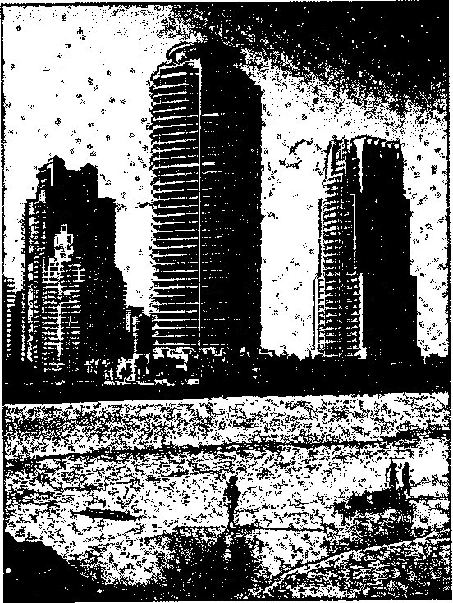

FIGURE 1.E South Beach Lifestyle Luxury condominiums at the southern tip of South Beach.
Lounge music from the 1950s has been displaced by Europop, samba from Brazil, salsa from Colombia, tango from Argentina, reggae from the English-speaking Caribbean, flamenco from Spain, and meringue and bachata from the Dominican Republic. The influence of sun, sea, and the warm weather has fostered a distinctive body-consciousness and standard of public exposure that would be censured in many other American cities.
Source: (Based on "South Beach" in Paul Knox, Palimpsests: Biographies of 50 City Districts, Basel: Actar/Birkhauser, 2012.)

29
28

