Week 4
Inheritance Lab
Instructions and Background

Introduction to the Inheritance Lab

In this lab you will:

- Observe and report your phenotype for the several Mendelian traits (listed below.)
- Infer and report your genotype or possible genotypes for each trait using your understanding of recessive and dominant characteristics.
- Infer and report all of the possible parental crosses that could have led to your possible genotypes by applying the logic of Mendelian genetics.

Please read the relevant sections of your textbook on Mendelian genetics and Punnett squares before proceeding with this lab. Use your text or an online search to learn the following vocabulary terms:

- phenotype
- genotype
- gene
- allele
- dominant allele
- recessive allele
- gamete
- genetic cross
- Heterozygous
- homozygous.

Be sure to save the Inheritance Lab Report document so you may complete and submit it.

Part 1. Phenotypes

For this part of the lab, you will observe and report about some of your phenotypic traits.

Each phenotypic trait is associated with a letter. If you have the dominant allele for a given trait, you would use the uppercase letter associated with the trait to report that phenotype in your lab report. On the other hand, if you have the recessive allele for that trait, you would use the lowercase letter to report your phenotype for that trait. You will also use this convention when identifying alleles in your possible genotypes (more about this in part 2.)

An example of a Mendelian trait (which we will do not analyze in the lab report) is the cleft chin, which is associated with the letter “c”. Cleft chins refer to the central dimple that some people exhibit in the chin. Cleft chins are the result of a dominant allele for this trait. If you have the dominant allele for the cleft chin, you would use the uppercase “C” to report that phenotype. If you do not have a cleft chin, this is associated with the recessive allele, and it is reported as the lowercase “c”.

Traits to be Analyzed

Each of the five traits that you will analyze in the lab are explained below. These traits include earlobe attachment or lack of attachment to the head, the presence or absence of dimples, the ability or lack of ability to roll your tongue, and the presence or absence of a widow’s peak.

EARLOBES
Having free earlobes is a dominant trait (E); having attached earlobes is a recessive trait (e). Explanation: A free earlobe hangs below the point where the ear attaches to the head. An attached earlobe attaches directly to the side of the head.

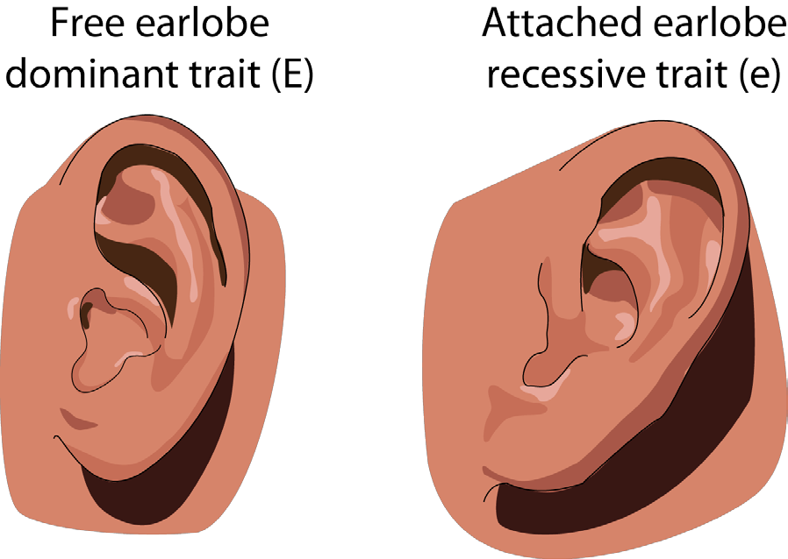

DIMPLES
Having dimples is a dominant trait (D); not having dimples is recessive (d).
Explanation: Dimples are natural indentations in the face on either side of the mouth. (A person may have just one dimple on one side of the mouth.)

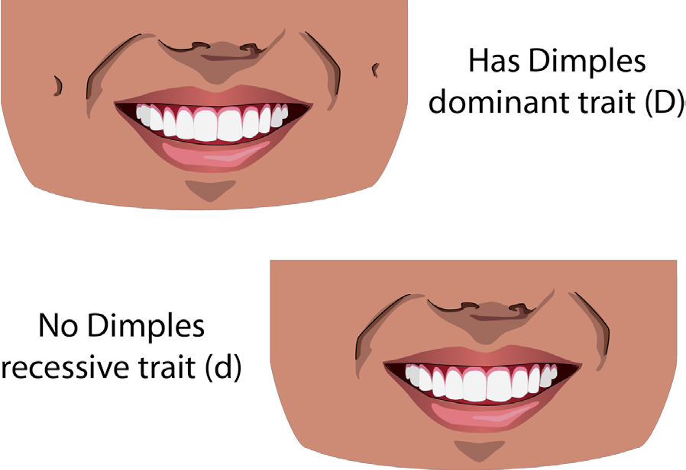

TONGUE ROLLING
The ability to roll up the sides of the tongue is dominant (T); not having the ability to roll up the sides of the tongue is recessive (t).
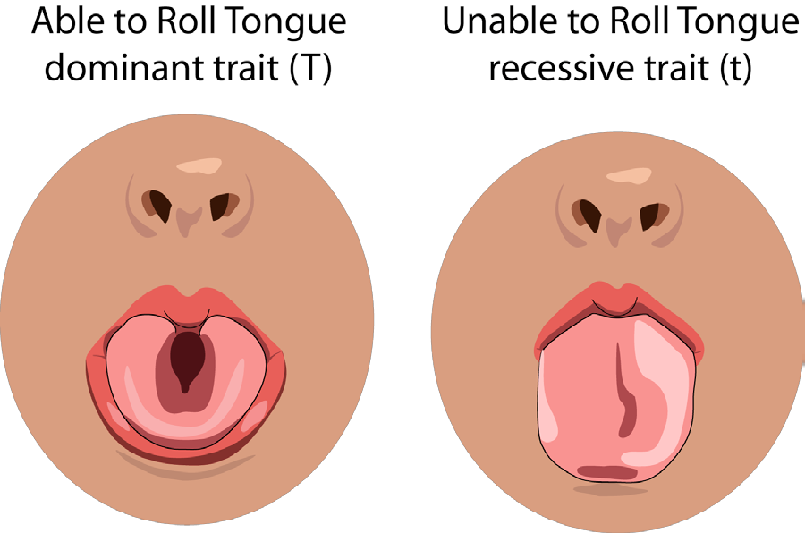.

TOE LENGTH ON FOOT
Having a second toe longer than the foot’s big toe is a dominant trait (F); having a second toe shorter than the foot’s big toe is a recessive trait (f).
Explanation: The second toe in the above statement refers to the toe that is adjacent (next to) the big toe on your foot. If the second toe is longer than the big toe, you have the dominant trait; if the second toe is shorter than the big toe, you have the recessive trait.

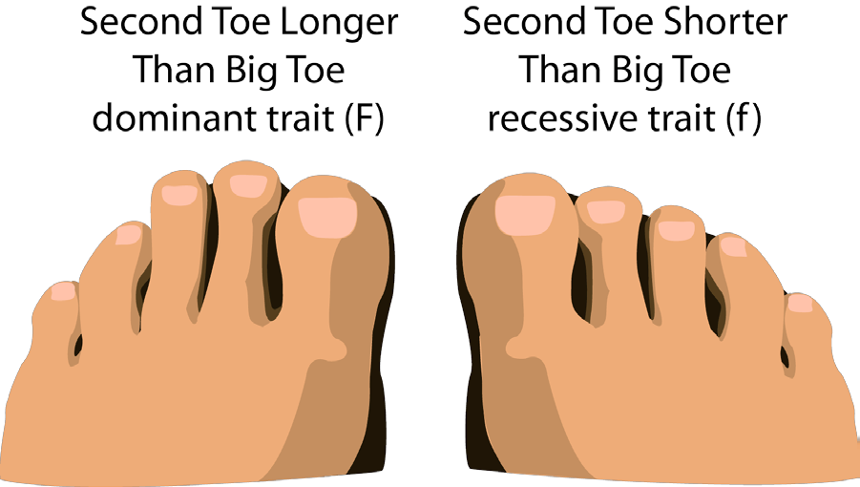

WIDOW’S PEAK
Having a distinct point in the hairline at the top of the face is a dominant trait (W); not having a distinct point in the hairline at the top of the face is a recessive trait (w).

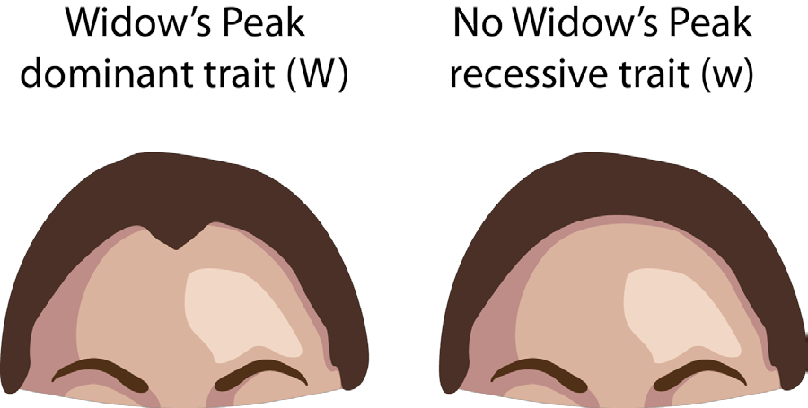

Part 2 Genotypes

Your phenotype represents the traits that visibly express themselves in your body. However, because you inherit an allele from both of your parents and thus carry two alleles for each trait it is possible that some of the alleles that you carry in your genome are not readily observed by looking in a mirror.

Alleles that are recessive will not be visible if you also carry a dominant allele. Thus, if you inherited a dominant allele from one parent and a recessive allele from the other parent you will show the trait associated with the dominant trait but not the trait associated with the recessive allele. In the case of phenotypes, you use a single letter to represent the observed trait but in the case of genotypes we must use two letters to represent the two alleles that you carry in your genome.

As we learned in part 1, the presence of a cleft chin represents a dominant allele and if you have a cleft chin you would represent your phenotype with regards to this trait as an uppercase “C” whereas if you do not show this trait then you would represent this trait as a lowercase “c”. By definition, if you do not have a cleft chin you can infer that you do not carry the dominant allele for this trait because if you did you would see it in your phenotype. Thus, a person without a cleft chin can infer that they received the recessive allele for this trait from both of their parents and that your genotype is a “cc” meaning that they have two recessive alleles. In the other situation, where your phenotype is a “C” (i.e. you would show the dominant trait of having a cleft chin) then you are not certain if you inherited the dominant allele from both parents or if you inherited a dominant allele from only one parent and a recessive allele from the other. In this case you can infer that your genotype is either “CC” or “Cc” referring to each of these cases respectively.

Part 3 Parental Crosses

BACKGROUND ON MENDELIAN GENETICS

When traits are the result of a single gene with a few distinct alleles, you may use the logic of Mendelian genetics to predict the genotypes of offspring. To apply Mendelian genetics, you must understand the following terms: genotype, phenotype, dominant allele, recessive allele, heterozygous, homozygous, and Punnett square.

Here is an example of a Punnett square. In this analysis, we will use our example of the cleft chin. The dominant allele for this trait is having a cleft chin “C” and the recessive allele is not showing a cleft chin “c”. Consider the case where a heterozygous parent with a genotype of Cc mates with a homozygous parent who has an cc genotype. Such a cross is represented as Cc x cc .

- Set up the square: To analyze the possible offspring from this paring CC x Cc we take the two alleles of each parent (representing the types of gametes that each produces) and place them along the sides of our Punnett square.

c c

C
c

- Fill in the square: With the alleles from the two types of gametes produced by the homozygous parent (c and c) along the top of the square and the alleles carried by the gametes produced by the heterozygous parent (C and c) along the sides of the square, we can now fill in what would happen when the gametes from one parent meet with the other. In this case the homozygous parent contributes a “c” to each cell in the square while the heterozygous parent contributes a “C” in the upper row and a “c” in the lower row. The four possible combinations in each cell represent the types of fertilized eggs that can be produced by this cross (Cc x cc)

c c
Cc | Cc
cc | cc

C
c

- Interpreting the Square: The four cells of the square represent the four possible types of offspring that could be produced in the pairing and each cell is equally probable. Based on this, what percentage of the offspring in the Punnett square above will display a cleft chin? (answer below)

You may also use Mendelian genetics to infer possible genotypes of parents based on the phenotype of a child. For example, if a child displays a cleft chin, what are his or her possible genotypes? (Hint: There are two possible genotypes.) Based on this answer, what possible crosses might the parents have?

Continuing with the above example, if you have a cleft chin, your phenotype is C, but what is your genotype? Both a “CC” and a “Cc” individual would display a cleft chin, so your genotype could be either of these. Using Mendelian genetics, you can infer the different possible pairings of parental phenotypes that would lead to your genotypes. For example, let’s examine the case in which you are a heterozygote for a cleft chin and consider what possible parental crosses could have resulted in the Cc genotype. Notice that we are leaving the “CC” case as an exercise for you.

All of the following parental crosses could lead to a “Cc” offspring:

CC x Cc
CC x cc
Cc x Cc
Cc x cc

Does this make sense? If not, run a Punnett square on each cross. (Refer to Chapter 8 in the textbook Concepts of Biology for more on Punnett squares.) You may also practice using a Punnett square by referring to the Punnett square calculator listed in the week’s Resources section. You can also predict which of the above crosses would be most likely by considering which of these pairings is most likely to give an Cc offspring (e.g., 25%, 50%, or 100% probability).

After identifying your possible genotypes, you will use this logic to infer all of the possible crosses that could have led to your possible genotypes.

Answer to Number 3 above: Two of the gametes produced have “cc” genotypes and two have “Cc”. Each cell has a 25% likelihood of occurring so there is a 50% chance that an offspring from this cross will have a cleft chin.

