

User’s Guide

- Neli, W
- Peri, V
- Sug, hoon
- Tem, Ter

Application Features
Application Requirements
Introduction
Weather Application App

Contents

Location
Check weather

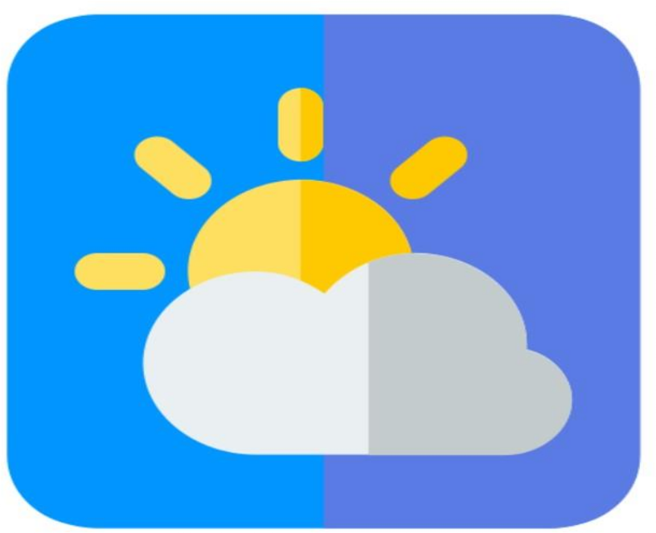
Introduction
Welcome to the Weather Application App, developed and maintained by Group 4. Our app is designed to provide users with accurate and up-to-date weather information at user’s fingertips.
The Weather Application App offers a user-friendly interface that allows you to access a wide range of weather data quickly and easily. From current conditions to extended forecasts, our app delivers reliable information to help you stay informed and prepared for whatever Mother Nature has in store.

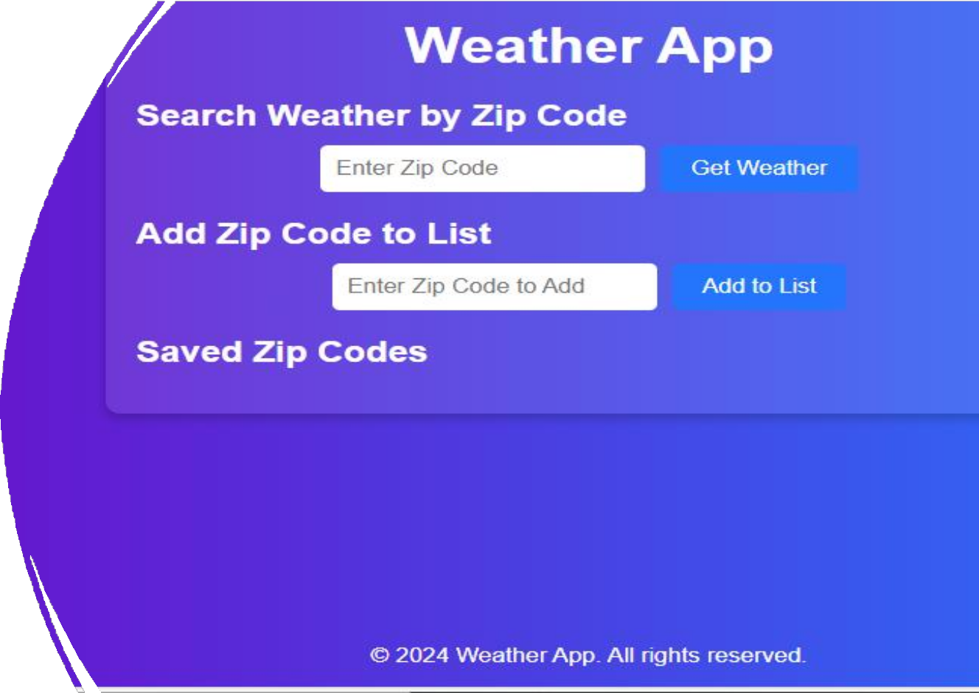
Features of the App

- Real-Time weather data Retrieval

- Comprehensive weather Display

- Personalized Zip Code management

- Easy-to-Use Navigation

System Requirements

- Device

A computer running Windows or MacOS
- Internet Browser
Any modern web browser such as Google Chrome, Mozilla Firefox, Apple Safari, Microsoft Edge
- Internet Connections
An active Internet connection for real- time weather updates

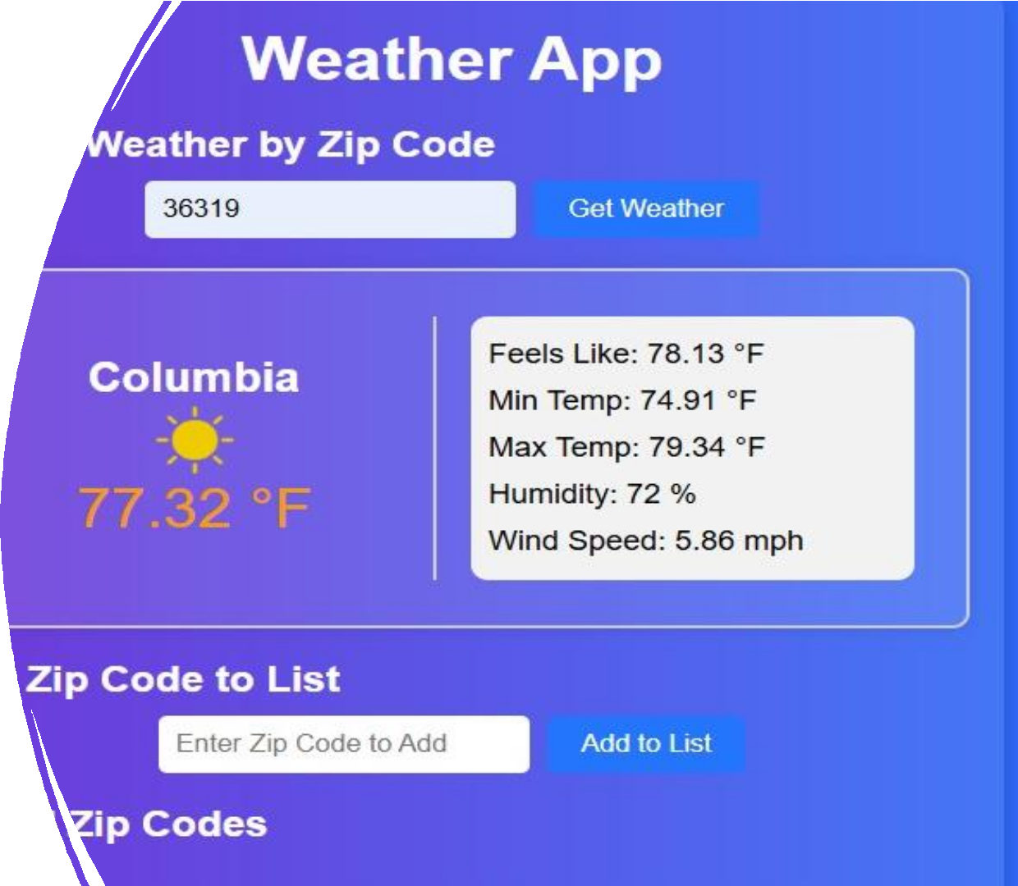
Using Zip Codes Location

- Location
  - To get weather information for a specific location, users need to enter its zip code.
  - The app accepts standard 5 digit zip codes used in the United States
  - Enter the zip code in the designated input field
on the app’s interface.
- Adding multiple Locations
  - Users can add multiple zip codes to track weather in different locations
- Saving Zip codes
  - The app allows user to save zip codes for quick access in future sessions

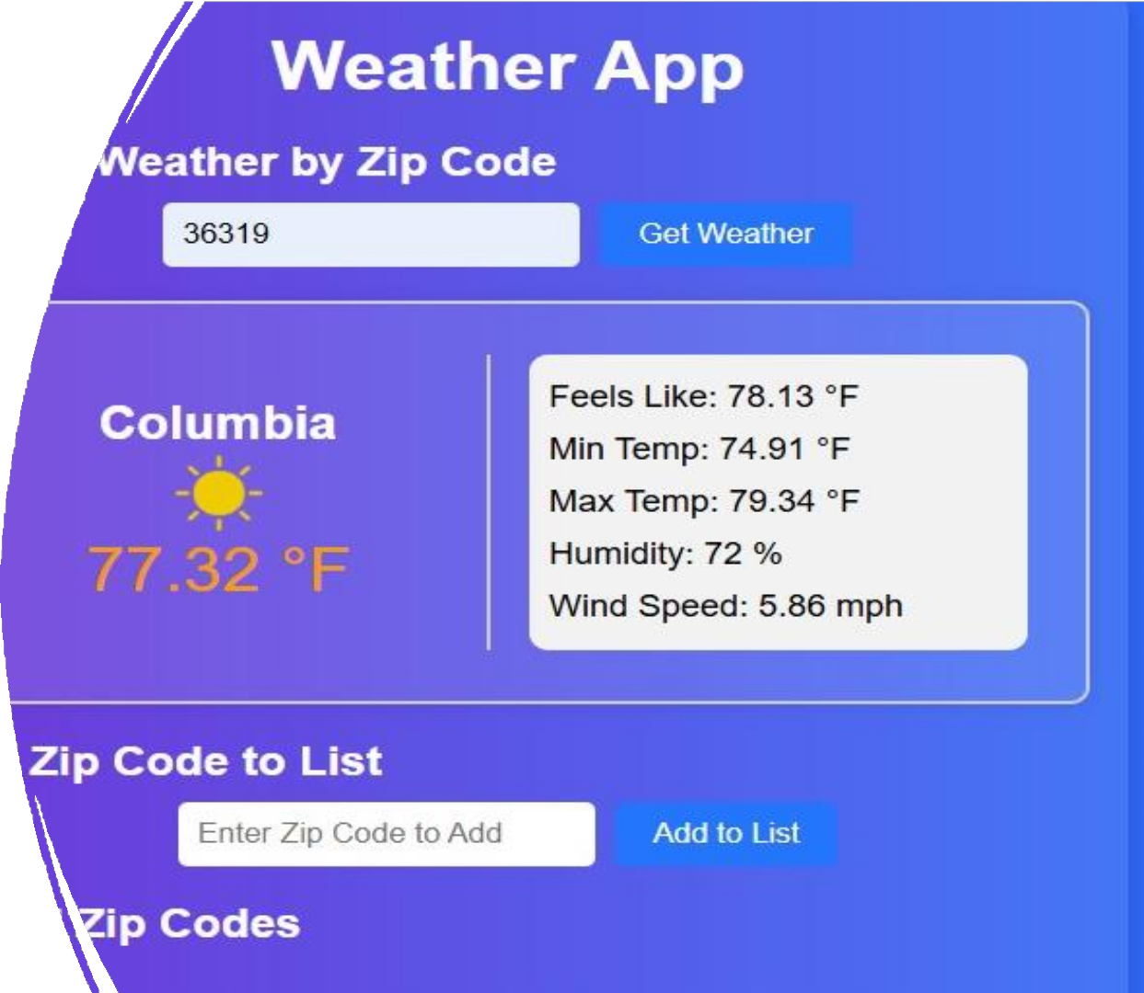
Checking weather

- Retrieving Weather Information
- After entering the zip code, click the blue “Get Weather” button to the right of input field.
- The app will process user’s request and
display the weather information
- Reading the weather Display
- The app will show the city name associated with the zip code
- Users will see temperature display and represent the current weather conditions.

Exit Application

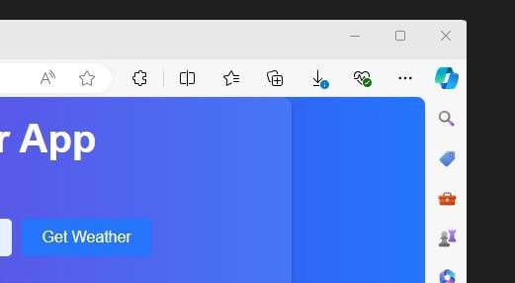
Close the tab

- Click the “X” on the right side
of the tab to close it

- This will close the weather application

