Question 5 (2.5 points)

The four elements of the SWOT analysis are: Strengths, Weaknesses, Opportunities and ______. (W6)

Question 5 options:
Timing
Threats
TRPs
Testing
Triggers

Save

Question 6 (2.5 points)

Which of the following would NOT be included in an analyses of frequency distribution? (W6)

Question 6 options:
medium users
heavy users
light users
extra-heavy users
non-users

Save

Question 7 (2.5 points)

A _________ is a formal statement that explains an organizations true purpose. (W6)

Question 7 options:
Situation analysis
Marketing plan
Marketing objective
Marketing strategy
Mission statement

Save

Question 8 (2.5 points)


If Nike runs a national TV ad for its latest shoe twenty times over a three-month period, the company is going for a/an ___________ strategy. (W6)

Question 8 options:
reach
frequency
geo-targeting
recency
exposure

Save

Question 9 (2.5 points)

The four basic types of segmentation include geographic, psychographic, demographic and _______. (W7)

Question 9 options:
generational
emotional
behavioral
topographic
fragmentation

Save

Question 10 (2.5 points)

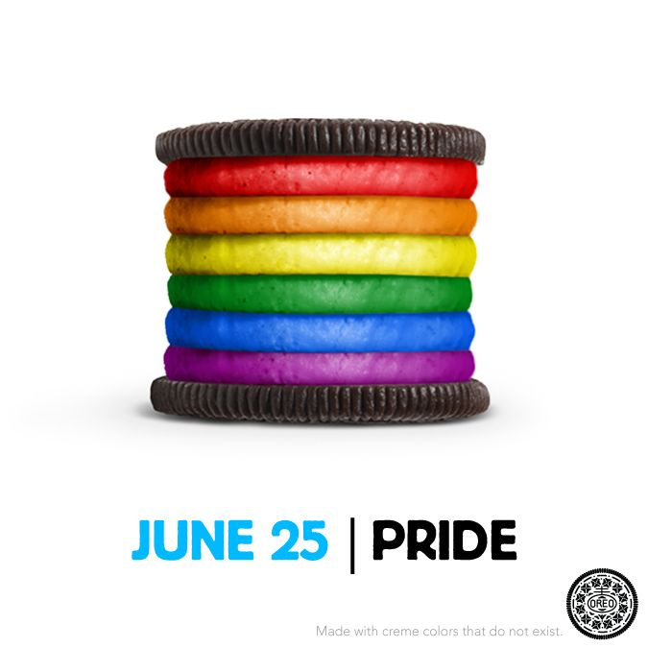
Different creative messages and media vehicles are needed to effectively communicate with gay consumers. (W7)

Question 10 options:
1
0

Save

Question 11 (2.5 points)

According to the heavy user concept, 25% of consumers usually consume 75% of a product. (W7)

Question 11 options:
1
0

Save

Question 12 (2.5 points)


According to PRIZM, the Young Digerati segment will act and behave the same in Dallas as they do in Los Angeles. (W7)

Question 12 options:
1
0

Save

Question 13 (2.5 points)

PRIZM, which is a tool based on geodemographic segmentation, defines every U.S. household in terms of _____ demographically and behaviorally disctinct types. (W7)

Question 13 options:
46
56
66
76
100

Save

Question 14 (2.5 points)


Today, there are 53 million Gen Xers (ages 36-49) in the U.S. They make up about 20% of the population and spend roughly $146 billion as a group. The annual spend of the total U.S. market is $485 billion. What Based on these numbers, how much does Gen X spend per capita? (W7)

Question 14 options:
$2 billion
$5 billion
$9 billion
$12 billion
$20 billion

Save

Question 15 (2.5 points)

_________ are indices that compare the relative strength of a market to overall sales. (W7)

Question 15 options:
DMA and SOV
GSP and TRP
BDI and CDI
CPM and GRP
Reach and frequency

Save

Question 16 (2.5 points)

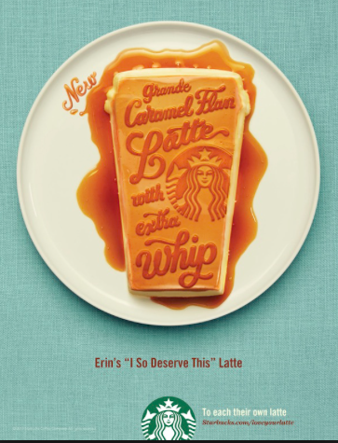
Starbucks largely markets to males and females between the ages of 25-54. This is an example of _________ segmentation. (W7)

Question 16 options:
psychographic
behavioral
geographic
demographic
sociographic

Save

Question 17 (2.5 points)

When using geo-targeting it’s better to stick with a businesses’ native language than to change the language based on location. (W7)

Question 17 options:
1
0

Save

Question 18 (2.5 points)

_________ are indices that compare the relative strength of a market to overall sales. (W7)

Question 18 options:
TRP and CPM
GSP and TRP
BDI and CDI
MRI and CDI
SOV and SOM

Save

Question 19 (2.5 points)

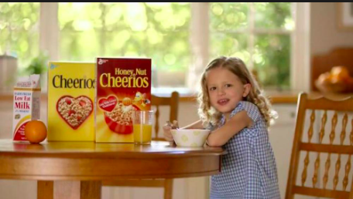
Each year, consumers in the Atlanta DMA spend an average of $500 per household on cereal and baked goods; the average total sales in the U.S. is $450 per household. Therefore, the CDI for cereal and baked goods in Atlanta is _____________. (W7)

Question 19 options:
100
111
145
162
180

Save

Question 20 (2.5 points)

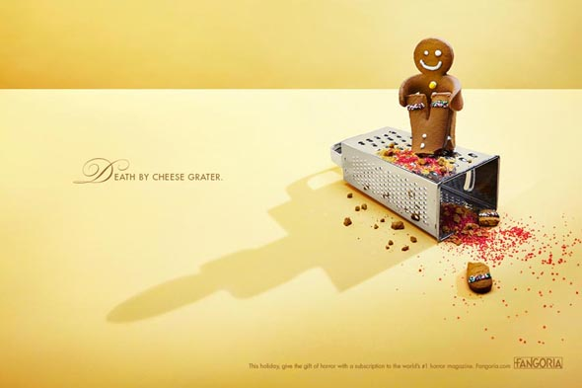
It is common for marketers to adjust their budgets, messaging and marketing approaches for the Q4 holiday period. (W8)

Question 20 options:
1
0

Save

Question 21 (2.5 points)

All things being equal, a brand whose share of voice (SOV) is greater than its share of market (SOM) is more likely to gain market share. (W8)

Question 21 options:
1
0

Save

Question 22 (2.5 points)

One of your articles from Week 8 indicates that a _________ is a good way to categorize a product around its launch, so that users can easily find information about it.

Question 22 options:
Facebook page
hashtag
product profile
tweet
photo

Save

Question 23 (2.5 points)

Using the advertising/sales ratio method, the budget for a brand with sales of $1.2 million and an industry A/S ratio average of 7% would be ________. (W8)

Question 23 options:
$840
$8,400
$84,000
$804,000
$840,000

Save

Question 24 (2.5 points)


An article from Week 8 explains that the purpose behind a teaser campaign is to build ____________.

Question 24 options:
sales
profits
inventory
awareness
customers

Save

Question 25 (2.5 points)

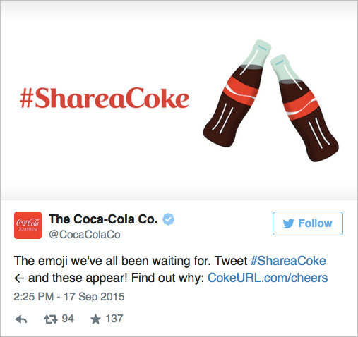
Companies that want to reach consumers on weekdays via Twitter should post ________. (W8)

Question 25 options:
early in the morning
around noon
in the late afternoon
in the early evening
in the late evening

Save

Question 26 (2.5 points)

According to one of the articles from Week 8, the best time of day to reach Twitter users is ________.

Question 26 options:
around 8:00 am
around noon
after 5:00 pm
after 8:00 pm
at midnight

Save

Question 27 (2.5 points)

Having a consistent campaign message, tone, look and feel across offline and online worlds is known as ________. (W10)

Question 27 options:
strategic communication
integrated marketing communications
public relations
media marketing
advertising strategy

Save

Question 28 (2.5 points)

Which of the following is NOT a benefit of advertising? (W10)

Question 28 options:
It can create awareness, familiarity or purchase consideration of a product, brand or business.
It can shape consumer attitudes and create product/brand images.
The content and execution of the message can be controlled.
It's easy to measure.
All of the above are benefits of advertising.

Save

Question 29 (2.5 points)

According to an article from Week 10, attracting new customers is much more important than maintaining them.

Question 29 options:
1
0

Save

Question 30 (2.5 points)


Barnes & Noble offers B&N Members five percent off of food and drinks at its in-store Starbucks cafes. This is known as a ________. (W10)

Question 30 options:
price incentive
sponsorship
cross promotion
bonus buy
loyalty program

Save

Question 31 (2.5 points)

______is a profession that uses paid communications to persuade an audience to take action on products, ideas or services. (W10)

Question 31 options:
Advertising
Branding
Media planning
Direct marketing
Media buying

Save

Question 32 (2.5 points)

A brand might take the shape of a name, sign, symbol or color combination. (W10)

Question 32 options:
1
0

Save

Question 33 (2.5 points)

In today’s market, the most influential factor on consumer purchase decisions is ________. (W10)

Question 33 options:
direct marketing
print advertising
television advertising
word-of-mouth marketing
radio advertising

Save

Question 34 (2.5 points)

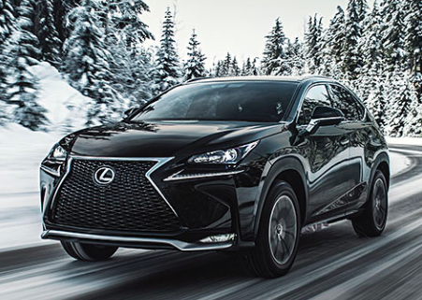
Which of the following is the best medium to use when advertising a Lexus? (W11)

Question 34 options:
Outdoor
Television
Radio
Magazine
Internet

Save

Question 35 (2.5 points)

As an advertising medium, radio is mostly utilized by local businesses. (W11)

Question 35 options:
1
0

Save

Question 36 (2.5 points)

At this point in time, _______ is the most influential marketing medium. (W11)

Question 36 options:
television
radio
print
social media
WOM

Save

Question 37 (2.5 points)

According to an article from Week 11, digital media has almost completely taken the place of print media.

Question 37 options:
1
0

Save

Question 38 (2.5 points)

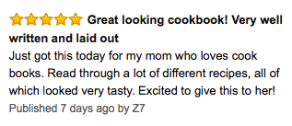
An Amazon customer's review of a cookbook would be an example of WOM. (W11)

Question 38 options:
1
0

Save

Question 39 (2.5 points)

The first step in creating a media plan is ________. (W11)

Question 39 options:
defining the task
determining the target audience
setting a budget
deciding which media to use
determining geographic coverage

Save

Question 40 (2.5 points)


Which of the following is the best medium to use when advertising a piece of exercise equipment? (W11)

Question 40 options:
Outdoor
Television
Radio
Magazine
Internet

