NOTES FROM THE PROFFESSOR
welcome to Week 4 in SOC 5620!
This week's topic is Technology Changes Everything.
Leaning Outcomes
These are the learning outcomes for week 4. Upon successful completion of the work this week, you will be able to:
- Identify how technology has changed work.
- Analyze the role of technology in easing/exacerbating work related inequities.
- Evaluate how technology has blurred the lines between personal and professional life.
Technological Change
Technology refers to any device that helps people to perform labor more efficiently, more easily, and more productively. The device usually is a human-made article, but can also be a work strategy or organizational system. While most people today equate technology with computing and communications equipment, including smart phones, electronic tablets, and the like, an organizational system that increases productivity, such as the assembly line developed in the early twentieth century to produce automobiles. Today, the assembly line has given way to robots that assemble cars, a technological change that has increased productivity further.
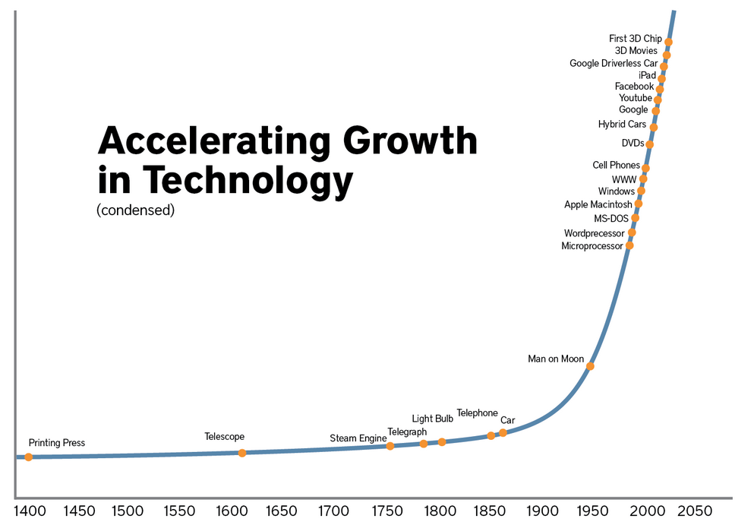
Technological change is closely tied to organizational systems. Historically, great technological changes have occurred at times, such as the agricultural revolution, when people moved from hunting and gathering, often in nomadic groups, to agriculture in settlements, relying on plows to turn the soil and prepare it for planting. Agriculture allowed for some division of labor in communities, as the production of a surplus of food could sustain people who dedicated themselves to craft production, religious ceremonies, and leadership positions. The industrial revolution was precipitated by the harnessing of steam power to run mechanical devices that could manufacture various goods. This freed many more people to dedicate themselves to specialized roles in the overarching production system, and created workplaces where people spent much of their day, engaging in labor in exchange for wages. Political, economic and educational institutions grew and became more prominent in society, producing new forms of organization to move industrialization forward. With the development of computers, the information revolution again led to new forms of organization, as people no longer were tied to one workplace, but could move more freely and maintain communications with co-workers. Information emerged as an important commodity in the service industries that became the major part of national economies in post-industrial societies. A hierarchical global system of organization emerged that featured the post-industrial information economies serving as the global administrative class, the industrializing countries where most manufacturing occurred as the global working class, and the resource-dependent least developed countries as the global supply centers for raw materials and cheap labor. Low cost communications and transportation technologies facilitated the global organization of work.
Technology and the Contingent Workforce
Communications technology, including social media, have opened up opportunities for new industries, and for new operations in old industries. For example, Uber and Lyft rely on a smartphone app and provide a service that competes directly with taxis in urban areas. These ride sharing services provide many people with an opportunity to earn extra income, or even to earn one steady income, by joining the "gig economy." Many see advantages in the gig model of work, including setting one's own schedule and greater freedom to determine one's income, based on how many hours one wants to work. And the gig economy fits into a broader and pervasive shift in work, in which temporary workers play an increasingly important role.

As Louis Hyman documents in his book Temp: How American Work, American Business and the American Dream Became Temporary (Viking Press, 2018), corporations are strategically divorcing themselves from their workforce, and replacing employees with temporary labor. This comes in various forms. In white collar work, consultants are hired on a temporary basis to provide expertise for specific projects. In blue collar work, employment agencies provide "temps," workers willing to work at short term work in a variety of areas, from clerical work, to driving and deliveries, to cleaning out storage closets. For very short-term assignments, day laborers line up in cities around the country, often in front of big box hardware stores, and hire themselves out for odd jobs, often for only one day or less. All of these represent a significant part of the American workforce today, as employers can cut costs substantially by relying on these workers. The model that business uses is often referred to a the contingent labor force model, as it gives employers flexibility in managing its workforce. Employers don't have to keep workers busy during slow times, they simply lay them off or dismiss them from a temporary assignment. And, employers often avoid having to provide benefits, which saves a lot of money, nor are perks necessary to keep employees happy. And, if a worker isn't working out, the employer can get rid of and replace him or her quickly and easily.
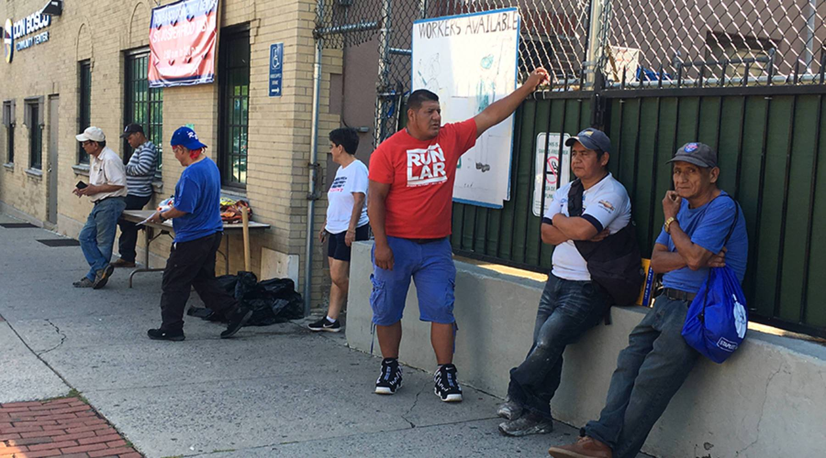
Day laborers congregate on street corners in the hopes of finding work one day at a time. [Source: Marketplace.org]
Technology facilitates the contingent workforce. Communications technology makes finding and screening qualified temporary workers much easier. Technology also can be used to monitor temporary workers, and to provide them with the tasks they need to complete, often with built in safeguards to ensure the workers don't make mistakes. Because many jobs today require people to work with machines, these machines can be programmed to make things very easy for workers, so that a temp can complete tasks reliably with little training and investment.
If education or training are necessary, technology can assist with those as well. College degrees can be earned entirely through on-line courses, and many workplaces now have apps and programs that provide workers with on-the-job training in various realms, from safety protocols, to applicable regulations, to company policies, to specific tasks they need to master in their work.
Technology and Unemployment
Of course, technology contributes not only to employment, but to unemployment as well. For decades, corporations have pursued a strategy of replacing labor with technology. While much press is focused on outsourcing jobs to developing countries where labor costs are cheaper and worker protections are more lax as a means of cutting corporate costs, the fact is that more workers lose their jobs to technology than to foreign workers. Farmworkers have been replaced by large combine tractors, so that food production that used to take dozens of workers can now be done with one tractor driver. Auto workers have been replaced by robots, who work on assembly lines 24 hours a day, 7 days a week, all year round, with no time off for illness or family emergencies, no need for overtime pay, no complaints or strikes, and much more standardized and reliable outputs. Clerks in retail outlets have been replaced by Internet shopping sites, which use computer algorithms to organize shopping and sales, and require much less labor to get good to consumers. And teachers have been replaced by online learning management systems, which provide content to learners and can repeat the same course to new students year in and year out, monitored by a facilitator rather than a trained teacher.
 | 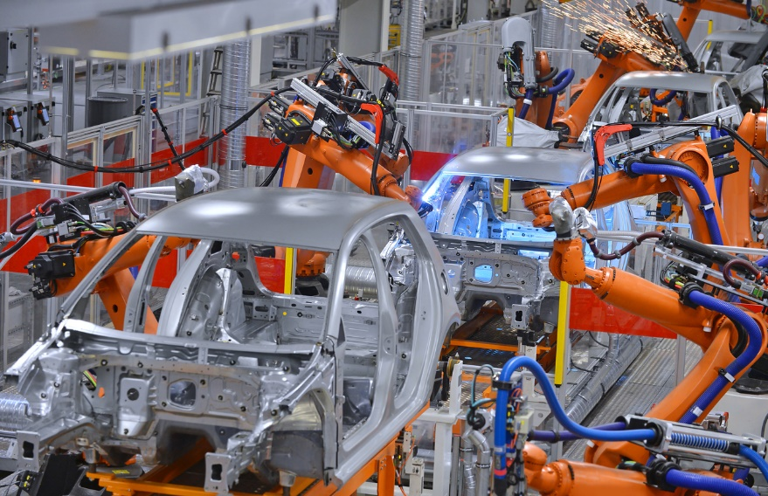
Technology has replaced many workers in agriculture and in manufacturing, as combines harvest crops and robots build cars. [Source: Grainews.ca, Robotics Industry Association]
When workers lose their jobs to a machine, it creates economic disruptions in communities and households. Often, it means a worker has to accept a lower paying, more menial job, with a consequent decrease in his/her family's standard of living. Or, workers have to go back to school for training in a different field, one that hopefully has a prospect for employment well into the future. With technological innovation, however, nothing is very secure anymore, and workers can probably expect to change jobs several times during their career, perhaps even changing fields once or twice as well. This is the reality for many workers in the 21st century.
The content of this announcement will not be visible to users until Dec 1 at 12:10pm
This announcement is closed for comments

