Chapter 8: Net Present Value and Other Investment Criteria
Chapter 8 Learning Objectives
1. Calculate the net present value of an investment.
2. Use the net present value rule to analyze three common problems that involve competing projects: (a) when to postpone investment expenditure, (b) how to choose between projects with unequal lives, and (c) when to replace equipment.
3. Understand the payback rule and explain why it doesn’t always make shareholders better off.
4. Calculate the internal rate of return of a project and know what to look out for when using the internal rate of return rule.
5. Calculate the profitability index and use it to choose between projects when funds are limited.

Valuation Techniques
This chapter presents multiple valuation techniques used during the capital budgeting process.

Chapter 8 Outline
- Valuation Techniques
  - Net Present Value
  - IRR
  - Payback Period
  - Profitability Index
- Mutually Exclusive Projects
- Capital Rationing

Net Present Value
- Opportunity Cost of Capital - Expected rate of return given up by investing in a project
- Net Present Value - Present value of cash flows minus initial investments.
- Present Value – Value of discounted cash flows at time t = 0

Net Present Value: Example 1
Assume you plan to invest $1,000 today and will receive $600 each year for two years (assume the cash is received at the end of the year). What is the net present value if there is a 10% opportunity cost of capital?

C₀ = $1,000
C₁ = $600
C₂ = $600
r = 0.10

Net Present Value: Example 2
Assume you invest $1,000 today and will receive $1,200 in two years (assume the cash is received at the end of the 2nd year). What is the net present value if there is a 10% opportunity cost of capital?
C₀ = ? C₀ = $1,000
C₁ = ? C₁ = $0
C₂ = ? C₂ = $1,200
r = ? r = 0.10

Net Present Value Rule
Managers increase shareholders’ wealth by accepting all projects that are worth more than they cost. Therefore, managers should accept all projects with a positive net present value.

Using the NPV Rule to Choose among Projects
When choosing among mutually exclusive projects, calculate the NPV of each alternative and choose the highest positive-NPV project. Example: Consider two projects, assuming a 10% opportunity cost of capital.
Which project should be selected?
Project | Cash Flows |  |  | NPV
Project | C₀ | C₁ | C₂ | NPV
Project 1 | - $1,000 | $700 | $500 | $49.59
Project 2 | - $1,000 | $500 | $700 | $33.06

Challenges to the NPV Rule
- The Investment Timing Decision
- The Choice between Long and Short-Lived Equipment
- When to Replace an Old Machine

Investment Timing
Sometimes you have the ability to defer an investment and select a time that is more ideal at which to make the investment decision.
Example: A common example involves a tree farm. You may defer the harvesting of trees. By doing so, you defer the receipt of the cash flow, yet increase the cash flow. Assume an opportunity cost of capital of 10%.
Year Cost Sales Value NPV
0 50 70 20 20.0
1 55 80 25 22.7
2 60 88 28 23.1
3 64 95 31 23.3
4 68 102 34 23.2
5 70 105 35 21.7

Long vs. Short-Lived Equipment: Equivalent Annual Annuity
The Choice between Long- and Short-lived Equipment:
- Equivalent Annual Annuity - The cash flow per period with the same present value as the cost of buying and operating a machine.

- Annuity Factor - The present value of $1 paid every year for each of t years.
Note: Think of the equivalent annual annuity as the level annual charge that is necessary to recover the present value of investment outlays and operating costs.

Equivalent Annual Annuity: Example
Given the following costs of operating two machines and an 8% cost of capital, select the lower-cost machine using the equivalent annual annuity method.
Project | Cash Flows |  |  |  | NPV
Project | C₀ | C₁ | C₂ | C₃ | NPV
Machine 1 | - $3,000 | -$800 | -$800 | -$800 | -$5,062
Machine 2 | - $2,000 | -$1,300 | -$1,300 |  | -$4,318
Select Machine 1 because its EAA is less negative.
Payback Method
- Payback Period - Time until cash flows recover the initial investment of the project.

Payback Rule
Says a project should be accepted if its payback period is less than a specified cutoff period.
- Payback Rule - Specifies that a project be accepted if its payback period is less than the specified cutoff period. The following example will demonstrate the absurdity of this statement.

Payback Method: Example
Example:
The three projects below are available. The company accepts all projects with a 2 year or less payback period. Show how this will impact your decision.
Project | Cash Flows |  |  |  | Payback Period | NPV  (@10%)
Project | C₀ | C₁ | C₂ | C₃ | Payback Period | NPV  (@10%)
Project 1 | - $1,000 | $700 | $500 |  | 1.6 years | $49.59
Project 2 | - $1,000 | $500 | $700 |  | 1.7 years | $33.06
Project 3 | - $1,000 | $500 | $700 | $700 | 1.7 years | $558.98

Drawback of Payback Rule
- Though Projects 1, 2 and 3 have payback periods less than 2 years, notice the differences in NPV.
- The Payback Rule ignores the time value of money.

- Discounted Payback Rule – This is the number of periods before the present value of prospective cash flows equals or exceeds the initial investment.

Other Investment Criteria: IRR
- Internal Rate of Return (IRR) - Discount rate at which NPV = 0.
  - Sometimes termed the discounted cash flow (DCF) rate of return.

Internal Rate of Return: Example*

Project | Cash Flows |  |  | NPV  (@ 10%) | IRR
Project | C₀ | C₁ | C₂ | NPV  (@ 10%) | IRR
Project 1 | - $1,000 | $700 | $500 | $49.59 | 13.90%
Project 2 | - $1,000 | $500 | $700 | $33.06 | 12.32%

* Calculating the IRR can be a laborious task. Fortunately, financial calculators and spreadsheets can perform this function easily

Internal Rate of Return Rule
Managers increase shareholders’ wealth by accepting all projects which offer a rate of return that is higher than the opportunity cost of capital.

NVP and Internal Rate of Return
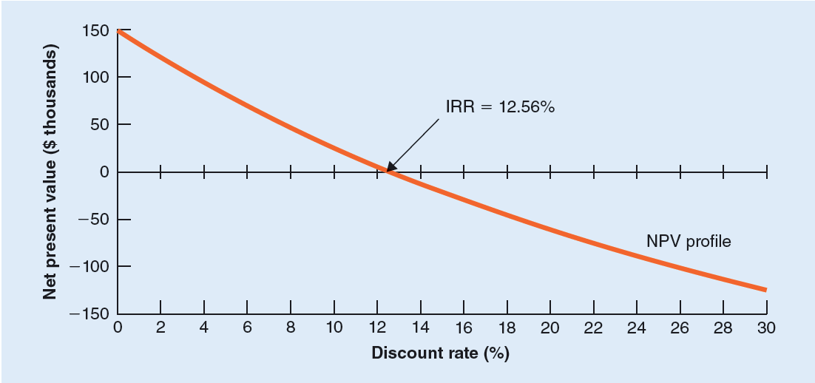
Note: The Internal rate of return rule will give the same answer (accept or reject) as the NPV rule as long as the NPV of a project declines smoothly as the discount rate increases.

IRR vs. NPC
Pitfall 1 – Lending or Borrowing?
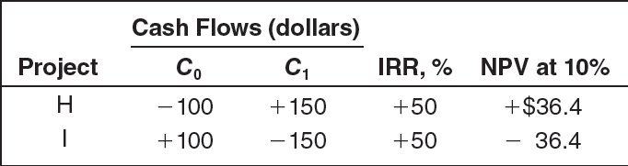

IRR vs. NPV
Pitfall 2 – Mutually Exclusive Projects

IRR vs. NPV
Pitfall 3 – Multiple Rates of Return
This problem can be corrected using MIRR (modified internal rate of return). See Chapter 8 appendix for details.

Other Investment Criteria: Profitability Index

Project | Cash Flows |  |  | NPV  (@ 10%)
Project | C₀ | C₁ | C₂ | NPV  (@ 10%)
Project 1 | - $1,000 | $700 | $500 | $49.59
Project 2 | - $1,000 | $500 | $700 | $33.06
Profitability Index – Ratio of net present value to initial investment.
Note: This method is more useful when comparing projects with similar NPVs but different initial investments.

- Capital Rationing - Limit set on the amount of funds available for investment.
  - Soft Rationing - Limits on available funds imposed by management.
  - Hard Rationing - Limits on available funds imposed by the unavailability of funds in the capital market.

Appendix A: IRR – Financial Calculators and Excel
Calculating the IRR can be a laborious task. Fortunately, financial calculators and spreadsheets can perform this function easily. Consider the example “Project 1”:
HP-10B BAII Plus
-1,000 CFj CF
700 CFj 2nd{CLR Work}
500 CFj -1,000 ENTER
{IRR/YR} 700 ENTER
500 ENTER
IRR CPT

All three methods generate an IRR of 13.90%.

Appendix B: Capital Budgeting Techniques
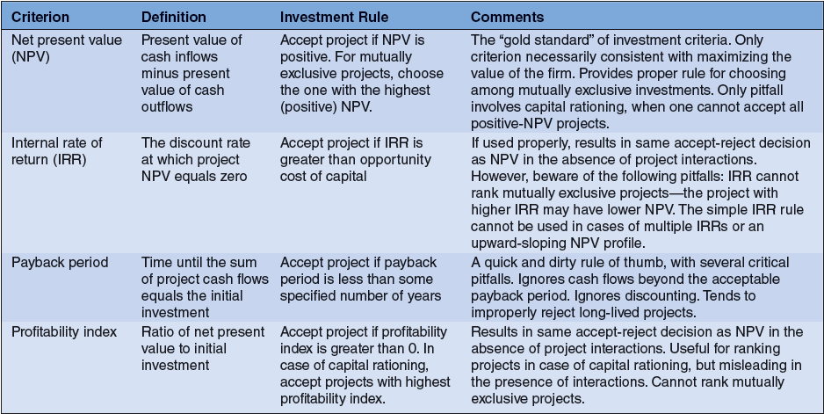

Appendix C: Valuation Technique Usage
