Lecture 3
Post-Apostolic Christianity

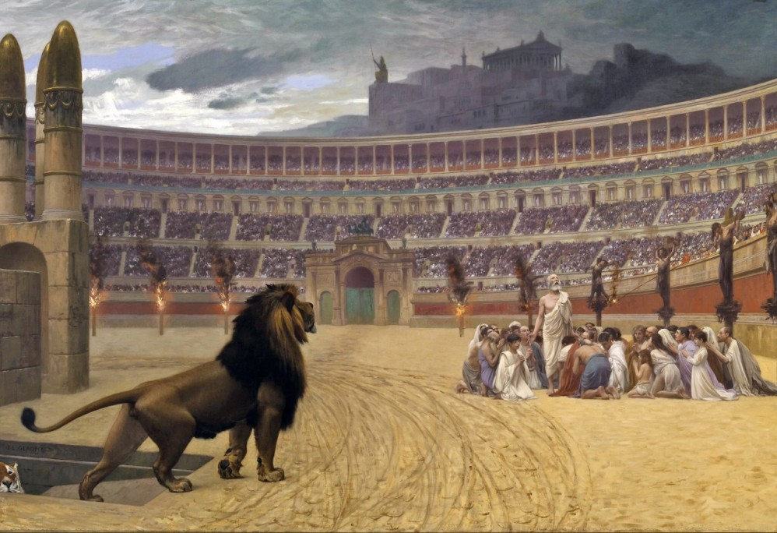

1. Introduction
A. Persecution
- Christianity had spread with unpredictable speed throughout the Mediterranean world. The first generation of eye-witnesses, apostles, disciples, family members and new converts all lived in a time of excitement and expectation.
- If any of the apocalyptic expectations voiced by Jesus in Mark 13 and Matthew 24 were upon the church, surely it was in the megalomaniacal reign of Nero in which Judea seethed with revolution and the first Christian generation bore the brunt of Roman rage.
- Peter and Paul were reputed to have died as martyrs in Rome sometime after 64 AD and the great fire in Rome.
  - According to legend, Peter was crucified upside-down
  - Paul, a Roman citizen, was beheaded, after a second trial by Nero. In the interim, he may have gone to Spain, perhaps even back to the east, but before the decade was out, he too would be dead.
  - 1 Clement indicates that Peter and Paul were the victims of ‘jealousy and envy’, and does not mention Roman aggression.
    - Perhaps this reflects the tensions that existed between Jews and Christians throughout the Empire. Nero’s concubine Poppaea, was Jewish, and Jews were eager to rid themselves of the reputation for being scape-goats.
    - Up to the destruction of the Jewish state, persecution was largely inspired by Jews against Christians, and in the book of Acts, Rome and its officials are portrayed in a positive light, indicating that the Church still hoped for some recognition of legitimacy from the government.
B. The Jewish Wars
- In 66 AD the Jews revolted against the Romans, and an intense and brutal war was carried out in Palestine, ending in the total defeat of the Jews and the destruction of their Temple.
- Christians had left the city for Pella across the Jordan in 68 AD, and from then on, they would become a marginalized minority, rejected by their Jewish compatriots as heretics, and misunderstood as legalistic judaizers by the growing Greek church.
- Between 71 AD and 135 AD, a period known as the Post-Apostolic age, the Church faced some major hurdles.
  - Its relationship with Judaism would continue to sour into disappointment and animosity…
  - Its self-understanding as an ordered community with specific beliefs would be concretized, and its greatest legacy…
  - The collection and production of the literature of the NT would be handed on to posterity as the ‘deposit of the faith’.
- Our task is to assess how the next generation appropriated the radical message of Jesus and his disciples, and what they bequeathed to their successors.

2. Jews and Judaism
A. Reconstituting Judaism
- With the temple in ruins and Palestine more firmly under Roman domination, the survivors of the Jewish faith faced a crisis. What would Judaism look like without the Temple?
  - Jews were banned form approaching Jerusalem on pain of death, and so their leaders based themselves out of Javneh’ (Jamnia) on the coast.
  - There, religious teachers Gamaliel II and Rabbi Akiba lead a reformation of Judaism based largely on the Pharisaic traditions.
    - Their reforms are distantly collected in what are know as the Targums and the Talmud.
    - By the early 90’s they had finally agreed on what the Hebrew Bible would look like and added to their 18 Benedictions, recited daily in Synagogues across the Mediterranean a curse against Christians and an avowel of broken fellowship forever.
B. The New Judaism
- The generation between the destruction of the Temple in 70 and the final defeat of Jewish apocalyptic hopes in 135 by Hadrian, saw the gradual and painful separation of Christianity from Judaism.
- No longer were there “Judaisms” within whose orbit the Church could legitimately claim a place.
- Now, only rabbinic Judaism was validated by Rome;
  - the Essenes had been massacred,
  - the Sadducees had become irrelevant without land and Temple,
  - and the Nazareans had been excommunicated with a curse. Judaism became distinctly rabbinic.
- What would Christianity look like without Temple and land, and without its firm connection to Judaism?

3. The Emergence of Gentile Christianity
A. From Jews to Christians
- In the later New Testament, we come into contact with an aggrieved relationship between the church and Judaism.
  - False teachers in the Pastoral Epistles, Judaizers in Hebrews, antichrists in 1 John, and the Synagogue of Satan in Revelations all reflect an increasing animosity between Jews and Jewish Christians and their Gentile converts.
  - In Acts the Jews are portrayed as opposing Christianity at every measure, and after Jamnia, it was clear that the two peoples were no longer one.
- Many refugees, both Jewish and Christian, fled Palestine and the War, and flooded Antioch and Alexandria, as well as Asia Minor.
  - These three regions became centers of early Christianity, and Antioch and Alexandria would become the two great rival sees, expounding their rival interpretations of theology in the 4th and 5th centuries.
  - In Rome, too, the church became firmly rooted, in spite of the persecution.
- The Church found itself faced with the ominous task of organizing the vision proclaimed by their forbearers.
  - How should Christians gather together, who should lead them, what should they do about the fading memories of the eye-witnesses? These and other questions began to answered differently, and yet, with some resemblances, throughout the cities where they were scattered.
B. Church Order
- Many of the Church’s original leaders had died, leaving a second generation of Christians to carry the church forward, many of whom had never known Jesus.
  - Peter and Paul in Rome, and James in Jerusalem.
  - Only John remained of the three pillars, and the rest had either disappeared from history or were carrying the gospel to the far ends of the earth.
  - Thomas is reputed to have gone to India via Osroehne in Parthia,
  - Mark to Alexandria, and others to Russia and south to Ethiopia.
- In the context of the next generation of Christians, two major forms of order and leadership began to emerge.
- In the east, in Jerusalem and Antioch, a monepiscopate seems to have developed.
  - James had acted as a virtual president of the Jerusalem church after Peter and John had left, and this continued to be the shape of leadership there, as late as the early second century, when Domitian questioned two of Jesus’ distant relatives, one of whom, Simeon, the son of Cleopas, had succeeded James as the second bishop, and died a martyr.
  - In Antioch, Ignatius ruled as the sole ‘bishop of Syria’ over a church struggling with turmoil from both Jewish and semi-pagan groups that had infiltrated the church.
    - On his way to die as a martyr in Rome, sometime around 108 AD, he wrote that without a bishop, elders and deacons, no group gathering together may be called a church. This seems to have been true in other places in Asia, where he wrote to bishops and elders and deacons, some of whom visited him.
    - While John was still alive in Ephesus, he is reputed to have worn the high priestly garb as he functioned as bishop in that city.
    - Phillip may have been the same kind of leader in the church at Hierapolis not far down the Lycus valley.
- However, this view of the ministry was not universal, in spite of Ignatius’ claims that bishops have been appointed throughout the world by Christ (Eph. 3.2). In many places, a council of elders seems to have predominated, especially in the west.
  - The Shepherd of Hermas seems to imply that Rome was ruled by a council of elders, one of whom may have been Clement, who wrote to the Corinthians a letter appealing them to reinstate their deposed elders.
  - Both these writings date from around the turn of the century, and indicate that in the west, at least, the monepiscopate was no universal.
  - Polycarp, the bishop of Smyrna wrote around the time of Ignatius a letter to the church in Philippi, and there again it appears that elders and not a bishop, were in charge.
    - Polycarp would live into his eighties, and would be known as the ‘teacher of all of Asia’, and yet still considered himself an elder, and not a bishop.
- There is also the evidence from a document from the period between 70-120 AD known as the Didache, or the ‘Teaching of the Twelve Disciples’ that seems to reflect the time of Paul’s letter to the Ephesians, where Teachers and Prophets were more common than bishops and deacons.
  - He says: “Therefore, appoint for yourselves bishops and deacons worthy of the Lord, men who are humble and not avaricious and true and approved, for they too carry out for you the ministry of the prophets and teachers. You must, therefore, not despise them, for they are your honoured men, along with the prophets and teachers.” (Did. 15).
- In any case, the model for the early church seems to have been that of the Synagogue out of which the Gentile ministry initially emerged.
  - It was characterized by the leadership of 12 elders and a president, who cared for the scrolls, the Synagogue and over saw its basic function.
  - As the Church spread into the Greek and Roman worlds, it invariably picked up the authority structures found in them (hierarchical in Rome, democratic in Greece).
- Clearly, the church’s structures were emerging during this generation, and a final form was never really settled upon until the council of Nicea in 325.
C. Churches Scriptures
- The Church’s literature was also emerging during this time.
  - Mark may have been written before the temple was destroyed, and the same may be true for the gospel of Luke.
  - Matthew likely wrote before 90 AD when the Jews officially broke of debate with the Christians, since his gospel has so many Judaic overtones, and seems to envision a time when the Church was still trying to win over the Jews to faith in the Messiah.
  - John is reputed to have written his gospel in Ephesus, during the reign of Domitian at the instigation of his followers, in order to cover the period between Jesus baptism and the imprisonment of John the Baptist (H.E., 3.24).
- At any rate, no ordered cannon had been established by the time that Clement of Rome wrote to the Corinthians, though he quotes from various NT books.
- There may have been something closer to a collection by Ignatius’ days, since he speaks of ‘all the letters of Paul’, and the ‘Gospels’,
- As late as the 160’s the Christian Philosopher in Rome Justin Martyr can speak only of the ‘memoirs of the Apostles’ as being read in the Church.
- Nevertheless, the generation between the two Jewish wars began to establish itself structurally and theologically, that is who is ‘in’, and what those who are ‘in’ look like when they come together.

4. Concerns
- Two main concerns seem to have dominated this age, however, and these regarded the church’s relationship with Judaism, and with Rome.
A. The Church and Judaism
- After the fall of Jerusalem, there was no great influx of repentant Jews into the fold of the Church, as might have been expected by those awaiting an apocalyptic end of history.
- The destruction of the Temple didn’t change their views and, it lead to the reformulation of Judaism into the Pharisaic mold, against which Jesus had combated so frequently.
  - The Jews wanted a complete separation, and this involved defining the legal nature of Judaism as well.
  - Christians might still pass for Jews, which was a tolerated religion, if they were Jewish, or even if they were not.
    - Perhaps this is the thrust of the writer of Hebrews, who cautioned Christians about returning to Jewish ways.
  - Worse, however, for the Church, is the impression gained from Revelation and Ignatius that Jews also opposed Christians publicly.
    - Persecution was still not an Empire-wide policy, and often, it was left to local instigation.
    - In the ‘Martyrdom of Polycarp’, written around 166 AD, the writer notes that when the crowds went to collect wood to for his pyre, ‘the Jews, as usual, freely offered their services for this purpose’ (H.E., 4.15.29).
B. The Church and Rome
- The two great persecutions in the memory of the early Church were those under Nero and Domitian.
- In both cases, Roman animosity to Jews seems to have spilled over into the Church, but in both cases as well, the Church grew stronger and more committed, as Tertullian would later observe: “the blood of the martyrs is the seed of the Church”.
- No laws against Christianity have come down to us, as is the case for the persecutions under Decius in 250 and Diocletian in 203.
  - However, it seems clear that Christianity was not a ‘religio licita’, and therefore could be prosecuted as an illegal organization by zealous accusers.
  - Peter and Paul were accompanied by a whole host of martyrs under Nero’s purge.
  - The persecution under Domitian and his followers (Trajan and Hadrian) seems to have been more eratic, claiming Ignatius in Antioch and Simeon in Jerusalem, and unnamed numbers in Bithynia-Pontus on Euxine.
  - Persecution would be a dominant feature of the early Church, but a new enemy arose after the passing of John, the last reputed eye-witness, and this was more of threat to the Church than all Rome’s hatred.
- No longer would the Church primarily fear the Roman Colesseum; it now battle intensely against the rise of heretical competitors. No threat was no longer external, it was, in some sense, the dangers from within.

