Student Name: Click here to enter text.
Kit Code (located on the lid of your lab kit): Click here to enter text.

“Pre-Lab Questions”
“View the images of cells below, paying attention to detail, and note the different characteristics of prokaryotes and eukaryotes. For each image, label the parts indicated in the table provided. Use the following list of terms to identify each cell structure (NOTE- some structures may be present in all three cells, while other structures may not be present at all):”
“Flagella” “Cilia “Nucleoid” “Nucleus”
“Centromere” “Golgi Apparatus” “Cell Wall” “Lysosome”
“Ribosome” “Chloroplast” “Nucleolus” “Endoplasmic Reticulum”
“Vacuole” “Mitochondria” “Centriole” “Plasma Membrane”
“Figure 1: Prokaryote- Bacteria Cell”
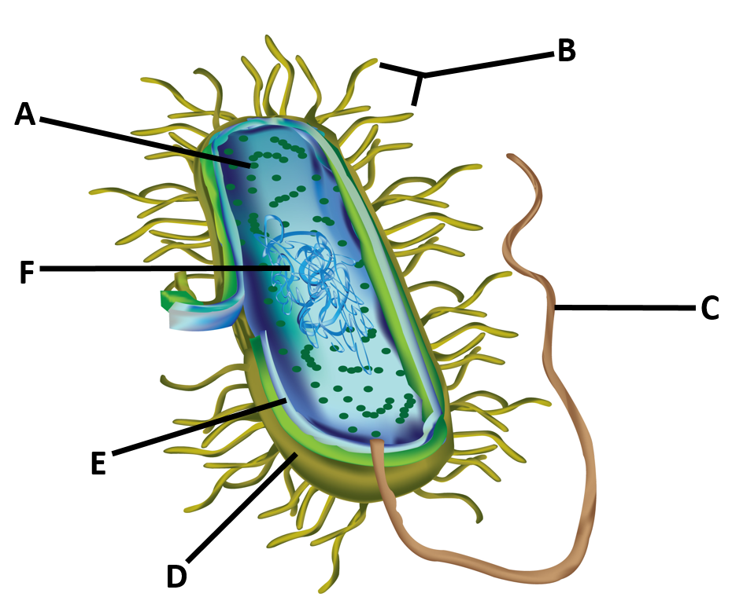
“Structure” | “Identity”
“A” | Click here to enter text.
“B” | Click here to enter text.
“C” | Click here to enter text.
“D” | Click here to enter text.
“E” | Click here to enter text.
“F” | Click here to enter text.

“Figure 2: Eukaryote- Protist Cell (Algae)”
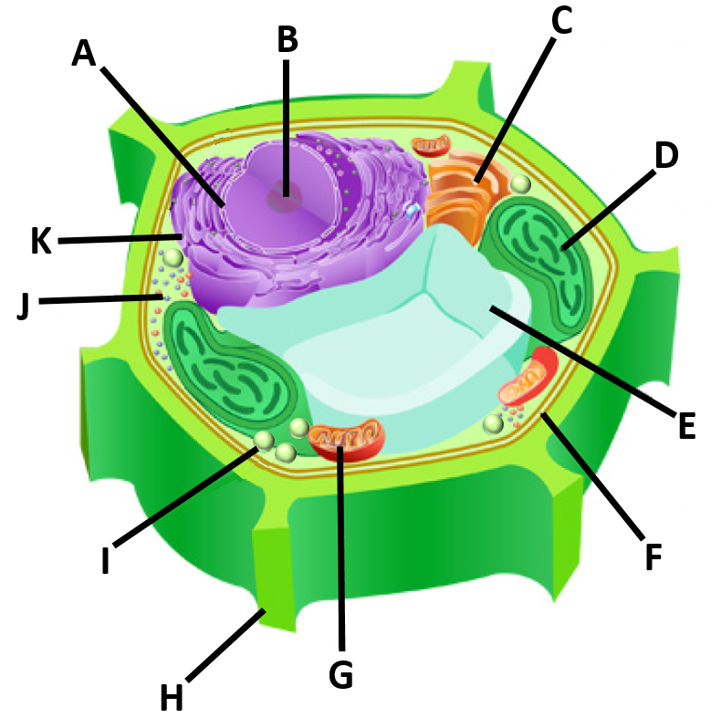
“Structure” | “Identity”
“A” | Click here to enter text.
“B” | Click here to enter text.
“C” | Click here to enter text.
“D” | Click here to enter text.
“E” | Click here to enter text.
“F” | Click here to enter text.
“G” | Click here to enter text.
“H” | Click here to enter text.
“I” | Click here to enter text.
“J” | Click here to enter text.
“K” | Click here to enter text.

“Figure 3: Eukaryote- Protist Cell (Amoeba)”
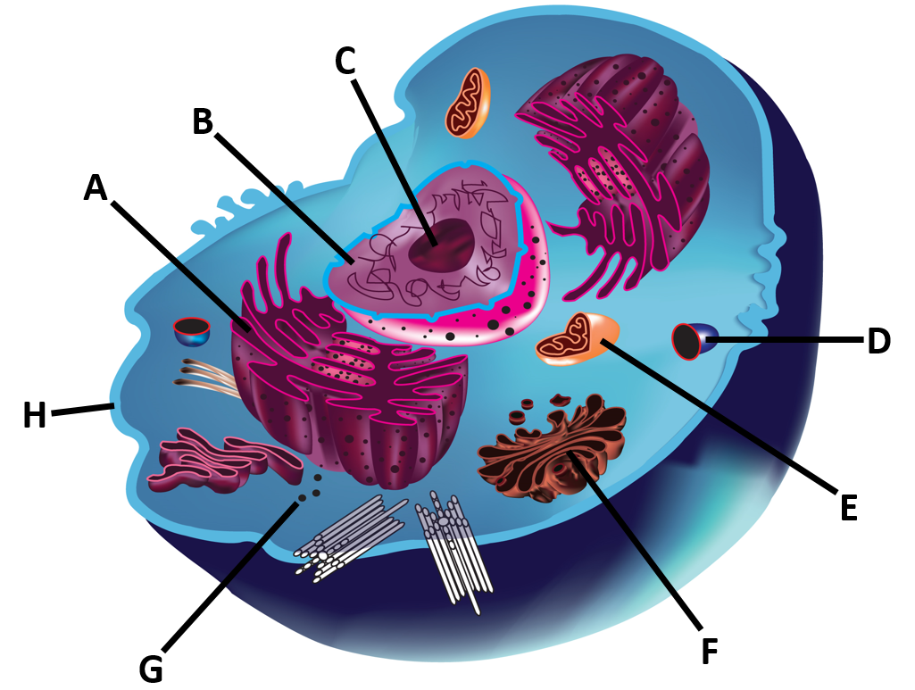
“Structure” | “Identity”
“A” | Click here to enter text.
“B” | Click here to enter text.
“C” | Click here to enter text.
“D” | Click here to enter text.
“E” | Click here to enter text.
“F” | Click here to enter text.
“G” | Click here to enter text.
“H” | Click here to enter text.

“Experiment 1: Create A Cell”
“1. In the table below, list the items you used to represent the various organelles in your BACTERIAL cell. Provide a brief rationale explaining why you selected each item.”
“Item” | “Organelle” | “Rationale”
Click here to enter text. | Click here to enter text. | Click here to enter text.
Click here to enter text. | Click here to enter text. | Click here to enter text.
Click here to enter text. | Click here to enter text. | Click here to enter text.
Click here to enter text. | Click here to enter text. | Click here to enter text.
Click here to enter text. | Click here to enter text. | Click here to enter text.
Click here to enter text. | Click here to enter text. | Click here to enter text.
Click here to enter text. | Click here to enter text. | Click here to enter text.
Click here to enter text. | Click here to enter text. | Click here to enter text.
Click here to enter text. | Click here to enter text. | Click here to enter text.
Click here to enter text. | Click here to enter text. | Click here to enter text.

“2. In the table below, list the items you used to represent the various organelles in your FUNGAL cell. Provide a brief rationale explaining why you selected each item.”
“Item” | “Organelle” | “Rationale”
Click here to enter text. | Click here to enter text. | Click here to enter text.
Click here to enter text. | Click here to enter text. | Click here to enter text.
Click here to enter text. | Click here to enter text. | Click here to enter text.
Click here to enter text. | Click here to enter text. | Click here to enter text.
Click here to enter text. | Click here to enter text. | Click here to enter text.
Click here to enter text. | Click here to enter text. | Click here to enter text.
Click here to enter text. | Click here to enter text. | Click here to enter text.
Click here to enter text. | Click here to enter text. | Click here to enter text.
Click here to enter text. | Click here to enter text. | Click here to enter text.
Click here to enter text. | Click here to enter text. | Click here to enter text.

“3. What structures, if any, are missing from your bacterial and fungal cells?”
Click here to enter text.
“4. Out of all of the items used to create your bacterial and fungal cells, which component(s) could also be used to create a virus? Why?”
Click here to enter text.

“Insert photo of your bacterial and fungal cells with your name clearly visible in the background:”


