
EDU 3338 Lesson Plan Template

Candidate Name:  Celine Hawkins | Cooperating Teacher Name:  Ms.Walters | Placement Site:  Brunson Elementary
Grade Level:  5th Grade | Subject:  Reading Comprehension | Length of Lesson:  45 minutes
Lesson Title:  Types of text Structure |  | Date of Lesson:  12/5/19

Learning Central Focus
Central Focus  What is the central focus for the content in the learning segment? | I will reintroduce the concept of various text structures with the four students. I will explain and be explicit about what they are and why there are organizational patterns, such as sequence, cause and effect, and compare and contrast.
Content Standard  What standard(s) are most relevant to the learning goals? | RL.5.2 RL.3 RL.5.5  Theses standards help guide me to teach comparing and contrasting ideas help readers build understanding.
Student Learning Goal(s)/ Objective(s)  Skills/procedures  What are the specific learning goal(s) for student in this lesson?  Concepts and reasoning/problem solving/thinking/strategies  What are the specific learning goal(s) for students in this lesson? | After this lesson, students will be able to:  define 'text structure'  explain different types of text structures  demonstrate understanding of analyzing text structuresTo help students learn more about the information that they read and how to organize information in different ways.  The students should be able to understand and identify the structures of informational text (Description, Sequence, Problem and Solution, Cause and Effect, and Compare and Contrast.)
Prior Academic Knowledge and Conceptions  What knowledge, skills, and concepts must students already know to be successful with this lesson?  What prior knowledge and/or gaps in knowledge do these students have that are necessary to support the learning of the skills and concepts for this lesson? | - Students should be familiar with the differences between fiction and non-fiction text.  - Students should be familiar with the meaning of the term text structure.
Theoretical Principles and/or Research–Based Best Practices  Why are the learning tasks for this lesson appropriate for your students? | The learning task for text structure lesson is appropriate for students because by teaching students how to thnik about what they read is a great way to increase comprehension.  The learning task for this lesson is appropriate for the students because Piaget helped to proposed that children progress through a sequence of four stages, and use their cognitive abilities.
Materials  What materials does the teacher need for this lesson?  What materials do the students need for this lesson? | - 4 Copies of the text lesson How to Identify & Analyze Text Structure, one for each student  - A wide variety of text samples with the structures listed in this lesson  - 4 charts  - 4 pieces of blank paper  - 10 index cards (5 per group)  - 4 sticky tabs for each student for notes  - 4 markers, 1 marker each child  - 4 copies of text structure vocabulary for each student

Assessments, Instructional Strategies, and Learning Tasks
Description of what the teacher (you) will be doing and/or what the students will be doing.
Launch  ____10-15______ Minutes  How will you start the lesson to engage and motivate students in learning? | - Good morning students, how is everyone doing today? (get each students response of how they are feeling)I will respond and let them know how I am doing.  - Today our topic is text structures. Text structures deals with Descriptions of readings, Sequence, Problem and Solution, Cause and Effect, and Compare and Contrast. Does anyone know what these are and what they are used for?(get a response from students)  - I will then give them a definition of each category of text structures. (Description, Sequence, Problem and Solution, Cause and Effect, and Compare and Contrast)  - Students will start off working individually and then in groups they are already grouped in by tables.
Pre-Assessment  How will you find out what students already know about the lesson objective?  What tangible pre-assessments will you administer?  How will you evaluate student performance on the pre-assessment? | - I will begin by asking guiding questions for this lesson such as, What is text structure?, What are the characteristics of each structure?, How can this information help us to understand what we are reading?  - I will ask students to work with a partner to create a definition of an assigned text structure. Partners can share their definitions with the group, and will show an example of their topics and definitions list.  - I will be able to monitor student understanding and identification of text structures.  - We are going to play a game using what you already know about text structures and what you will be learning about each category relating to text structure.  - I will divide each of you into two groups of two at the table.  - I will write on the board and mix the topics.  - Each group will have five cards. I will explain to the students that the cards have the definitions that go to each topic i have written on the board.  - You will each have a minute to figure out which topic goes with each definition. Each group will get a chance to come to the board and place the index card next to correct topic.  - In the game students are given a brief overview of the different structures and shown/given a list of topics of text structure and the definitions. Students will start off working individually and then in groups they are already grouped in by tables.
Instruction  _______15___ Minutes  What will you do to engage students in developing understanding of the lesson objective(s)?  How will you link the new content (skills and concepts) to students’ prior academic learning and their personal/cultural and community assets?  What will you say and do? What questions will you ask?  How will you engage students to help them understand the concepts?  What will students do?  How will you determine if students are meeting the intended learning objectives? | I will ask questions and say :  - what might you read that breaks down information?  - In what subject do you usually think about what causes things to happen?  - Where might you read descriptions of how things are alike and different ?  - What clues alerted you in the text ?  - Does this text tell about things in order, events that resulted in other events, or what is similar and different between things?  - Does anyone know what these are and what they are used for?(get a response from students)  - I will then give them a definition of each category of text structures. (Description, Sequence, Problem and Solution, Cause and Effect, and Compare and Contrast)  - Students will start off working individually and then in groups they are already grouped in by tables.  - I will begin by asking guiding questions for this lesson such as, What is text structure?, What are the characteristics of each structure?, How can this information help us to understand what we are reading?  - I will ask students to work with a partner to create a definition of an assigned text structure. Partners can share their definitions with the group, and will show an example of their topics and definitions list.  - I will be able to monitor student understanding and identification of text structures.  - We are going to play a game using what you already know about text structures and what you will be learning about each category relating to text structure.  - I will divide each of you into two groups of two at the table.  - I will write on the board and mix the topics.  - Each group will have five cards. I will explain to the students that the cards have the definitions that go to each topic i have written on the board.  - You will each have a minute to figure out which topic goes with each definition. Each group will get a chance to come to the board and place the index card next to correct topic.  - In the game students are given a brief overview of the different structures and shown/given a list of topics of text structure and the definitions. Students will start off working individually and then in groups they are already grouped in by tables.  - I will provide each group with a copy of definitions and topics of text structure.  - I will review the kinds of text structures using the chart/list of definitions. I will then give each student a piece of paper and a marker and allow them time to browse through any books of their choice, and record the kind of text structures we have learned and gone over today.  - Students must justify their decision for the kind of text structure by giving examples from the book they have chosen. Once the students have made their decisions have them share their ideas with the group.  - I will monitor groups, listening for understanding of the different text structures.  The content will be linked to students' prior academic knowledge of learning and their personal/ cultural and community by giving students a opportunity to take a topic and match it with the correct definitions during the game and by writing a paragraph on the topic using each of the particular text structures.  - After they are done we will talk and use the text structure compare and contrast to compare and contrast things in the classroom and see what causes things to happen and effect of them.  - I will help students understand and how to use different text structures in the same selection, and how to recognize these shifts. by telling them the definitions of (Description, Sequence, Problem and Solution, Cause and Effect, and Compare and Contrast)
Structured Practice and  Application  ______10____ Minutes  How will you give students the opportunity to practice so you can provide feedback?  How will students apply what they have learned?  How will you structure opportunities for students to work with partners or in groups? What criteria will you use when forming groups? | - Hey you guys so this is just a little cool down activity.  - We will write a short paragraph on what you learned today. Students will take a topic and write a short paragraph about one of the topics of text structure and how they are used.  Students will be given the opportunity to practice by taking a topic and writing a paragraph on the topic using each of the particular text structures. I will provide feedback on correct text structures.  Student's will apply what they have learned by talking to group members and discussing what they have written and the different text structures.  The students with the text they have chosen with varied text structures, will be put in small groups and be administered a text structure chart in each group.(one per group) then have students work together to identify and analyze their text structures. Teacher will also provide prompts to guide their thinking, and have them take notes.
Formative Assessment  What formative assessment techniques will you utilize to determine if students are meeting the intended learning objectives? | - During the guided practiceII will ask questions while the students are working such as : How did those two compare? How are they different? Are those scene in the story written in sequence? What do you think will happen if..? What will be the effect?  - I will then monitor the students and their discussions to see if students understand and can identify the different text structures.  At the beginning of the teaching phase the teacher could ask students to work with a partner to create a definition of an assigned text structure.
Differentiation/ Planned Support  How will you provide students access to learning based on individual and group needs?  How will you support students with gaps in the prior knowledge that is necessary to be successful in this lesson? | Whole Class:  As a whole the teacher will work with the class going over terms and text structures. Then help students identify and find particular text structures with short stories and books provided in classroom. As a class the teacher will discuss the charts and how to fill out each column.  Groups of students with similar needs:  Students who are english language learners will be grouped with at-least one person at there table who can help translate. Students are working in their groups, the teacher can monitor the discussions in the groups to see if students understand and can identify the different text structures.  At the beginning of the teaching phase the teacher could ask students to work with a partner to create a definition of an assigned text structure.  Individual students:  Teacher can help and monitor individual students while students are working on a topic they have chosen or the teacher has provided. Students will take a topic and write a sentence or two on the topic using each of the particular text structures.  Students with IEP’s or 504 plans:
Enrichment/Remediation  What might not go as planned and how can you be ready to make adjustment?  What activities have you planned for students who quickly grasp the concept and need to be challenged?  What activities have you planned for students who are still struggling to understand the concept and need extra support? | Teacher will reintroduce text structures and definition cards. Students will take a topic and write a sentence or two on the topic using each of the particular text structures.  What might not go as planned is students might have difficulty recognizing text structures in reading.  For students who quickly grasp the concept and need to be challenged will be given a check for understanding chart that is also a compare and contrast organizer. On the organizer students will compare and contarst two different text and use the different structures.  For students who are struggling, students who have grasp the lesson can help others with understanding. The teacher can introduce the various text structures to the students again. Students can use flash cards and definitions to help remember text structure.
Closure  __15________ Minutes  How will you end the lesson? | - Did you all enjoy the game? I surely did enjoy you all this morning.  - Students will be able to apply their knowledge of text structures to any nonfiction text that they read. The teacher should emphasize that the purpose of understanding text structure is to help students to comprehend what they are reading.  The teacher will offer practice tips such as:  - Examine topic sentences and key words that clue the reader in to a certain text structure.  - Model using graphic organizers to collect information.  - Provide graphic organizers for students to use for each text structure to collect information.  - Model the writing of a paragraph that uses a specific text structure.  - Students can complete a text structure match-up- Match the text structure with its definition to show understanding of each of the five text structures.
Summative Assessment  How will you find out what students have learned about the lesson objectives?  What tangible pre-assessments will you administer?  How will you evaluate student performance on the post-assessment? | - Good morning students, how is everyone doing today? (get each students response of how they are feeling)I will respond and let them know how I am doing.  - Today our topic is text structures. Text structures deals with Descriptions of readings, Sequence, Problem and Solution, Cause and Effect, and Compare and Contrast. Does anyone know what these are and what they are used for?(get a response from students)  - I will then give them a definition of each category of text structures. (Description, Sequence, Problem and Solution, Cause and Effect, and Compare and Contrast)  - Students will start off working individually and then in groups they are already grouped in by tables.  - I will ask questions and say :  - what might you read that breaks down information?  - In what subject do you usually think about what causes things to happen?  - Where might you read descriptions of how things are alike and different ?  - What clues alerted you in the text ?  - Does this text tell about things in order, events that resulted in other events, or what is similar and different between things?  - Does anyone know what these are and what they are used for?(get a response from students)  - I will then give them a definition of each category of text structures. (Description, Sequence, Problem and Solution, Cause and Effect, and Compare and Contrast)  - Students will start off working individually and then in groups they are already grouped in by tables.  - I will begin by asking guiding questions for this lesson such as, What is text structure?, What are the characteristics of each structure?, How can this information help us to understand what we are reading?  - I will ask students to work with a partner to create a definition of an assigned text structure. Partners can share their definitions with the group, and will show an example of their topics and definitions list.  - I will be able to monitor student understanding and identification of text structures.  - We are going to play a game using what you already know about text structures and what you will be learning about each category relating to text structure.  - I will divide each of you into two groups of two at the table.  - I will write on the board and mix the topics.  - Each group will have five cards. I will explain to the students that the cards have the definitions that go to each topic i have written on the board.  - You will each have a minute to figure out which topic goes with each definition. Each group will get a chance to come to the board and place the index card next to correct topic.  - In the game students are given a brief overview of the different structures and shown/given a list of topics of text structure and the definitions. Students will start off working individually and then in groups they are already grouped in by tables.  - I will provide each group with a copy of definitions and topics of text structure.  - I will review the kinds of text structures using the chart/list of definitions. I will then give each student a piece of paper and a marker and allow them time to browse through any books of their choice, and record the kind of text structures we have learned and gone over today.  - Students must justify their decision for the kind of text structure by giving examples from the book they have chosen. Once the students have made their decisions have them share their ideas with the group.  - I will monitor groups, listening for understanding of the different text structures.  - The content will be linked to students' prior academic knowledge of learning and their personal/ cultural and community by giving students a opportunity to take a topic and match it with the correct definitions during the game and by writing a paragraph on the topic using each of the particular text structures.  - After they are done we will talk and use the text structure compare and contrast to compare and contrast things in the classroom and see what causes things to happen and effect of them.  - I will help students understand and how to use different text structures in the same selection, and how to recognize these shifts. by telling them the definitions of (Description, Sequence, Problem and Solution, Cause and Effect, and Compare and Contrast)  - This would be a graded paragraph. Students will take a topic and paragraph on the topic using each of the particular text structures. The teacher circulates to each group, checking to see that the group members are correctly identifying characteristics of each type of text structure and writing down their observations and information from readings.  - After students are done I will grade and check for correct text structures.

Resources:
Attach all supplementary materials to be used with this lesson plan (PowerPoint presentations, handouts, worksheets, assessments, as well as the associated evaluation criteria/rubric/answer key for each assessment).
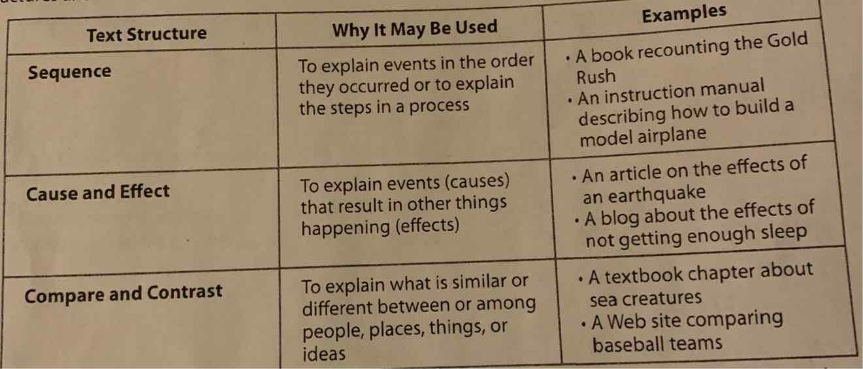
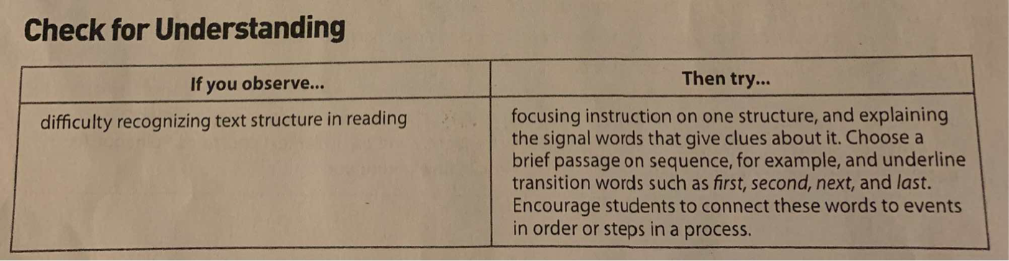

Definitions and topics of text structures:
- Description -Descriptive Text is a text which says what a person or a thing is like. Its purpose is to describe and reveal a particular person, place, or thing.
- Sequence- Authors sometimes use sequence to structure their writing. Sequence is the order in which things happen.
- Problem and Solution -is a pattern of organization where information in a passage is expressed as a dilemma or concerning issue (a problem) and something that was, can be, or should be done.
- Cause and Effect-is a common way to organize information in a text. Paragraphs structured as cause and effect explain reasons why something happened or the effects of something.
- Compare and Contrast-is a text structure or pattern of organization where the similarities and differences of two or more things are explored.

