Well Testing
Objective:
In this well testing project, that are define the well testing, and the types. Also, describe the diffusivity equation and defines the steady state flow equation, unsteady state flow equation, and pseudo steady state flow equations. Also, understanding the analysis methods of well testing. Moreover, we conduct these analyses to two well tests which were drawdown and build up tests.
The oil well testing is conducted to assembly the next purposes:
- To find reservoir limits for reservoir characterization.
- To define if all the drilled length from oil well is a producing area.
- To assess well condition and reservoir description.
- To evaluate skin factor or else drilling and completion linked damage to an oil well. Founded upon the magnitude of the damage so a choice about well stimulation that can be completed.
Well test definition:
Well test is a method of getting information through discovering the pressure data by distinctive apparatuses and techniques. It is the means to know well and reservoir performance. So that, they are conducted at all phases in the oil and gas area since exploration over development, injection and production (Silin, 2003).
To accomplish a well test effectively that should determine the time, the pressure, the rate, and also control the rate. So, whether it is designed correctly that mean can be applied to determine the parameters such as skin factor, drainage shape, drainage area, distance to faults, fractured well parameters, and flow conductance (Silin, 2003)

Types of the well testing:
The key types of well tests are drill stem test (DST), drawdown test, buildup test, and interference test. Moreover, injection tests and falloff tests (Silin, 2003).
Types:
1.Drill stem test
The testing tool assembly attached to the lower part of the string of the drill pipe (or drill stem) is lowered and placed opposite to the reservoir rock, isolated by an expandable packer, relieved of the mud column pressure, and allowed to produce through the drill stem. The hydrostatic pressure of the mud column inside the hole is always greater than the formation pressure of the production zone to be tested. The basic drill stem test tool assembly consists of packers, valves and pressure gauge. (Edwards AG & Winn RH, 1974).
To elaborate on how the DST tool works, we can explain by using a pressure vs. time graph as shown, with two flow periods and two shut in periods.
- From point A to B: the tool is lowered into the wellbore and hydrostatic mud pressure is increasing.
- Point B: the tool reaches the bottom.
- Point C: an increase in pressure due to setting of packers.
- Point D: the pressure decreases as the tool is open for inflow from formation.
- Point D to E: as fluid accumulates at the drill stem above the pressure gauge pressure rises, this is the initial flow period.
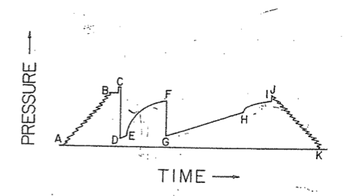
Figure 1: Drill stem test pressure chart (Lee W. J., 1982).

- Point E: the well is shut in for initial buildup period.
- Point G to H: the well is reopened for a second flow period, and pressure rises once more.
- Point H to I: final shut-in period.
- Point J to k: the packers are released; the tool is pulled from the wellbore. (Lee W. J.,1982).

- Drawdown test:
Drawdown tests are achieved by the engineers will open the well after a fixed shut-in time to monitor BHP lessening. It is a test that the rate is kept almost constant whereas the well pressure is gauged. Then closed the well until the pressure arrives static level and at that moment the flowing the well by a constant rate (q) and then gauging the ( $P_{wf})$. The pros of this test are fit in new boreholes and no necessity to be unable to find production, and also the size of reservoir be able to be specified. In contrast, it is hard to keep constant production rate and long closed consequently the Pi is accomplished is needed. Another definition for a pressure drawdown test is basically a sequence of bottom-hole pressure (BHP) gauge that complete throughout a time of flow on constant production rate. Typically, the well is shut in previous to the flow test for a duration of time adequate to permit the pressure to steady during the formation to arrive static pressure (Chaudhry, 2004).
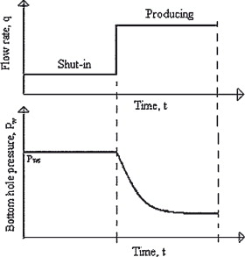
Figure 4 Drawdown test (Kutasov, 2005).
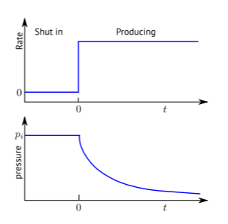
Figure 5 the ideal drawdown test (Berg, 2017).

The purposes of a drawdown test are to get a medium permeability (𝑘) of the drainage zone, to evaluate the skin (𝑆), to find pore volume from the reservoir, and also to discover reservoir heterogeneousness (Berg, 2017).
In this drawdown test that will display and will be utilized to conclude from reservoir and well characteristic for instance permeability (K) and skin factor (S) (Berg, 2017).

- Buildup test:
Buildup tests are achieved through closing in the well after a few times of flow to gauge rise in bottomhole pressure (BHP). The pressure is registered by a function of time. The pros are the control of rate is accurate and P* be able to be defined. In contrast, by closed the lack of production will occur.
Fundamentally, the test is led through producing a well on constant rate for several time, closing in the well typically at the surface that permitting the pressure to build up in the wellbore, and registration the down hole pressure in the wellbore by way of a function of period. So that, ss of these data it is probable to evaluate the formation permeability and present drainage zone pressure, and to describe stimulation or damage and reservoir heterogeneousness or else borders frequently (Chaudhry, 2004).

Figure 1 Ideal drawdown–buildup sequence (Berg, 2017).

Horner analysis:

To conclude the well pressure used for a well test that together the buildup time 𝛥𝑡 and production time 𝑡𝑝 is short adequate to use the transient infinitely acting resolution. The term used for well pressure through buildup that comprise two, the first one used for a well by constant rate 𝑄 beginning at time 𝑡 = 0, and the second one used for a well by constant rate −𝑄 beginning at time 𝑡 = 𝑡𝑝 (Berg, 2017).

The wellbore storage and skin effects then begin of closed-in, then use the equations:
Where: 𝑚 = $-\frac{p_{c}}{2}$.
$$p_{w}\left(t\right)=p_{i}-\frac{p_{c}}{2} (\ln\left(4η \frac{t}{{r_{w}}^{2}} \right)-γ+2S$$
So, the m equals the slope in this equation from the drawdown test.

$$p_{w}\left(t\right)=-\frac{Qμ}{4πkh}\ln\left(t\right)+[ p_{i }-\frac{Qμ}{4πkh} (\ln\left(\frac{4η }{{r_{w}}^{2}} \right)-γ+2S)]$$

But even though the pressure that was a function of ln (𝑡) in the drawdown test, then detect that pressure is a function of ln [(𝑡𝑝 + 𝛥𝑡)/𝛥𝑡] in the buildup test. As the plot of $p_{w}$ as opposed to is ln [(𝑡𝑝 + 𝛥𝑡)/𝛥𝑡] is that define the Horner plot. So that the permeability and skin is calculated from the straight line fit. So that, the rising time goes as of right to left on the x-axis (Berg, 2017).

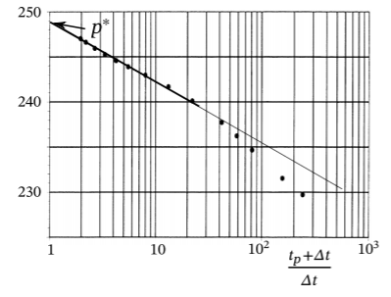
Figure 2 Horner plot that pressure is plotted as a function of ln [(𝑡𝑝 + 𝛥𝑡)/𝛥𝑡] (Berg, 2017).

The permeability equation:
$k =-\frac{Qμ}{4πkh} \frac{1}{m}$
The skin equation:
$$S=-\frac{1}{2m} \left(p^{*}-p_{w}\left( t_{p}\right)\right)-\frac{1}{2}\ln\left( \frac{4ηt_{p}}{{r_{w}}^{2}}\right)+\frac{γ}{2}$$

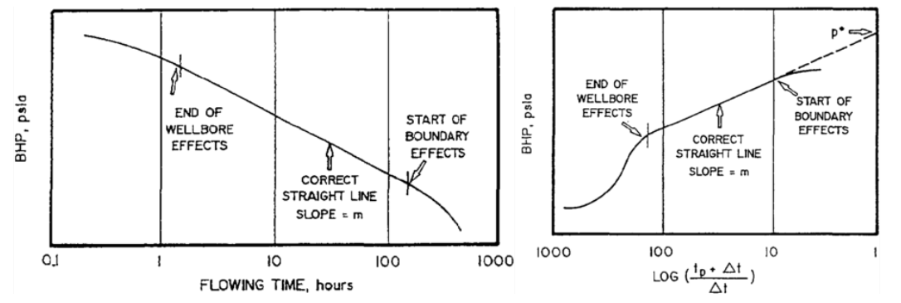
Figure 3 Typical flow test data graph and Figure 2 Typical buildup test graph (Horner plot) (Pecher, 1995).

Well pressure:
The bottom hole well pressure is the main measurement in a well test. The late times that can obtain well pressure through introducing the well radius in the equation as shown below (Berg, 2017).
$$p \left(r,t\right)=p_{i}- \frac{p_{c } }{2} \left(\ln\left(4η\frac{t}{r^{2} }\right)-γ\right)$$

Furthermore, the impact of skin also should be considered. Then a steady state pressure profile improves in the near well zone, so the skin impact quantities to more constant pressure decline 𝛥𝑝𝑠 but for so short times (Berg, 2017).
$$Δps=p_{c}S$$
That gives:
$$p_{w}\left(t\right)=p_{i}-\frac{p_{c}}{2} (\ln\left(4η \frac{t}{{r_{w}}^{2}} \right)-γ+2S$$
Permeability and skin:
In this well test data that will demonstrate the reservoir permeability and the skin factor that obtain from the well through evaluating these well test data. An ideal drawdown test that was conclude in the pressure response above equation:
$$p_{w}\left(t\right)=p_{i}-\frac{p_{c}}{2} (\ln\left(4η \frac{t}{{r_{w}}^{2}} \right)-γ+2S$$

By rewriting of the characteristic pressure:
$$p_{c}=\frac{Qμ}{2πkh}$$

Then obtain:
$$p_{w}\left(t\right)=-\frac{Qμ}{4πkh}\ln\left(t\right)+[ p_{i }-\frac{Qμ}{4πkh} (\ln\left(\frac{4η }{{r_{w}}^{2}} \right)-γ+2S)]$$
Where:
$$m=-\frac{Qμ}{4πkh}$$

The well pressure by way of a function of ln(t) (semilog plot) that apply a straight line by slope 𝑚 (Berg, 2017).
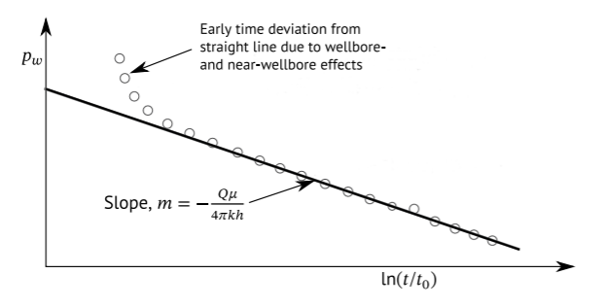
Figure 6 Semilog plot of a drawdown test (Berg, 2017).

The early portion of the data that will turn of the straight line because of wellbore and near wellbore effects, and the late time portion of the data that will turn because of the effect of boundaries or big scale heterogeneity, then permeability and skin can be projected by $$p_{w}\left(t\right)=p_{i}-\frac{p_{c}}{2} (\ln\left(4η \frac{t}{{r_{w}}^{2}} \right)-γ+2S$$
founded on the portion of the data which drop on a straight line. Permeability can be valued founded on the slope, from the line, 𝑚 as demonstrated in figure 5.
$$k= -\frac{Qμ}{4πkh} \frac{1}{m}$$

The skin may be measured as of the fitted straight line intercept or else value on the straight line by any additional point in time $t_{s}$ when the permeability is identified (Berg, 2017).

$$s= \frac{1}{2 } (\frac{p\left(t_{s}\right)-p_{i}}{m}-\ln\left(\frac{4ηt_{s} }{{r_{w}}^{2}} \right)+γ$$

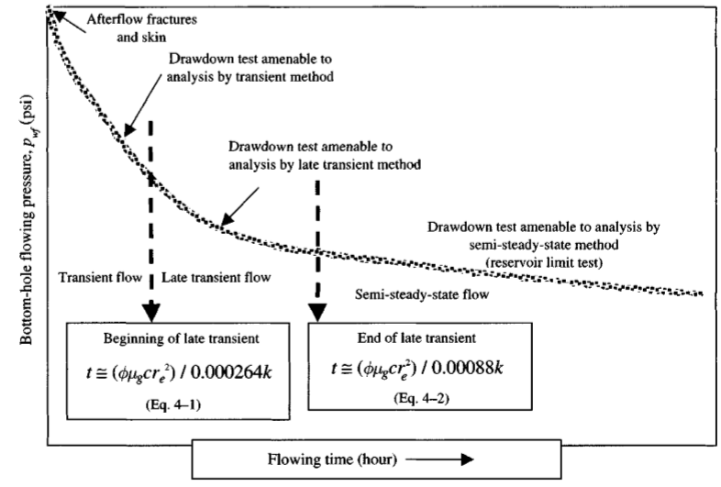
Figure 7 Schematic pressure-time times past for a constant-rate drawdown test (Chaudhry, 2004).
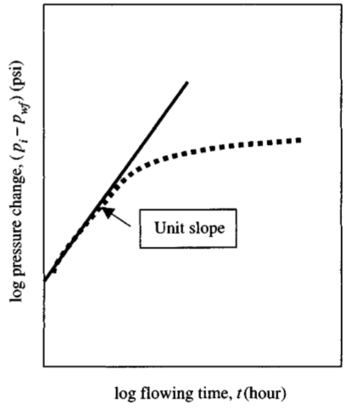
Figure 8 Semi log pressure drawdown data scheme (Chaudhry, 2004).

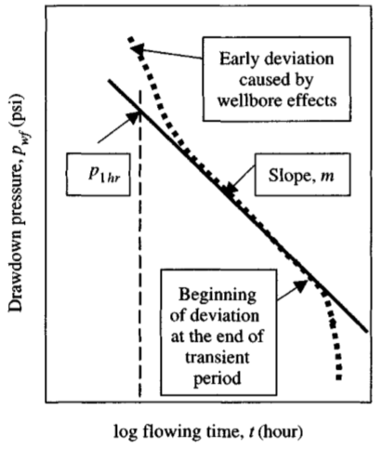
Figure 9 log-log pressure drawdown data scheme (Chaudhry, 2004).
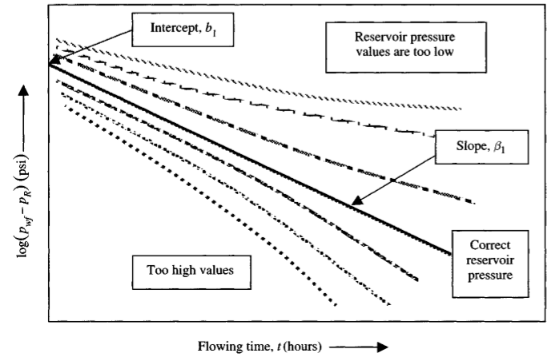
Figure 10 Schematic late-transient drawdown analysis scheme (Chaudhry, 2004).

- Injection tests and falloff tests:
The fluid is injected inside the formation, then the BHP is rises as an outcome that is observed. Then the well is closed, and the reducing BHP is recorded as an outcome.
- Interference test:
This test records the pressure variations in next wells once the test well pressure is altered. In this test give engineers the size of the reservoir and the flow that can be enhanced approximations of directional permeability (Kitson, 2010).
Diffusivity Equation:
The diffusivity equation associates the pressure of fluid in a penetrate media to space and time. It is a first-order partial differential equation in time and second order in space.
There are three laws that are combined to develop the diffusivity equation for barely compressible liquids in Cartesian coordinates. These three laws or principles include:
- Conservation or protection of mass principle (the continuity equation).
- The equation of motion (Darcy's law) (Shingo Tomiyama, 2020).
- The equation of state (PVT relations).
The significance of the diffusivity equation prevents the fact that the solution the equation permits the engineers to order to indicate the distribution of pressure in the reservoir related to time space and location by evaluating the pressure at any point in the reservoir and at any point in time. The time zero is supposed to be the start production time. It has several applications in order to optimize reservoir performance. The application of these solutions includes the following:
- Their use in well test analysis.
- The developed production data analysis.
- The analysis of water influx into the reservoir.
- The estimation of reservoir performance.
To solve the diffusivity equation, we need to determine the initial and the boundary circumstances as the first derivative of pressure related to time are included in diffusivity derivation. It requires one primary or initial condition to solve. The basic theory here is that pressure is equal to the initial pressure qt where the time is zero in all the reservoir (Toshifumi Igarashi, Carlito Baltazar Tabelin, 2020).
Furthermore, the equation of diffusivity requires the belief in two boundaries conditions for the application of the equation of diffusivity equation in pressure transient and the late transient estimation. The premise of the inner boundary is that the well is generating at either a constant rate or at constant pressure. Conditions included in other boundaries are an infinite reservoir, a closed reservoir, also known as the no-glow outer boundary, and constant pressure (Pawit Tangviroon, 2020).
The main goal of well testing is to give information about the reservoir properties, permeability, skin, as well as the radial importance of Its reservoir (Lindsay V Reynolds, 2018).
It can be inaugurated by observing or testing the well through installing a gauge downhole the well changing the flow rate. The whee in the bottom hole flowing pressure versus time can be read by this gauge. They provide the data, and the analysis of bottom hole flowing presence versus time is based on this data (David M Merritt, 2018).
- The aims of the analysis are the following:
- To evaluate the reservoir in real-time
- To determine the properties of the reservoir.
- To determine how much it can produce from the reservoir.
- Establishing the deliverability equation
- Establishing the Inflow Performance Relationship (IPR).
But It is better and appropriate to discuss the basic concept before studying the analysis and various methods of interpretation to well testing.
Diffusivity equation derivation:
Diffusivity equation is a differential equation. It can be known as a non-linear differential equation. It characterizes the change of pressure according to the time, location, and radius in the reservoir. The basic concept of the diffusivity equation is that a percentage of the reservoir is accepted by the law of conservation of mass, Darcy's law, and the equation of state that we can modelized the reservoir. To know the main premises and the idea behind the theory of the final form first, we need to well understand the derivative of the diffusivity equation (Jesus Carrera, 1986).

To know the main premises and the idea behind the theory of the final form first, we need to well understand the derivative of the diffusivity equation (Jesus Carrera, 1986).

Driving the diffusivity equation starts with the continuity equation for single phase flow and conservation of mass in volume element (Berg, 2017).:

M in – M out = change in mass

$-∇ ⋅ (ρq) =\frac{∂}{∂t}$(𝜙𝜌) (1)
Where : $ρ is fluid density$, q is volume flow rate flux , 𝜙 is the porosity ,$∇ is del opertator which is equal to \left(\frac{∂}{∂x} ,\frac{∂}{∂y},\frac{∂}{∂z}\right)$.

The q can be found by the gradient in pore pressure by Drays law as:

𝑞 = − 𝑘 𝜇 ∇p (2)
By inserting eq. 1 in 2. with assuming that the permeability (K) is constant and the pressure independent viscosity (𝜇). Therefore, we get:

$\frac{k}{μ}$∇ ⋅ (𝜌∇𝑝) = $\frac{∂}{∂t}$ (𝜙𝜌) (3$)$

For both sides of eq.3 could expand their derivatives which result in:

$\frac{k}{μ} \left(∇ρ ⋅ ∇p + ρ∇2p\right)= ρ \frac{∂}{∂t} ϕ + ϕ\frac{∂}{∂t}ρ$ (4)

By looking at the left side of eq.4, the compressibility c can be calculated from the relative volume change due pressure change as :

$c = -\frac{1}{V}\frac{∂V}{∂p}$ (5)

the liquid compressibility can be used to convert derivatives of density into derivatives of pressure. Then the liquid compressibility can be as (6), were the liquid the density $ρ =\frac{m}{Vl}$:

$c_{l} = -\frac{1}{Vl} \frac{∂Vl}{∂p} = -\frac{ρ}{m} \frac{\frac{∂m}{ρ}}{∂ρ}\frac{∂ρ}{∂p} = -ρ -\frac{1}{ρ2}\frac{∂ρ}{∂p} =\frac{1}{ρ} \frac{∂ρ}{∂p}$ $(6)$

Therefore, the left side of eq.4 is going to be:

$$∇ρ ⋅ ∇p =\frac{∂ρ}{∂p}∇p ⋅ ∇p = ρcl{ \left|∇p\right|}^{2} ∝ cl , (7)$$

In the low compressibility limit this term is proportional to the compressibility and can by ignored , thus the left side of eq.4 will be:

$ρ \frac{k}{μ} { ∇}^{2}p$ (8)
By Applying the chain rule for the right side of eq.4 where it can be expressed as the time derivative of the pressure as shown:

$ρ\frac{∂}{∂t}ϕ + ϕ\frac{∂}{∂t}ρ = ρ \frac{∂ϕ}{∂p} \frac{∂}{∂tp} + ϕ\frac{∂ρ}{∂p} \frac{∂}{∂t}p = ρϕ \left(\frac{1}{ϕ}\frac{∂ϕ}{∂p}+\frac{1}{ρ}\frac{∂ρ}{∂p}\right)\frac{∂}{∂t}p (9$)

Where the formation compressibility, $c_{ϕ}$, can be measured as:

$c_{ϕ}=\frac{1}{ϕ}\frac{∂ϕ}{∂p}$ (10)

and the total compressibility is:

$c_{t}$ = $c_{l}$ + $c_{ϕ}$ (11)

Thus, eq.9 can be simplified as:

$$ρ\frac{∂}{∂t}ϕ + ϕ \frac{∂}{∂t}ρ = ρϕc_{t} \frac{∂}{∂t}ρ (12)$$

By equating left (8) and right side (12), and dividing by 𝜌𝜙𝑐𝑡 the results will be :

$$\frac{k}{μϕc_{t}} ∇^{2}p =\frac{∂}{∂t}p (13)$$

This is the essential formula in well testing which is the hydraulic diffusivity equation:

$$η =\frac{k}{μϕc_{t}} (14)$$

And the unit for hydraulic diffusivity 𝜂 is

$\left[η\right]=\frac{\left[k\right]}{\left[μ\right]\left[ϕ\right]\left[c_{t} \right]} =\frac{m^{2}}{\left(Pa ⋅ s\right)\left(Pa-1\right)} =\frac{m^{2}}{s}$ (15)

By using the 𝜂 notation for the eq.13 we get the diffusivity equation in a simple form :

$η∇^{2}p =\frac{∂}{∂t} p$ (16)

This equation was derived by assuming the following:
- Isothermal flow
- A single fluid phases.
- Constant isotropic permeability
- Fluid viscosity independent of pressure
- Compressibility independent of pressure
- Uncompressible (Low compressibility) which is water.

There for this equation can be used only for water reservoir. However, this diffusivity equation can be used for oil reservoir at the irreducible water saturation Swi, where the water does not flow. Thus, the following will be provided:

• Permeability for water, 𝑘w, is replaced by oil permeability, 𝑘𝑜 = 𝑘𝑟𝑜(𝑆𝑤𝑖)𝑘.
• Viscosity, 𝜇, is the oil viscosity, 𝜇𝑜
• Total compressibility can be measured as: $c_{t}$ = $c_{ϕ}$+ 𝑆𝑜C𝑜 + 𝑆𝑤C𝑤.

There for the diffusivity equation for oil reservoir can be as:

$$\frac{ko}{μoϕc_{t}} ∇^{2}p =\frac{∂}{∂t}p$$

- Reservoir Flow regime:
According to the change of pressure of the reservoir to time is that thee flow distributed into three regimes such as (Jonathan D Tonkin, 2018):
- Steady-state flow.
- Pseudo steady state.
- Unsteady state.

Steady-state flow condition:
In a well for a long time is generally the steady-state constant rate and if the distribution of pressure around the whole wellbore will remain constant. The flow state is named steady-state flow. The opening time or steady-state flow is denoted by t_{ss}. When t > t_{ss}, the pressure at any point of the formation does not change with time, that is, $\frac{∂p}{∂t}$= 0.
As to the natural water drive reservoir with considerable containing water or the water flooding reservoir. The oil-water boundary probably forms the "constant pressure boundary." Developing the well production stays at a steady flow state or almost attains a steady flow state. The diffusion of pressure in the vicinity of such a well is shown in the figure below.
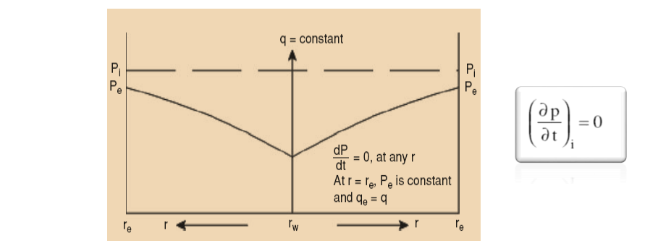
Figure 1:Steady state (Jonathan D Tonkin, 2018)
The steady-state flow circumstances on reservoirs occur only when the reservoir is changed completely, and it has consented as a powerful pressure provision operation or aquifer.
The steady-state flow or pseudo-steady-state flow is referred to as the period after the pressure deviation all over the formation has been established. As the state of constant pressure outer boundary, the pressure from all over the reservoir does not change, but according to the state of the closed outer boundary, the pressure change, Ir uniformly drops In all over the reservoir with time.

Steady-state flow equation and their practical applications.
There is no change in steady-state flow with time, i.e., the right-hand side of all the continuity and diffusivity equations are zero. Regardless of the solution for the steady state are helpful for certain unsteady state problems. The steady-state flow equations can be originated from combining and analyzing the integration constant from the boundary situations. Darcy's equation and steady-state flow equation accounting for particular geometry are presented here (Giulio G Giusteri & Ryohei Seto 2018). The steady-state flow equation is established on the following assumptions:
- Consistency is uniform, and the permeability is constant.
- The fluid is incompressible.
- The flow is constant across any circumferences.
Steady-State Diffusion
These are the assumption for steady-state condition:
- $\frac{dp}{dt}=0$ at all positions and times
- $p\left(r=rw\right)=pw$
- p ($r=re)=pe$

$\frac{1}{r} \frac{d}{dr}( r \frac{dp}{dr}) =$ $0$

$d ( r \frac{dp}{dr}) =$ $0$

Integration is applied

$r \frac{dp}{dr} =$ $0$

$r \frac{dp}{dr}=\frac{qμ}{2πkh}=0$ $dp=\frac{qμ}{2πkh} \frac{dr}{r}$

$$\int_{Pwf}^{Pe}{dp}=\frac{qμ}{2πkh} \int_{rw}^{re}{\frac{dr}{r}}$$

$$Pe-Pwf=\frac{qμ}{2πkh} ln⁡(\frac{re}{rw})$$

To introduce the average pressure:

$$Pe-Pwf=\frac{qμ}{2πkh} ( ln⁡(\frac{re}{rw})-\frac{1}{2})$$

Steady-State condition
- Concentration at the boundaries is constant with time.
- Within solid diffusion is limited to molecular motion.
- Concentration does not influence the diffusivity.
- Within the solid, there is no temperature gradient.

Pseudo steady state flow condition:
When the transient stage ends, the pseudo-steady (semi-steady) state occur. It is stage when there is boundary-dominated flow, and the flow has affected by all the boundaries of the reservoir. It is late time flow regime. In the pseudo-steady state, the pressure change is constant over time
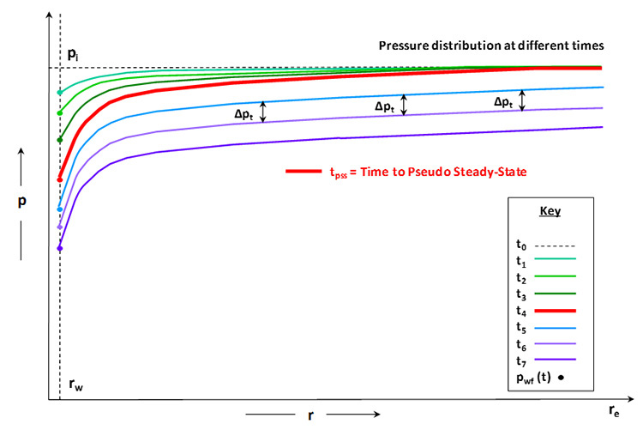
($\frac{∂p}{∂t}=constant$). And it illustrated in the figure below (figure.1) which shows the transient flow stages through the time (king ,2010).
Figure 2: Pressure Distributions p. throw the time t (king,2010)

The figure above shows how the pressure behave over the time. The green curves show the early time pressures which they propagate to the external boundary (red curve) through the time. The time where the pressure disturbance reaches the external boundary is called pseudo steady state
($t_{pss}$ ). It is a flow condition which known as the constant pressure drop over the same time intervals ∆Pt and same at reach radius in the reservoir, as explained in the figure by the blue curves (king,2010).

The general form of diffusivity equation for radial flow shown as (king ,2010):
$$\frac{1}{r}\frac{∂}{∂r} \left(r\frac{∂p}{∂r}\right)=\frac{ϕμct}{\left(5.615\right)\left(1.127×10-3\right)k}.\frac{∂p}{∂t}=\frac{ϕμct}{0.006328k}\frac{∂p}{∂t} (a)$$
The solution of equation (a) for the time which are greater than $t_{pss}$ can simplified by:

$pwf=pi-\frac{141.22μBq}{kh} [\frac{0.012648kt}{ϕμctr^{2}e} +loge(\frac{re}{rw})-\frac{3}{4}]$ (b)

Where:
- 5.615 is a unit conversion constant, ft³/bbl
- 1.127x10⁻³, 141.22, and 0.012648 are equation constants
- Pwf is the flowing well pressure, psi
- pi is the initial reservoir pressure, psi
- μi s viscosity, cp
- B is the formation volume factor, bbl/STB
- q is the liquid rate in STB/day
- k is the permeability, md
- h is the reservoir thickness, ft
- t is the time, days
- ϕ is the porosity of the reservoir, fraction
- ct is total compressibility of the system, 1/psi
- re is the external radius of the drainage volume, ft
- rw is the well radius, ft
To calculate the average reservoir pressure for an oil which is slightly compressible liquid by using the compressibility:
$$pi-\overline{p}=\frac{ΔV}{ctV}=\frac{5.615qtB}{ctπ\left(r2e-r2w\right)ϕh} (c)$$
In eq.(c) the $∆V\left({ft}^{3}\right)=5.615 qtB({ft}^{3})$ , which is the volume produced from the will over a period of time . and V is the pore volume of the derange volume in ${ft}^{3}.$
By inserting eq € into (b) the results will be:

$$pwf=\overline{p}+\frac{1.787qtB}{ct\left(r^{2}e-r^{2}w\right)ϕh}-\frac{141.22μBq}{kh}[\frac{0.012648kt}{ϕμctr^{2}e} +loge\left(\frac{re}{rw} -\frac{3}{4}\right] (d)$$
It has been assumed that the reservoir radius is much bigger than the wellbore radius
re >> rw. Thus , $r^{2}$e –$r^{2}$w≈ $r^{2}$e leading to cancel the terms $\frac{1.787qtB}{ct\left(r^{2}e-r^{2}w\right)ϕh}$ and $\frac{0.012648kt}{ϕμctr^{2}e}$ which results in:

$q=\frac{kh\left(\overline{p}-pwf\right)}{141.22μB\left[loge\left(\frac{re}{rw}\right)-\frac{3}{4}\right]}$ (e)

Also, the skin factor (S) can be added to eq.(e) to account for the well damaging and stimulation:

$q=\frac{kh\left(\overline{p}-pwf\right)}{141.22μB\left[loge\left(\frac{re}{rw}\right)-\frac{3}{4}+S\right]}$ (f)

unsteady-state flow condition:
Transient flow is a flow that occurs while the pressures and/or rate are not constant with time. The greater the compressibility of the fluid, the more pronounced the unsteady-state effect of the reservoir fluid. The engineers use the diffusivity equation for studying the unsteady-state flow of fluid in porous media. Since this solution is not influenced by any boundaries it is called an infinite acting solution. In the derivation we will treat the well as a line source by ignoring any effects due to the finite well (Chaudhry, 2004).
The line source solution is precise for distances far away from the well at all times but is not accurate for the well pressure at short times. Moreover, the diffusivity equation for cylindrical coordinates can be seen in the equation below:
$$η\frac{1}{r}\frac{∂}{∂r}(r\frac{∂P}{∂r})=\frac{∂P}{∂t} (I)$$
By the use of product rule for differentiation and rearrangement we will get the following equation
$$(\frac{1}{r}\frac{∂}{∂r}+\frac{∂^{2}}{∂r^{2}}-\frac{1}{η}\frac{∂}{∂t})p=0 (II)$$
Moreover, by taking the inner constant flow boundary condition at 𝑟 = 0 and not at $r_{w}$. This is equal to the correct boundary condition as long as we consider large distances. Furthermore, the skin effect will result in additional constant pressure drop, 𝛥$p_{s}$. Furthermore, As the hydraulic diffusivity 𝜂 has unit $\frac{m^{2}}{s}$, we see that the diffusivity constant (𝜉) is a dimensionless variable . Moreover, this diffusivity constant can be used a replacement of variable from r and t to $ξ=\frac{r^{2}}{(4ηt)}$ in the diffusivity equation (equation number) resulting that:
$$\frac{∂ξ}{∂r}=\frac{∂}{∂r}\left(\frac{r^{2}}{4ηt}\right)=\frac{2r}{4ηt}=\frac{2ξ}{r}$$
$$\frac{∂^{2}ξ}{∂r^{2}}=\frac{∂^{2}}{∂r^{2}}\left(\frac{r^{2}}{4ηt}\right)=\frac{2}{4ηt}=\frac{2ξ}{r^{2}} (III)$$
$$\frac{∂ξ}{∂t}=\frac{∂}{∂t}\left(\frac{r^{2}}{4ηt}\right)=-\frac{r^{2}}{4ηt^{2}}=-\frac{ξ}{t}$$
Gathering these terms, the diffusivity equation (II) will result in creating:
$$\left[\left(\frac{4ξ}{r^{2}}+\frac{4ξ^{2}}{r^{2}}\right)\frac{∂}{∂ξ}+\frac{4ξ^{2}}{r^{2}}\frac{∂^{2}}{∂ξ^{2}}\right]p=0 (IV)$$
Which can be rearranged into:
$$\left[\left(1+ξ\right)\frac{∂}{∂ξ}+ξ\frac{∂^{2}}{∂ξ^{2}}\right]p=0 (V)$$
Since equation (equation number) is only suitable for $ξ$ only for inner boundary condition at r = 0. Therefore, equation (equation number) needs to be changed by the use of back substitution to correspond to an outer boundary condition at $ξ=∞$ and will form (Chaudhry, 2004).:
$$P(ξ)=A+BX(ξ) (VI)$$
Where:
- X($ξ)$ is a function that satisfy the condition and is equal to $E_{1}(ξ)=\int_{ξ}^{∞}{-\frac{e^{-t}}{t}}dt$
- A is a constant which is equal to the initial pressure $A=P_{i}$
- B is a constant which can be found by the use of Darcy’s law $B=-\frac{Qμ}{4πkh}$
As a result, substituting those terms in equation (VI) provides the final equation for the infinite acting line source solution for a constant rate drawdown test.
$$P=P_{i} - \frac{Qμ}{4πkh} E_{1} \left(\frac{μϕc_{t}}{4k} \frac{r^{2}}{t}\right) (VII)$$
Using the 𝜂 notation for hydraulic diffusivity and 𝑝𝑐 for the characteristic pressure, this equation simplifies to:
$$P= P_{i} - \frac{1}{2} P_{c} E_{1} \left(\frac{1}{4η}\frac{r^{2}}{t}\right) (VIII)$$

Wellbore storage effect:
In a drawdown test when the well is open to flow, production is initiated at the surface due to the expansion of the fluid stored in the wellbore. This flow regime, called wellbore storage effect, and it usually varies between a few seconds to a few minutes. Afterwards, the reservoir production starts, and the sand face flow rate (interface between formation and wellbore) increases until it becomes the same as the surface flow rate. When the flow rate becomes constant, the wellbore storage has no effect anymore, and so, as the data describes the reservoir behavior, and it can be used for transient analysis (KUSHTANOVA G. G., 2015).
On the other hand, for a buildup test, the wellbore storage effect is also called after-flow or after-production. After shutting in the well, the reservoir will continue to produce and the fluid will be compressed in the wellbore, the flowrate will keep on declining until the flow will be equals to zero. The same sequence with three different pressure behaviors can be observed: the pure wellbore storage effect, transition when the sand face rate declines, and the end of the wellbore storage effect when the sand face rate decreases until reaching zero. (KUSHTANOVA G. G., 2015).
Wellbore storage coefficient:
The wellbore storage coefficient defines the rate of pressure change at the wellbore storage effect. Thereby, the wellbore storage coefficient could be calculated on a plot of the pressure change vs. the elapsed time on a linear scale. (KUSHTANOVA G. G., 2015).
Wellbore storage coefficient C is calculated from the straight-line slope $m_{wbs }:$
 | $$C=\frac{qo Bo}{24 m_{wbs}}$$ | $( SEQ Equation \backslash * ARABIC 1$)
where: qo is the oil flowrate in bbl
Bo is oil formation volume factor in bbl/stb
$m_{wbs }$is the slope
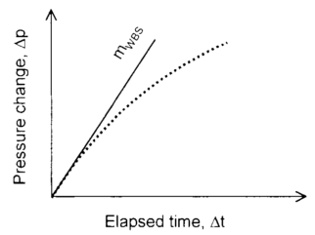
Figure 4. Wellbore storage effect analysis on a linear scale. (KUSHTANOVA G. G., 2015).

Or Ramey defined the wellbore storage effect by the following equation:
 | $$C=\frac{∆G}{ρ ∆p_{w}}$$ | $( SEQ Equation \backslash * ARABIC 2$)
Where: $∆G$ is fluid mass change in well in Ibm.
$ρ is fluid density in well in Ibm/{ft}^{3}$.
$∆p_{w }$bottom hole pressure changes in psi.
(HEINEMANN. Z., 2013).

Minimization and Elimination of Wellbore Storage Effect:
Basically, well testing examines the changes of bottom-hole pressure versus time. However, because of the wellbore storage effect, the bottom-hole flow rate will be so high at the early stages of well testing which makes the analysis challenging to be conducted, such that, the test will have short time interval. Thus, this kind of data requires precise-type of measuring devices, nonetheless, bottom-hole measuring instruments are very expensive and lack precision and accuracy when it comes to measure lower flowrates (Ahmadi et al., 2018; Razminia et al., 2014). So, to address and minimize this issue, a mathematical approach called deconvolution is introduced.
This approach has been developed by multiple scientists including Russel’s straight approximation in 1966, Fetkovich and Vienot rate normalization technique in 1984, Johnston material balance deconvolution in 1992, Joseph and Koederitz beta-deconvolution in 1982 and Kuchuk beta-deconvolution in 1981. First of all, Russel’s straight approximation, which adjust the affected pressure readings by wellbore storage effect to a true pressure corresponding to a constant flow rate. Nevertheless, this method might result in low accurate results and incorrect approximation of skin factor. Secondly, rate normalization method is usually utilized in cases where evaluation of well testing data is influenced by persistent changes of flowrate. In addition, precise readings of bottom-hole flowrate is required in this method. This method can precisely approximate permeability, however, it can also give incorrect approximation of skin factor. Lastly, material balance deconvolution by Johnston, in which pressure data are being used to approximately obtain reservoir flowrate (Ahmadi et al., 2018; Razminia et al., 2014).

Line Source Solution
Moreover, One of the most important problems in petroleum reservoir engineering, and the well test analysis, is to calculate the pressures in the reservoir, and at the well, while the fluid is flowing into a vertical well at a constant rate, from a homogeneous, across infinite reservoir.

The problem is if the fluid were injected into the reservoir from the well, this line would provide as a source of fluid for the reservoir therefore, the solution to this problem is called to the line source solution. While the resulting solution for the pressure is more often used, by an suitable change of signs, for the situation when fluid is produced from the reservoir, in which situation the well actually serves as a sink as far as the reservoir is concerned, rather than a source of fluid, the term line source solution is typically used in the both cases. (Ebenezer, 2018)

Line source solution is also called Theis curve and exponential integral solution. Line source solution can be analyzed by two wells, one observation well and one production well, both wells are located in a homogenous infinite reservoir. (Bath,1998)
Line source solution can be used to determine the effect on observation well induced by production well. Assumptions of line source solution are listed below: (Jelmert, 2013).
- Initially static equilibrium
- Constant production
- Homogenous infinite acting reservoir
- No wellbore storage with zero skin
Assuming well as the shape of line the diffusivity equation has a simple solution i.e r_{w} = 0, the wellbore equation becomes (Jelmert, 2013).
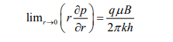

Diffusivity equation solution becomes (Jelmert, 2013).
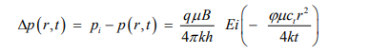
Ei function is defined as integral (Jelmert, 2013).
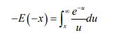
A semi-log equation becomes (Jelmert, 2013).
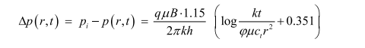
Like other functions some limitations are also associated with implementation of Ei function: initial flow into wellbore cannot be determined through this function because it assumes wellbore as a line which is definitely not the case and to counter this thing some large value of time has to be passed so the effects of expansion are negligible (Jelmert, 2013).

Elaboration of dimensionless time and dimensionless pressure is introduced by line source solution model. This model also has dimensionless distance which is used as the separation of two well.
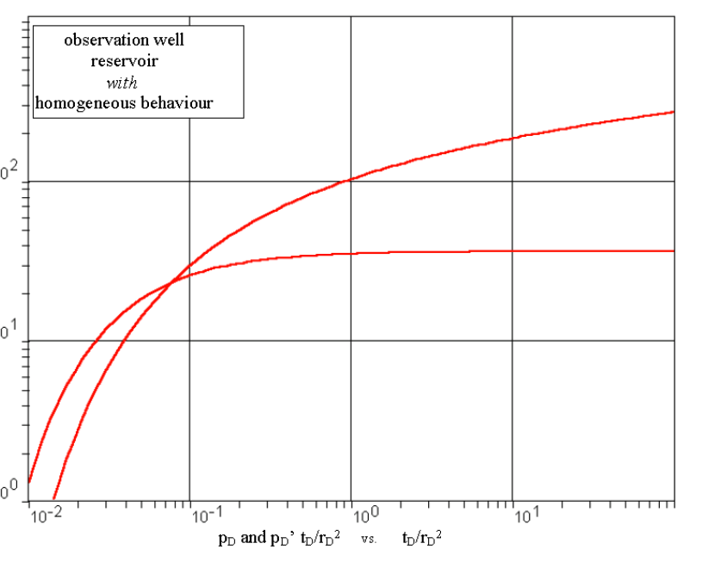
Figure 3: Line Source Solution. (Bath,1998)
Well testing analysis methods:

Cartesian (Linear) Analysis Method
The analysis of well testing is dealing with the fluid flow principals in porous rock and to examine and understand the reservoir characteristics, and all of this is considered reservoir engineering. The analysis of the tests is conducted using many tools inorder to get the information needed. In order to reach the Cartesian method analysis, it is important to understand the elements of the oil well testing and its nature. This is accomplished by understanding the diffusivity equation with the derivations in addition to the fluids type that’s flowing to finally reach the curve types and learn them. (Earlougher, 1977)
The objective of analyzing and testing.
- Average pressure (current)
- Pressure (initial)
- The absolute open flow potential
- The capacity of the flow in the formation (reservoir ability to transmit)
- Porosity or storage capacity of a reservoir
- Presence of simulation
- Presence of formation damage
- Drainage area size
- Boundaries of the reservoir
- Existence of boundaries (faults)
- Existence, fracturing if natural or extent. (artificial or natural)
- Importance and effectiveness of treating the formation
The main differentialequation is derived in the radial form, which simulates the fluid slow in well vicinity. The analytical solution can be obtained in initial conditions and various boundary for describing the well testing and the inflow of a well, which have important applications in reservoir engineering. It is considered better than driving the main equation in Cartesian coordinates. Cartesian is very useful for the early time and late time.

Analysis method using Cartesian plotting to estimate the bulkvolume:
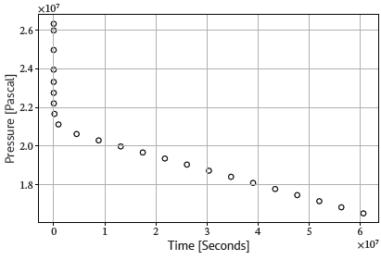
Figure 1:The pressure data from the drawdown test in a plot withc Cartesian scales(Slotte & berg, 2020)
Reservoir pore volume and shape factor is found from the semi steady state flow period using a Cartesian plot (𝑝𝑤 vs. 𝑡). This is illustrated in Fig. 1
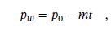eq 1
Then the reservoir volume is estimated from the slope 𝑚: Estimating reservoir volume
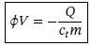

Cartesian plot appears to be sensitive to flow regimes as opposed to semi-log plot. Cartesian plot
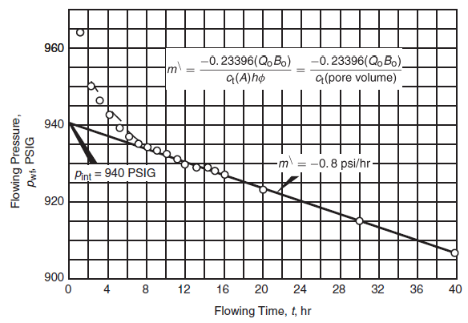
Figure 2: An example of cartesian plot (𝑝𝑤 vs. 𝑡). ) (Slotte & perre,2020)

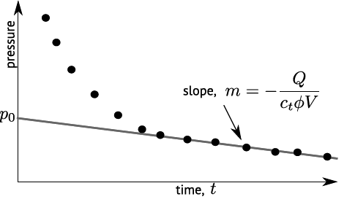
exposes the transient state portion of the data as well as the onset of Pss flow regime.
Figure 3:Flowing time Vs powing pressure. (Chaudhry,2003)

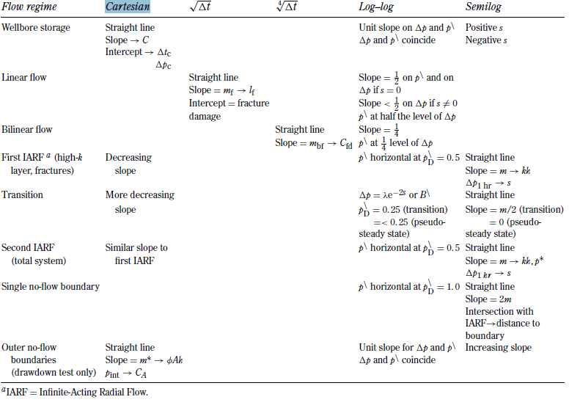
Figure 4:Flow regions with plot types (Chaudhry,2003)
the permeability:
$$\sqrt{K}=\frac{14,407}{Fm×Ye×Mdlf}\frac{1B}{h}{(\frac{µ}{ØCt})}^{0.5}$$

F_{m}= Correction factors
Y_{E} = Reservoir width
Ø = Porosity
Ct =total compresibility, psi-'
µ = Viscosity
Mdf = Mass transfer in medium density

Total skin factor:
S_{t} = Sr + S_{DL} + S_{pL}

Semi-Log Analysis Method:
The testing analysis aims to productivity estimation of a well along with the properties of the formation. The data from the research reflects the formation properties like porosity and permeability under dynamic in-situ conditions.
The general semi-log plot shown in the figure below is different from two rates, and Horner plots can handle only two steps of the flow or multi-rate superposition plots that can take a flow step at any number but don’t plot a single transient.(AI-Khatib,1992)
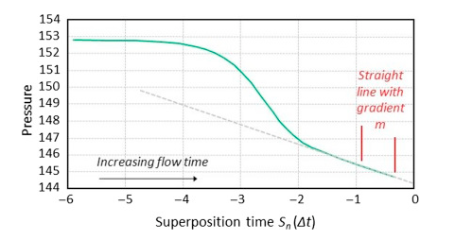
Figure 1: General semi-log ( Cinco,1992)
The straight-line gradient is considered the section for permeability calculation as for a Horner plot from the following equation:
$$K=0.1832\frac{qBμ}{mh}$$

As for the skin factor, it is calculated first any point (X, Y) in the straight-line side and then apply the following equation:
$$S=1.151( \frac{Pi-P1hr}{m}-log\frac{k}{ØµCt{rw}^{2}}-0.3514)$$

Semi log type curves
Semi log curves can be used when working with short time test data, unlike the conventional because conventional methods can’t provide a suitable solution as for the log-log plots, they tend to minimize differences among the various shapes of curve types. Thus, it is essential to develop a method to ensure the outcomes of a well testing analysis. Semi logs are more sensitive; they allow a better resolution than the test data and curve types.( Al-Hussainy.1970)

Hornor semi-log plot
This type was specially designed for two steps of the flow of build-up pressure. (Horner, 1951). Hornor plot is like the pressure recovery plot for the groundwater, although both of them developed separately. (Ramey, 1975). This type of plot did not replace the Miller, Dyes, Hutchinson (MDH) plotting method that has never been used by the industry because of its poor performance in the infinite acting tests, but the MDH was preferred it is easy. Meanwhile, Hornor plots are not a useful alternative when the production times in the shut-in are short. (Al-Hussainy.1970)
Brief on pressure drawdown tests
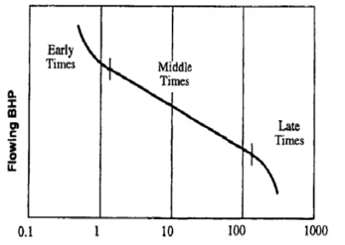

Figure 2: Semi-log drawdown test. (Cinco,1992)
- Early time flow
Storage of the wellbore dominate the flow
- Mid time (transient) flow
In this period, flow acts as an infinite, and a semi-log is used to plot Pwf Vs time, which can be utilized for permeability calculations.
- Late time flow
It is the flow period in which the data of the pressure is dominated by the boundary.
- Late time flow
Pressure data dominated by the boundary and is used to calculate the shape and size of a reservoir

Why do we have types of curves?
In perfect conditions, the tests of the useful data are only affected by the characterizes of the reservoir. However, in real-life situations, the data is affected by wellbore conditions, especially in the early stages of the test. (Al-Hussainy.1970)
The wellbore conditions that affect the tests are:
- Hydraulic fracturing
- Wellbore storage
- Phase separation
- Partial perforation
Fundamentals of curves types
- The curves are plotted from the theoretical solution into a flow equation.
- The curves can be utilized for estimating the properties of the reservoir, define an appropriate model for the reservoir, and examine and identify the patterns of the flow during the test.

Log-Log Analysis Method
The log-log analysis is a graphical representation of the data provided by the test in log-log scale where $∆P$ is plotted on log-log scales versus the$∆t$. As shown in Fig.1
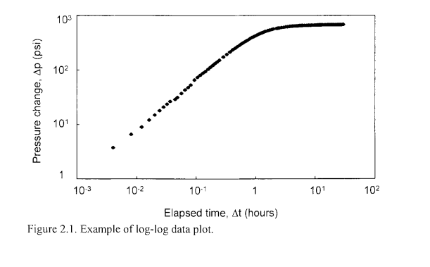

Fig.1 Log-log Data Plot (Bourdet, 2002)
The Methodology of Log-Log Analysis:
- The flow rate will be manipulated from the surface, which will create pressure pulses (changes of pressure with time). The recorded pressure changes is plotted on Log-Log scales versus the elapsed time.

The Objective of Log-Log Analysis:
- Identify the different flow regimes (types of flow)
- Identify reservoir characteristics

The change in pressure,

Identifying the Different Flow Regime
A full production test consists of several distinctive flow regimes. Originally starts with wellbore storage and conditions around wellbore (early time region), to middle time region, and finally to late time boundary effects. Most of the transitional behaviour from one regime to the next is described in the reported pressure data. (Bourdet, 2002)
- Well Bore Storage
Well bore storage is identified by unit slope line in the early time region. It is described in log $∆P$ versus log $∆t$ plot. As shown in Fig.2

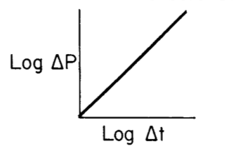

Fig.2 Well Bore Storage Regime Plot ( Ershaghi, 1985)

The slope of well bore storage in the provided Fig.2 = 1

- Infinite Acting Radial Flow

Infinite acting radial flow is identified by slightly increasing line in the middle time region. It is described in log $∆P$ versus log $∆t$ plot. As shown in Fig.3

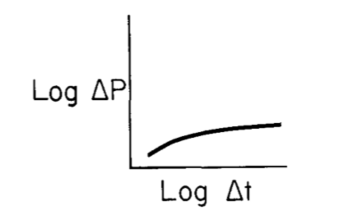

Fig.3 Infinite Acting Radial Flow Regime Plot ( Ershaghi, 1985)

- Formation Linear Flow

Formation linear flow is identified by a half slope. The formation linear flow describes the presence of fracture. It is described in log $∆P$ versus log $∆t$ plot. As shown in Fig.4
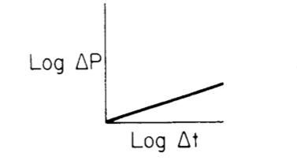

Fig.4 Formation Linear Flow Regime Plot ( Ershaghi, 1985)

Table.1 Different Characteristics That Can be obtained from Each Time Region:
(Slotte , Per Arne ; Berg, Carl Fredrik;, 2017)
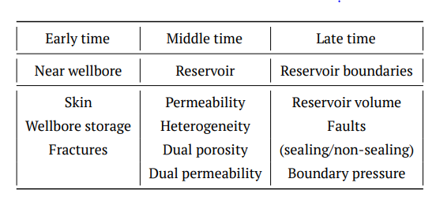

- Log-Log Derivative Plot
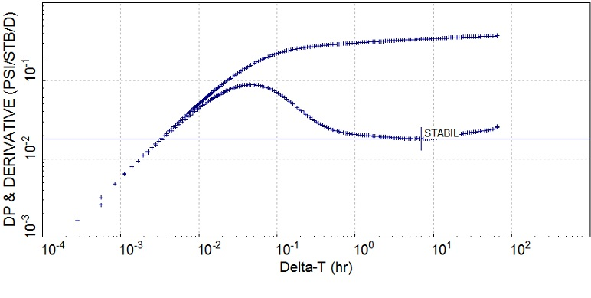
Log-Log derivative plot can be used to identify the amount of skin. Where the higher vertical separation between the stabilization line and $∆P$ plot means a higher skin. On the other hand, the lower vertical separation means a lower skin. Fig.5 illustrates an example of log-log derivative plot.

Fig.5 Log-Log Derivative Plot (Bourdet, 2002)

- Identify Reservoir Characteristics

Log-Log analysis can be used to determine several reservoir characteristics such as:
- Reservoir Permeability (k)
k = $\frac{162.6 q βμ}{mh}$
Where:
- m (the slope) = 2.303 × ∆P_{Fr`}
- $q$ = Flow rate in STB/day
- $β$= Oil FVF in bbl/ STB
- $μ$ = Oil viscosity in cp
- h = Height in ft
- Well Bore Storage Coefficient (C_{ws})

C_{ws} = $\frac{q β}{24 Mwbs}$
Where:
- M_{wbs} = Slope of well bore storage
- $q$ = Flow rate in STB/day
- $β$ = Oil FVF in bbl/ STB

Dietz shape factor
D. N. Dietz is electrical engineer who developed and simplify a method in order to determine average reservoir pressure from build-up survey, which is simpler to apply than previous method (i.e. Matthews’ method) as Dietz mentioned in his article.
Dietz obtained Shape Factor numbers ($C_{A}$) of drainage areas having diverse shapes and well positions graphically from the straight-line portion of various build-up curves presented by Matthews. Dietz generalized the pseudosteady inflow equation for a wide variety of regular shapes with their Shape Factor numbers ($C_{A}$) are listed in (Table 1).Because he used the method of images (PIII), any shape that can “pave” the plane can be modelled. Dietz evaluated the shape factor ($C_{A}$) for various geometries for rectangles of various aspect ratios with single wells in various locations.
However, wells rarely drain ideally shaped drainage areas. even if they are assigned regular geographic drainage areas, they become distorted after production commences, either because of the presence of natural boundaries or because of lopsided production rates in adjoining wells. To account for irregular drainage shapes or asymmetrical positioning of a well within its drainage area. Dietz also mentioned that his method relies more heavily on this assumption, and, in the transient state, becomes increasingly inaccurate for smaller production times. Identical results are obtained in the steady state, and in this region his method may be preferred for its simplicity. (Dietz, 1965)
The Dietz method can be used to estimate the average drainage area pressure from the following equation:
$${∆t}_{\overline{p}}=\frac{∅μc_{t}A}{0.0002637kC_{A}}$$
The unit $C_{A}$ represent a constant dependent on shape of area, positioned of well and on production character.
To use Dietz method, some conditions must be met:
- The drainage-area shape and size are known, as is the location of the well within the drainage area.
- The well is produced at a constant rate long enough to reach pseudosteady-state flow before the beginning of the build-up.
- Infinite-acting radial flow (IARF) is present during the build-up test, and it lasts long enough for the correct semi-log straight line to be identified.

Application of method:
1. Divide the reservoir on a map into drainage areas proportional to offtake rates per unit sand thickness of wells.
2. Plot pressure build-ups against $ln, ∆t$ and determine $k/µ$ from slopes.
3. Determine $t, ∅, c and A$ by generally known methods.
4. Check applicability of method by comparing $kt/∅µcA$ required values in the table.
5. Select $C_{A}$ from the table and read straight-line partsof pressure build-ups or their extrapolations at ${∆t}_{\overline{p}}=\frac{∅μc_{t}A}{0.0002637kC_{A}}$
Nomenclature:
${∆t}_{\overline{p}}$ = time at which the average drainage-area pressure $\overline{p}$ can be read directly from a semilog straight line
$∅$ = porosity
$μ$ = viscosity of reservoir fluid, cp
$c_{t}$ = total compressibility, ${psi}^{-1}$
$A$ = drainage area or associated reservoir area, sq cm
$k$ = permeability, md
$C_{A}$ = constant dependent on shape of area, position of well

Table 2: Is Obtained for Different Locations of a Well in Different Aspect Ratios of the Rectangle Including the Shape Factors by Graphic or Truncation of the Infinite Sum, so Their Results are of Limited Accuracy. (Dietz, 1965)

Well Testing Projects:
- Drawdown Test:

Analyzing Single-Rate, Single-Phase Pressure well test a constant-rate well test was run in an oil well with the following characteristics: $q_{o}$= 250stb/day, $μ_{o}$= 0.8 cP, $β_{o}$= 1.136 rb/stb, $C_{o}$= 17.0 x ${10}^{-6}{ Psi}^{-1}$, $∅$= 0.039, h = 69 ft, $P_{i}$ = 4412psi, and $r_{w}$= 0.198 ft. Last flowing time = 460 hr. From the test data given in Table 1, plot the data and estimate the formation permeability, skin factor, pressure drop across skin, flow efficiency.

Table 1: Well test data (Single-Rate and Single-Phase Well test)
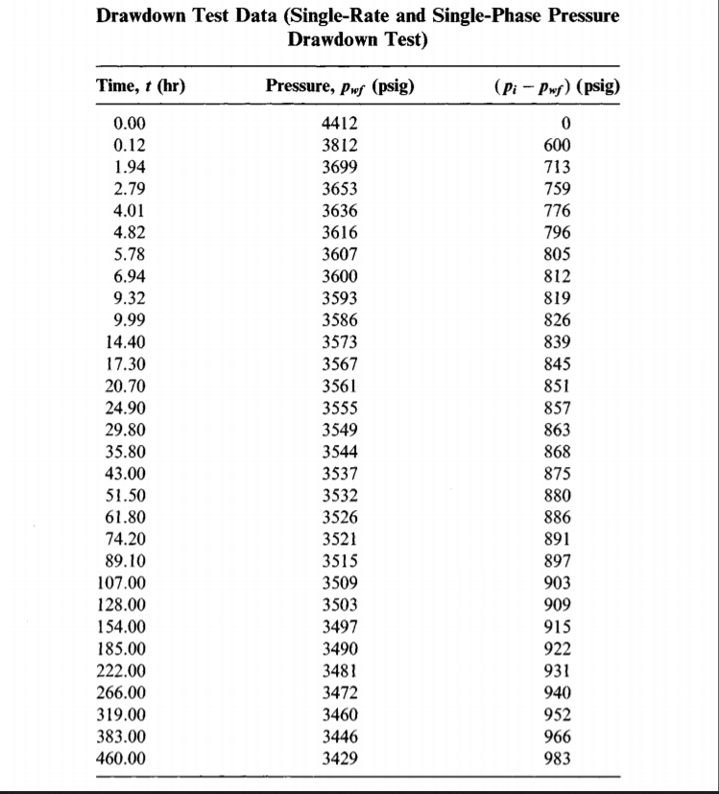

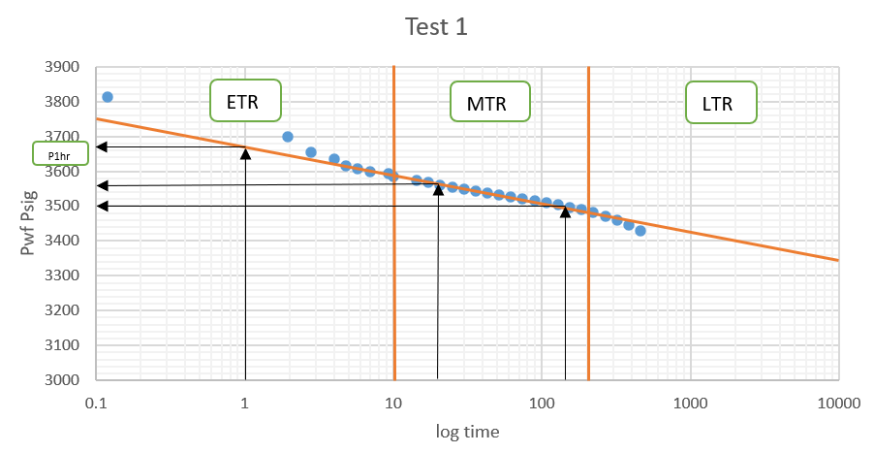
- Semi log analysis:

- K (Permeability):
$$m=slope=\frac{∆y}{∆x}$$

$$x=20, y=3560$$
$$x=150, y=3500$$

$$m=\frac{y2-y2}{logx2-logx1}$$
$$=\frac{3500-3560}{log150-log20}$$
$$= -68.5\frac{Psi}{cycle}$$

$$k=162.6 \frac{q μ B}{\left|m\right| h}=162.6 \frac{250 ×0.8 ×1.136 }{\left|-68.5\right|×69}=7.8 md$$

- S (Skin factor):

$$s=1.151 \left[\frac{Pi-P1hr}{\left|m\right|}-\log{(\frac{k}{∅ × μ ×ct×r^{2}w}}+3.23 \right]$$

$$from the plot P1hr=3670$$

$$s=1.151 \left[\frac{4412-3670}{\left|-68.5\right|}-\log{(\frac{7.8}{0.039× 0.8 ×17×{10}^{-6}×{0.198}^{2}}})+3.23 \right]=+6.4$$

- Due to the sike is > 0 , the well will require further stimulation process.

- To determine ${∆P}_{skin} \left(Pressure Drop Due to Skin\right)$:
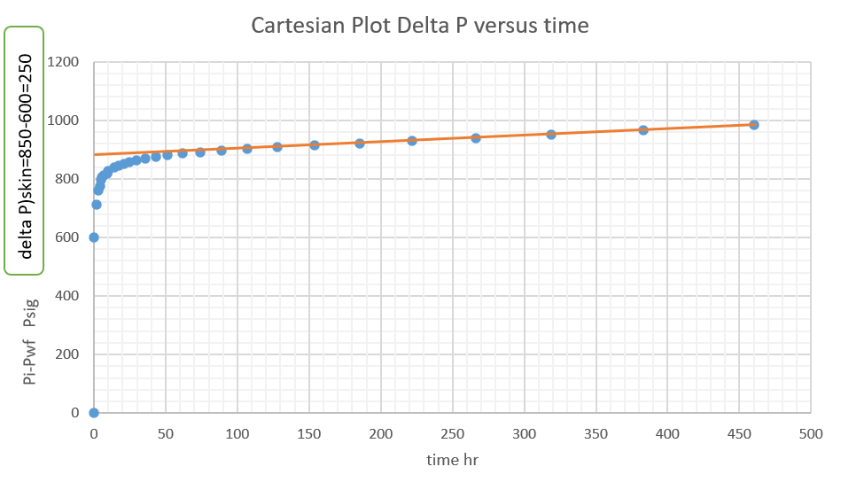
plot of P versus radius should be performed to illustrate the increase in pressure from Pwf to reservoir pressure but here in this data we can use a plot of delta p (Pi-Pwf) versus time on a cartesian plot it will give the same indication: change the plot
$$from the above plot {∆P}_{skin} =840-600=240 Psig$$
Or it can be calculated using the formula
$${∆P}_{skin}=141.2 \frac{q ×B ×μ}{k ×h} × S$$
$${∆P}_{skin} =141.2 \frac{250 ×1.136 ×0.8}{7.8×69} × 6.4=381.5 Psig$$
- Flow Efficiency
$$FE=\frac{Pi-Pwf,ideal}{Pi-Pwf,real}$$

Based on Darcy law radial flow:
$$q=\frac{0.00708 k h (Pi-Pwf,ideal)}{μ Bo (ln⁡(\frac{re}{rw})-0.75+S))}$$
$$from the above equation if we know re we can get Pwf , ideal$$
$$Pwf real=Pwf ideal+ {∆P}_{skin}$$

$$FE=\frac{ideal Draw Down}{Real Draw Down}=\frac{Pi-pwf-{∆P}_{skin} }{Pi-pwf}$$

$$= \frac{4412-3530-381.5}{4412-3530}x 100=56.7\%$$

- Log -Log analysis: NEED TO PLOT DERVITIVE POT .
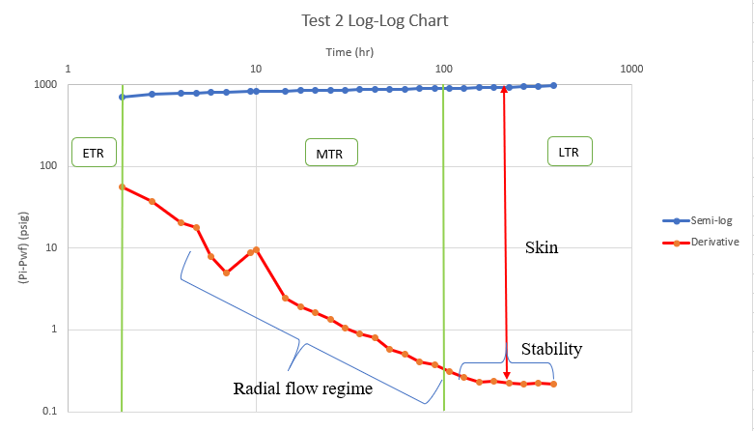
To determine the value of well bore storage or well bore storage effect it is clear that from log-log analysis, well bore storage will not appear as it is defined by unit slope line in the early time region and the data point in the early tome region is not giving straight line, so the effect of well bore storage is not clear. And based on this through cartesian analysis we cannot identify the well bore storage as there is no sign when it ends.

- Build-up Test:
A single-phase and single-rate pressure well test was conducted on an oil well. The data in the first two columns of Table 2 were recorded. The following well/reservoir parameters are given: $β_{o}$= 1.224 rb/stb, h = 55 ft, $∅$= 0.06, $r_{w}$ = 0.21 ft, $C_{o}$ = 1.5 x${10}^{-6}$, and $μ_{o}$= 0.65 cP, $P_{sc}$ = 14.65 psia, T = 200$℉$, $r_{e}$ = 1520ft, and $ρ_{o}$= 53.5${lb}_{m}$/${ft}^{3}$ . Assume the well is draining from the center of a square. Well depth = 4500 ft. $t_{p}$ = 13630 hours. Plot the data in table 2 and find the requirement below:
1. Formation permeability, K
2. Skin factor, S
3. Additional pressure drop near the wellbore, ($∆P)_{Skin}$
4. Effective wellbore radius, $r_{wa}$
5. Flow efficiency FE using p*
6. Damage ratio DR using p*
7. Productivity index, PI
8. Radius of investigation (determine the radius of investigation at $∆t$ = 6 hours and $∆t=$ 50 hours).
9. wellbore storage effect.
Table 2: Well test data (Single-Phase Well test)
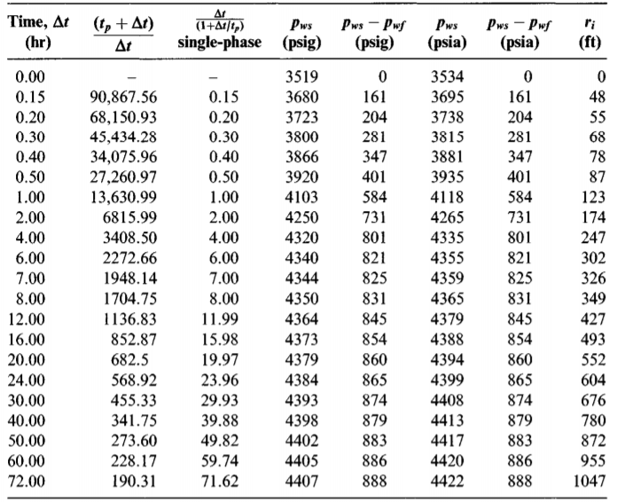
To calculate the Slope (m) from simlog straight line
Equation of slope $m=\frac{p2-p1 }{HTR1-HTR2 }$
$$=\frac{4378.919-4400}{\log\left(1000\right)-log⁡(500)}$$
$$=70 {psi/}_{cycle .}$$
Where $p_{1h}$
From the semi-log straight line HTR 1h
Equation ${HTR}_{1H}$ = $\frac{t_{p+1}}{1}$
$$=\frac{13630+1}{1}$$
$$=13631$$
We read from the semi-log straight line at 13630 p1h = 4294 psi
1) Permeability Using Build up Test:
Equation k = $\frac{162.6 q Bμ}{\left|m\right|h}$
$$= \frac{162.6 ×250×1.224×0.65}{70×55}$$
$$=8.4 mD$$
Where:
- $q$ = Flow rate in stb/day
- $β$= Oil FVF in bbl/ stb
- $μ$ = Oil viscosity in cp
- h = Height in ft
- k = permeability in mD
- s = skin in
- m = slope
2) Skin Factor Determination Using Build up Test:
S = $1.51 \{ \frac{Pws 1hr-Pwf}{m}-\log{(}\frac{k}{∅µ ct {rw}^{2}})+3.32\}$
S = 1.51 {$\frac{4294-3519}{70}-\log{(\frac{8.5}{\left(0.06\right)\left(0.65\right)\left(1.5x{10}^{-6}\right)\left({0.21}^{2}\right) }})+3.23\}$ = 5.9
Where:
- P_{ws} = Shut-in bottomhole pressure (psig)
- P_{wf} = the flowing bottomhole pressure at the moment of shut-in (psig)
- M = Slope
- K = Permeability (mD)
- ∅ = Porosity
- µ = Viscosity (cp)
- r_{w} = Wellbore radius (ft)

3) The pressure drops near the wellbore (ΔP) _{Skin} can be determined by:
ΔP = (141.2) $\frac{q β μ}{kh}$ s where:
- $q$ = Flow rate in stb/day
- $β$= Oil FVF in bbl/ stb
- $μ$ = Oil viscosity in cp
- h = Height in ft
- k = permeability in mD
- s = skin
ΔP = (141.2) x $\frac{250 x 1.224 x 0.65 }{8.4 x 55}$ x (5.9) = 355.9 psia

4) Effective wellbore radius $r_{wa}$
Equation for $r_{wa}= r_{e}e^{-s}$
$$=0.21e^{-5.9}$$
$=5.9×{10}^{-4}$ft
Where:
- $rw=$ wellbore radius, ft
- $β$= Oil FVF in bbl/ stb
- $μ$ = Oil viscosity in cp
- h = Height in ft
- k = permeability in mD
- $C_{A}=$Dietz shape factor
5) Flow Efficiency FE using P*
$FE=\frac{P*-pwf- ∆P}{p*-pwf}$
=$\frac{4576-3519-355.9}{4576-3519}$
= 66%
6) The damage ratio DR can be determined by:
DR = $\frac{1}{FE}$ where:
- FE = Flow efficiency
DR = $\frac{1}{66\%}$ = 1.515

7) Productivity Index
Equation for PI = $\frac{kh}{141.2βμ(\ln\left(\frac{re}{rw}\right)-\frac{3}{4}+5+\frac{1}{2}\ln{\frac{10.06π}{c_{A}}}}$
$$= \frac{8.4×55}{141.2×1.22 ×0.65(\ln{\frac{1520}{5.9×{10}^{-4}}-\frac{3 }{4}+}5.8 +\frac{1}{2}\ln{\frac{10.06π}{30.9}}}$$
$$=0.207 Std/D/psi.$$
Where:
- $rw=$ wellbore radius, ft
- $β$= Oil FVF in bbl/ stb
- $μ$ = Oil viscosity in cp
- h = Height in ft
- k = permeability in mD
- $C_{A}=$Dietz shape factor
8) Radius of investigation at ∆t = 6 hours and ∆t= 50 hours:
$$rin=0.03\frac{\sqrt{ kt}}{∅µ ct}$$
Where:
- K = Permeability (mD)
- T = Time (hrs)
- ∅ = Porosity
- µ = Viscosity (cp)
at ∆t = 6 hours
$rin=0.03 \frac{\sqrt{ (8.4)(6)}}{\left(0.06\right)(0.65)(1.5x{10}^{-6})}$ =880.5ft
At ∆t = 50 hours
$rin=0.03\frac{\sqrt{ (7.9)(50)}}{\left(0.06\right)(0.65)(1.5x{10}^{-6})} =$ 2541.95 ft
9) The wellbore storage effect can be determined by wellbore storage coefficient:
C_{s} = $\frac{q β}{24 } (\frac{∆t}{∆P})$ where:
- $q$ = Flow rate in STB/day
- $β$ = Oil FVF in bbl/ STB

C_{s} = $\frac{250 x 1.224}{24 }$ ($\frac{0.1}{100})$= 0.01275 bbl/psi
After that we should substitute the C_{s} in the following formula:
C_{SD} = $\frac{0.984 Cs}{ Ø Ct h rw2}$ where:
C_{s =} wellbore storage coefficient in bbl/psi
- C_{SD =} wellbore storage distortion in bbl/psi
- $Ø$ = Porosity
- $h=$ height in ft
- $r$_{w}² = wellbore readies in ft

C_{SD} = $\frac{0.984 x 0.01275}{ 0.06 x 1.5x{10}^{-6}x 55 x {0.2}^{2}}$ = 63363.6 bbl/psi
10) Graph analysis notes:
The graph consists of Y axis that represents DP & Derivative (PSI/STB/D). And of an X axis that represents Delta T in logarithmic scale.
There are two plots. The first represents Delta P (Blue). The second represents Derivative (Orange).
The graph can be divided vertically into three parts, early time, middle time, and late time, in that order from left to right.
Early time can give information about the wellbore’ condition and specifically the wellbore storage delay.
Middle time can give information about the transition from wellbore to reservoir, it can give indications about the time length of that transition. Also, it can indicate the flow regime is radial flow.
Late time can give information about the reservoir’ condition.
The distance from the two plots in late time can give information about the skin.
The Derivative plot in late time can give information about the stability of the flow.

Problems Associated with these tests:
The pressure build-up and drawdown tests, including drill stem tests, are commonly used to estimate formation characteristics such as permeability and wellbore damage. The differences between sand face and surface flow rates during the initial part of these tests cause serious inconsistencies, called wellbore storage effects, which produce serious problems. These problems happen for two main reasons: The wellbore storage effects in a build-up or drawdown test prevent the appearance of the ideal straight-line region on a plot of test data and the slope of this line, which is connected to formation permeability, is the key to proper analysis of the test. Furthermore, False straight lines perform in plots of the data distorted by wellbore storage. Thus, if the analyst efforts to estimate formation permeability from the slope of a false straight line, significant error can result. (Lee,1971)
Some major problems we can consider in drawdown test is that the rate may not be constant. However, changing the choke periodically to maintain a constant rate will cause more problems than letting the rate change. To get accurate analysis on a drawdown test, it is critical that no choke changes happen during the test. Build up test main problem is the loss of production due to shut in. (nisle,1958)
Recommended flow and shut-in times:
For the initial flow period it is recommended to be briefly in between 5 to 10 minutes to remove excess pressure. After, the initial shut-in period is between 30 to 60 minutes to let the reservoir regain its true static pressure. And so, during this period we can find out the reservoir’s static pressure by using DST tool. On to the second flow period, is almost 60 minutes as during this period, a large fluid sample of formation is obtained and drawdown of formation pressure to maximum extent possible. Lastly, the second shut-in period is between 30 to 60 mins and we can obtain formation properties. (Chaudhry, 2004).

Problems of DST analysis:
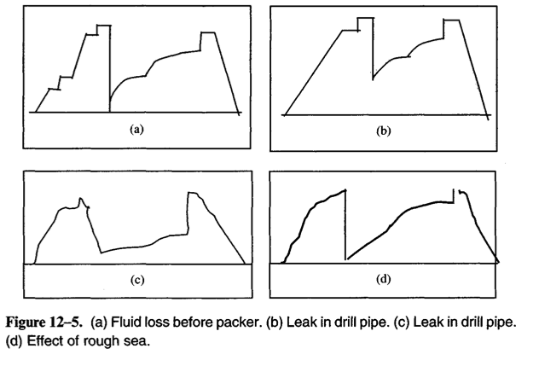
Various issues may occur during the DST analysis, some might be interpreted by simply looking at the pressure chart such as:
Figure 1: DST pressure chart problems (Chaudhry, 2004).

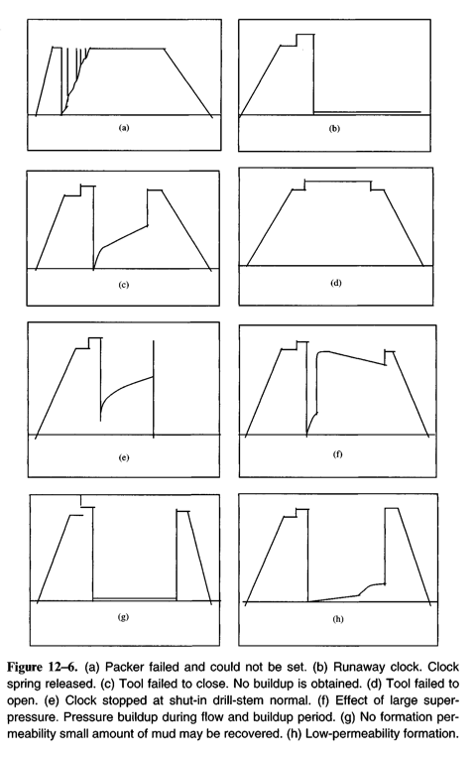

Figure 2: DST pressure chart problems (Chaudhry, 2004).
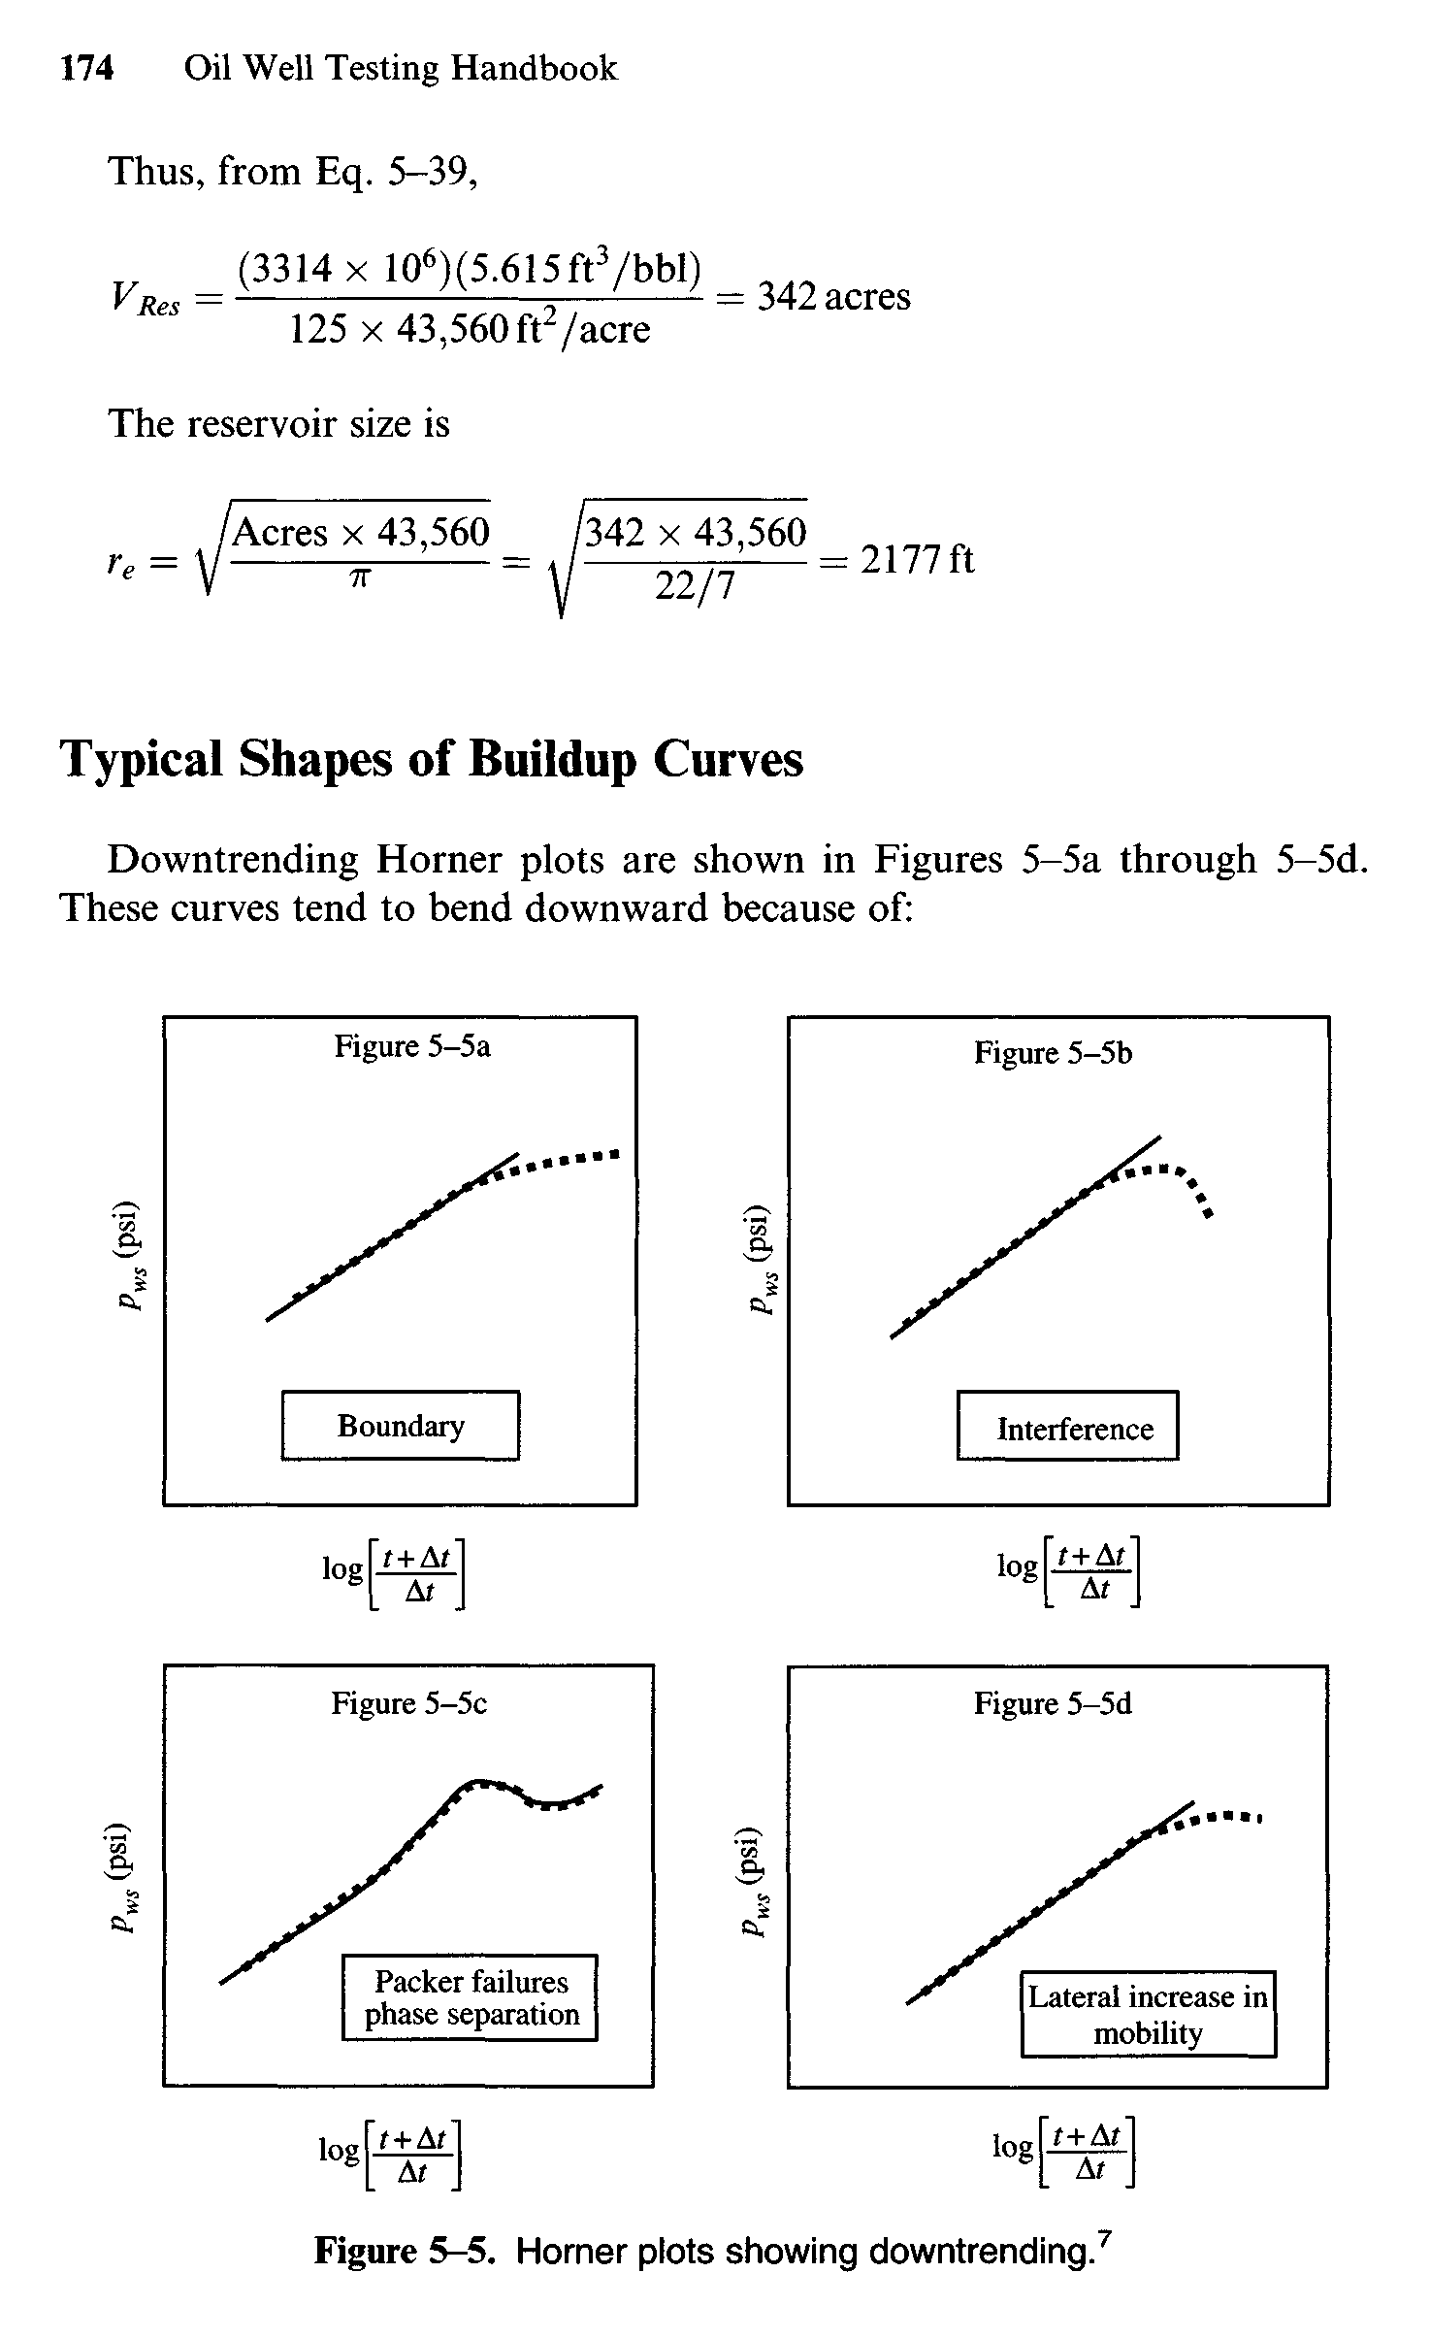
Other issues may occur and can be seen in Horner’s plot, examples are:

Figure 3: Boundary issue (Chaudhry, 2004).
Reservoirs with an apparent boundary that result in pressure depletion.

Figure 4: Interference issue (Chaudhry, 2004).
The well’s pressure was changed as production occurs from other nearby wells.

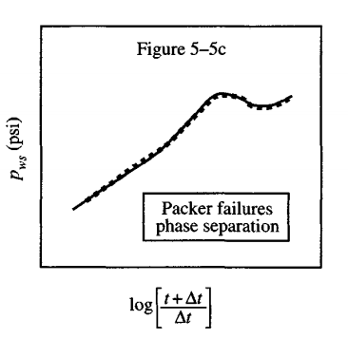
Figure 6: Packer failures (Chaudhry,2004)

Packer can easily damage because of the pressure changes during the production and shut in the well and cause a large pressure different on the packer, which make the packer fails.

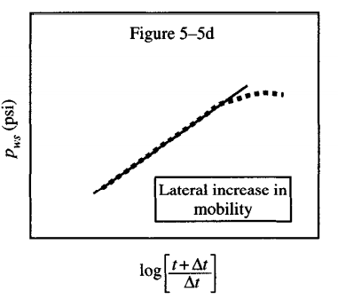
Figure 7: Fluid mobility increases. (Chaudhry,2004)

In reservoir intervals with great permeabilities and high production rates, the relatively high mobility of gas compared to oil will lead to a turbulent flow being seen in the wellbore thereby introducing noise that will cover the sensing of pressure transients by the drill stem test.

Horner's Plot Method
The data of DST pressure build-up can be evaluated in a similar way of evaluating other build-up tests, such that, the flow time interval is approximately equal to the shut-in time interval. Thus, to evaluate the data of pressure build-up, Horner’s plot method can be applied. In Horner’s plot method the bottom-hole pressure at any time ($P_{ws}$) is plotted versus log of time ($log\left(⁡\frac{t_{p}+∆t}{∆t}\right)$), where $t_{p}$ is the time interval of the flow. It should be noted that, it is very precise to use the total time interval of the flow for $t_{p}$ in the final build-up, if the initial flow time interval is very long. In addition, when the wellbore storage effect is negligible and the shut-in duration is long enough, it will result in a straight-line with negative slope (-m) in the Horner’s plot. This slope can utilize in determining the formation permeability (k), using this equation (Chaudhry, 2004):
$k=\frac{162.6q_{o}β_{o}μ_{o}}{mh}$ … (eq. 1)
Where.
$k$: Formation Permeability (mD)
$q_{o}$: Production Rate (bbl/d)
$β_{o}$: Oil Formation Volume Factor (STB/bbl)
$μ_{o}$: Oil Viscosity (cP)
$h$: Formation Thickness/Net Thickness of Productive Zone (ft)
$m$: Slope $\left(\frac{P_{ws}}{log\left(⁡\frac{t_{p}+∆t}{∆t}\right)}\right)$

In cases where the net thickness is not available, we can apply this equation of formation capacity ($kh$) (Chaudhry, 2004):
$kh=\frac{162.6q_{o}β_{o}μ_{o}}{m}$ … (eq. 2)

And in cases where all the parameters are not available, we can apply this equation of transmissibility (${kh}/{β_{o}μ_{o}}$) (Chaudhry, 2004):
$\frac{kh}{β_{o}μ_{o}}=\frac{162.6q_{o}}{h}$ … (eq. 3)

Data of the DST might be deviated as a result of formation damage; therefore, we have to take into consideration the flow restriction effects resulting from damaged formation. An empirical equation was derived to approximate the skin factor (s) which a is dimensionless factor (Chaudhry, 2004):
$s=1.151\left[\frac{P_{1hr}-P_{wf(∆t=0)}}{m}-log\left(\frac{k}{ϕμ_{o}c_{t}{r_{w}}^{2}}\right)+log\left(\frac{t_{p}+1}{t_{p}}\right)+3.23\right]$ … (eq. 4)

It should be noted that, when$t_{p}$ is larger than 1 or when the skin factor is extreme, the term $log\left(\frac{t_{p}+1}{t_{p}}\right)$ is usually ignored.

Onto calculating the damage ratio (DR), which compares flow rate obtained from the DST ${"q}_{o}"$ and theoretical flowrate “$q_{t}$”.
$DR= \frac{q_{t}}{q_{o}}$ … (eq. 5)
Calculating DR based on skin factor.
$DR=\frac{p_{i}-p_{wf}}{m(\log\left(\frac{k t_{p}}{ϕ μ_{o}c_{t}{r_{w}}^{2}}\right)-2.85)}$ … (eq. 6)
If DR is greater than 1.0, damage is indicated.

Moreover, estimated damage ratio (EDR) can be obtained by:
EDR= $\frac{p_{i}-p_{wf}}{m (\log{t_{p}+2.65)}}$ … (eq. 7)
Determination of well flow efficiency plays an essential role in assessing the need for well treatment or production stimulation affected by skin factor. Flow efficiency is defined as (Chaudhry, 2004):
$Flow Efficiency= \frac{P_{i}-P_{f}-{\left(∆P\right)}_{skin}}{P_{i}-P_{f}}$ … (eq. 8)
Where, the pressure drop due to skin is:
${\left(∆P\right)}_{skin}=\frac{141.2q_{o}μ_{o}β_{o}}{kh}s$ … (eq. 9)

It must be noted that, initial pressure $P_{i}$ or average pressure $\overline{P}$ are extrapolated pressure from Horner’s plot at Horner’s time equal to 1, $\frac{t_{p}+∆t}{∆t}=1$. On the one hand, the radius of investigation in a DST is the same as the radius of drainage (Chaudhry, 2004):
$r_{i}=\sqrt{\frac{k∆t_{max}}{948ϕμ_{o}c_{t}}}$ … (eq. 10)

On the other hand, to approximate the radius of investigation of a specific DST, where the system is infinite radial flow, we can apply Van Poollen equation (Chaudhry, 2004):
$r_{i}=\sqrt{\frac{kt_{p}}{5.76×{10}^{4}ϕμ_{o}c_{t}}}$ … (eq. 11)

Results
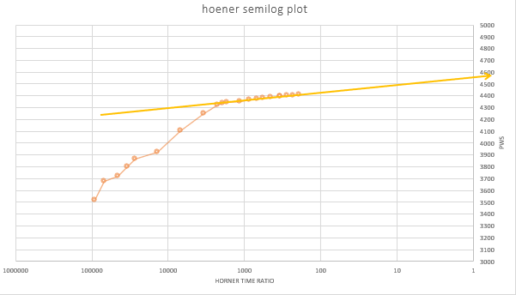
Figure 8: Horner’s semi-log plot

To conclude, referring to fig. 4 and fig. 8, pressure points in semi log plot droped from the slope in a shape of semi line which seems like boundry effect problem not curvy line. So, when we compare the figure, it seems it is a boundry effect.

References:
- Silin, D., 2003. A Well-Test Analysis Method Accounting for Pre-Test Operations. SPE Journal, 8(01), pp.22-32.
- Kitson, A., 2010. The Defining Series: Well Testing Fundamentals. International Journal of Practice, 16(4), pp.423-434.
- Chaudhry, A., 2004. Oil Well Testing Handbook. [online] Oilcraft.io. Available at: <http://oilcraft.io/books/Chaudhri%20%E2%80%93%20Oil%20Well%20Testing%20Handbook%20(2004).pdf> [Accessed 12 November 2020].
- Kutasov, I., 2005. Drawdown test for a stimulated well produced at a constant bottomhole pressure. First Break, 23(1080).
- Pecher, R., 1995. Pressure Transient Testing of the Heterogeneous Reservoirs. Journal of Canadian Petroleum Technology, 34(03).
- Berg, C., 2017. Lecture Notes In Well-Testing. [online] Folk.ntnu.no. Available at: <http://folk.ntnu.no/perarnsl/Literatur/lecture_notes.pdf> [Accessed 13 November 2020].
- Giulio G Giusteri & Ryohei Set,2018.Application of diffusivity; Journal of Rheology 62 (3), 713-723.
- Jesus Carrera & Shlomo P Neuman. 1986. Water Resources Research 22 (2), 199-210,
- Jonathan D Tonkin & David A Lytle, 2018.Nature Ecology & Evolution 2 (1), 86-93.UK
- Shermon, P.G.& McGraw-Hill,1963.Diffusion in Solids, Scribd
- Gregory King.2010, Professor of Practice, Petroleum and Natural Gas Engineering Lessons, The Pennsylvania State University Source URL: https://www.e-education.psu.edu/png301/node/854
- Jelmert, t. (2013). Introductory to well testing. Retrieved 14 November 2020, from https://home.czu.cz/storage/52485_introductory-well-testing.pdf
- Bath, 1998. Introduction to Well Testing. [online] Issuu. Available at: <https://issuu.com/e-librarysnsc/docs/schlumberger_-_introduction_to_well_testing_>
[Accessed 14 November 2020].
- Ebenezer. (2018). line-source-solution-for-a-vertical-well-in-an-infinite-reservoi-2018. LA TROBE UNIVERSITY.
- Ahmadi A., Ashouri, S., And Mousavi, S.H., 2018. Application of Deconvolution Methods to Eliminate Wellbore Storage Effect In Well Test Analysis, A Case Study. Biochemical Technology Society, 2018, Pp. 158-164.
- KUSHTANOVA G. G., 2015. Well Test Analysis, KAZAN (VOLGA REGION) FEDERAL UNIVERSITY INSTITUTE OF PHYSICS, Department of Radioelektronic.
- HEINEMANN. Z., 2013. Well Testing, Textbook Series. VOL 2. PHDG. Verein Zur Förderung von Wissenschaftlichen Arbeiten In Reservoircharakterisierung Und-Simulation.
- Razminia, K., Hashemi, A., Razminia, A. And Baleanu, D., 2014. Explicit Deconvolution of Well Test Data Dominated by Wellbore Storage. Abstract and Applied Analysis, 2014, Pp.1-12, Http://Dx.Doi.Org/10.1155/2014/912395
- DIETZ, D. N. (1965). Determination of Average Reservoir Pressure From Build-Up Surveys. Journal of Petroleum Technology, 955-959.
- MATTEWS, s. c., BRONS, F., & HAZEBROEK, P. (1953). A METHOD for DETERMINATION of AVERAGE PRESSURE in a BOUNDED RESERVOIR . Petroleum Transaction, AIME, 182-191.
- Spivey, J. P., & Lee, W. J. (2013). APPLIED WELL TEST INTERPRETATION. Texas: Society of Petroleum Engineers.
- Ershaghi, I. (1985). Examples of Pitfalls in well test analysis . SPE, 7.
- Chaudhry, Amanat U., 2004. Oil Well Testing Handbook. Amsterdam: Gulf Professional Pub.
- Edwards AG & Winn RH, 1974. A summary of modern tools and techniques used in drill stem testing; presented at the dedication of the US East-West trade center. Tulsa.
- J.A. Murtha et.al 1989. Practical Problems in Well Testing Shale Gas Wells. Paper SPE-19312-MS presented at the SPE Regional Eastern Meeting, Morgan Town, West Virginia.
- Lee, W. J., 1971. Wellbore Storage: How It Affects Pressure Build-up and Pressure Drawdown Tests. In SPWLA 12th Annual Logging Symposium. Society of Petro physicists and Well-Log Analysts.
- Lee, W. J., 1982. Well Testing. Society of Petroleum Engineers of AIME. Texas A&M University.
- Nisle, R. G. 1958. The effect of partial penetration on pressure build-up in oil wells. Transactions of the AIME, 213(01), 85-90.

