Discussion Question
First watch this video:
https://youtu.be/YIiPRfjIzdE
Please answer one of the instructor provided questions below. The initial post with well referenced facts is due by Wednesday, 11:55 p.m. ET. (in the subject line, place a creative, enticing title, the question number, and your answer). Two peer responses are due by Friday, 11:55 p.m. ET--respond to at least one student who answered a different question from you. The answers should come from your textbook, the lectures, videos, and the research you conducted in the APUS Library.
In Essay Format:
1. You will need to have at least 300 words in this post plus full references due Friday. ...Research must be done in the library using JSTOR database or other sources that are creditable.

2. Also 2 peer responses that make a contribution to the historical discussion with at least 100 words for each required response due Sunday. Research must be done in the library using JSTOR database or other sources that are creditable.

3. You must reference using one of the three formats and following your major's designated style: MLA, APA, CS, Kate L. Turabian's Manual, and the Chicago Manual of Style (CMS). YOU MUST CITE YOUR SOURCES! (See syllabus for links to the Style websites to learn how to cite and references)

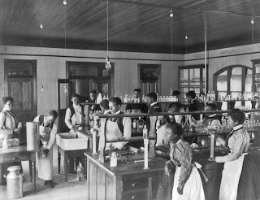

This 1899 photograph of students at the Hampton Institute in Virginia was taken by Frances Benjamin Johnston. It is from Artstor.org.
1.) In Plessy versus Ferguson, what were the arguments for "separate but equal" legislation? What were the arguments against this legislation? What is a dissent? What are the implications of Harlan's dissent? What is Harlan's fundamental objection to the decision? What is Harlan's view of legal distinctions based on racial considerations? What does he feel will be the consequences of this decision? What does the Court say is the underlying fallacy of the plaintiff's argument? Give three examples during this time in which state legislation sustained separation. Make sure you read about the Plessy case.
2.) Explain: Legislation "is powerless to eradicate racial instincts or to abolish distinctions based upon physical differences, and the attempt to do so can only result in accentuating the difficulties of the present situation." What effect did Plessy versus Ferguson have? Make sure you read about the Plessy case.
3.) How and why had blacks, particularly in the South, been subjected to second-class citizenship by 1900? Why were Jim Crow laws predominantly in the South? How did Jim Crow happen? Make sure you read about the Plessy case.
4.) Analyze how African Americans were challenging white supremacy before World War I. Make sure you read about the Plessy case.

