Business: Costa’s Customs
Industry: Retail Clothing and Tailoring
Owners: Alberto and Sara Costa
Employees: 43
Management Staff: 10
History: Costa’s Customs is a medium to high-end tailoring and clothing shop established in 1968 by husband and wife team Alberto and Sara Costa. The Costa family emigrated from Italy in the early 1900s and brought their ancestral knowledge of clothing and tailoring with them. The business is family oriented with three generations working in and around the facilities.
Originally, Costa’s was strictly a standard B2C tailoring shop. Customers would bring in articles of clothing, get measured for alterations, and the Costa employees would then make customizations specific to each person’s needs. In the early 2000s Costa’s expanded their offerings to include selling name brand quality clothing lines. This made Costa’s Customs a one stop-shop by combining retail clothing purchases and any alterations the customer might need. Shoppers could now come in, pick something out, and immediately get measured for tailoring.
Current Status: Costa’s has two locations in the Chicagoland area. Their original shop is located about 10 minutes north of downtown Chicago. A second location was added five years ago and is situated 30 minutes outside of Chicago in the affluent western suburb of Oakbrook. They offer both men’s and women’s attire ranging from professional dress to more upscale casual wear. Costa’s emphasizes quality materials and precise fittings in an effort to put customers in to comfortable clothing that will last. Common products available for purchase include suits, dress shirts, jeans, slacks, dresses, and coats. Offerings are available in store or on a fully functioning website where products can be browsed, measurements can be entered, and purchases can be made.
Costa’s is departmentalized in to a functional structure that breaks apart the tailoring and retail clothing aspects of the company. Both departments have their own manager who then filter up to the store manager. Each location has its own functional setup and each store manager reports up to owners Alberto and Sara Costa. This allows for decentralized decision making and a narrow span of control. Costa’s takes pride in listening to and rewarding their employees. They believe that developing and retaining employees long-term will lead to better relationships with repeat customers and more engaged workers.
Marketing Position: Costa’s positions themselves as a medium to high-end clothing retailer that sets themselves apart through customer centric business practices. They strive to go above and beyond for consumers both in their product offerings and a superior buying experience. The retail locations present a cozy yet professional atmosphere with attentive employees that listen to customer needs. These locations are a physical representation of what Costa’s embodies. Each store is tastefully decorated, highlights the quality of their services, and provides amenities to present a certain level of comfort to shoppers. Costa’s also has an established reputation within the surrounding communities due to their history with the city of Chicago and their involvement with neighborhood outreach. This involvement has created general goodwill towards the company and a recognition for the value they bring to the area.
Target Market: Costa’s main target market has always been upper middle class business professionals from ages 25 and up and from the Chicagoland area. These individuals include men and women of all ethnicities who make upwards of $60,000/year. Costa customers are fashion forward, value outward appearances, and feel at their best when they look their best. They also tend to lean towards high levels of loyalty, enjoying feeling valued by a company, and are comfortable purchasing big ticket clothing items.
Marketing Strategy: Marketing efforts at Costa’s have traditionally been focused on word of mouth and the occasional ad spots in local media. The general idea would be to let the quality of the products and satisfaction of customers speak for the business and generate demand. These strategies have been met with success in the past but Costa’s average customer has slowly gotten older and older. This presents a problem as Costa’s business model is based around developing longer standing relationships with consumers that benefit from repeat business. Management has been exploring ways to reach out to younger demographics in order to find new connections that will hopefully last. Recently they did attempt a digital marketing campaign meant to filter consumers to both the new website and the physical locations. It was expensive and had very mixed results. Some new customers were brought in to the shop but not enough to justify the money put in to the campaign. Details on strategy, tactics, and objectives of that previous campaign are featured in the following pages of this report.

Costa’s Digital Marketing Plan
Important: Below are the details provided by Costa’s on their previous attempt at a digital marketing campaign. You will find information on the situation analysis, objectives, strategy, tactics, as well as past analytics performance. Our research team has simplified the information to make analysis easier and to focus on the more important data they collected and decisions that they made. This information will be helpful in pinpointing Costa’s success and failures for digital marketing choices that will need to be made going forward. It is worth nothing that the previous campaign was mostly considered a failure.
Situation Analysis
- Strengths
  - Company Culture: Costa’s actively considers the well-being, engagement, and development of their employees. This has created a family atmosphere that is furthered by the closeness of relationships between the staff. The company is flexible and receptive to employee needs which has led to a wealth of benefits for the business.
  - Staff Expertise: Employees at Costa’s maintain a high level of knowledge in both fashion and properly tailoring articles of clothing. Much of what they do on the tailoring side is above and beyond the average shop. The care and precision necessary to properly tailor expensive materials sets them apart from the competition.
  - Customer Centric Business Processes: Many of the processes at Costa’s are designed with the end user in mind. Special care is put in to creating a company where customers will feel comfortable, are understood, and catered to. Examples span from the atmosphere at the physical locations to lenient customer service policies.

- Weaknesses
  - Retail Brand Selection: Costa’s has chosen and relies on very specific brands to supply them with the clothing and accessories necessary to do business. Contracts and agreements with these companies are generally fiercely negotiated often leaving Costa’s on the losing end. At the same time, customers have come to expect specific brands in Costa’s inventory. Because of this, Costa’s has avoided pivoting to new clothing lines and companies.
  - Existing Marketing Efforts: Costa’s tried and true marketing efforts have been successful in the past but have not adapted to changing times. Not only do they rarely look at what has become traditional media, but they have also avoided commitment to any type of digital platform up until this point. This has led to an aging customer segment and a company hungry for new customers.
  - Timely Tailoring Services: The tailors at Costa’s, being the industry experts that they are, tend to be perfectionists when it comes to making alterations and getting clothing out to customers. This need to get everything perfect can lead to a backlog of work, which means customers that are being forced to wait longer than should be necessary. It can also force Costa’s to suffer in terms of revenue and cash flow as customers won’t leave clothing for tailoring business if the wait is too lengthy.

- Opportunities
  - Online Shopping: Growth in the online retail segment continues to grow as consumers become more and more comfortable shopping online. While Costa’s does have most of the infrastructure in place, this has not been an area where many sales are currently coming from. The increase in mobile devices and instant access to the Internet ensures that this trend isn’t going anywhere.
  - Collaborations: It has become very common in fashion for shops like Costa’s to collaborate with the companies that create the clothing in order to form an exclusive line of items that’s only sold at the shop. Costa’s currently does not do this and has never pursued it. On a more local level, Costa’s also does not have many existing partnerships with other businesses in the surrounding areas. This is a missed opportunity as Costa’s reputation is a strength that could be utilized.
  - Consumer Segment Expansion: Costa’s has focused on the same customer for almost the entirety of their existence. As the marketplace changes, so do the consumer segments. There is potential opportunity in Costa’s looking to other target markets as potential revenue streams.

- Threats
  - Volatile Fashion Trends: Fashion trends, in regards to style of clothing, cut, and even materials, change quickly and often. Keeping up with these trends can prove both difficult and costly. Societal ideas of what is currently in style could drastically impact the stock on the retail side and the knowledge needed on the tailoring side.
  - Evolving Competitive Market: There are no real barriers to entry in the tailoring and clothing business. The ease of entry in to the clothing entry for new companies is high and they easily and quickly start fighting with Costa’s for market share. All a business initially needs is the segment knowledge and a small amount of infrastructure. Competition tends to be fierce and abundant especially near the downtown location.
  - Economic Downturn: Costa’s has survived through many economic downturns over the years. These dips in the economy are outside of our control and hit our bottom line immediately. Expensive clothing is a luxury and one of the first things eliminated when consumers have to tighten their budgets due to factors like unemployment and a loss of discretionary income.

Objectives, Strategy, & Tactics
- Objective: Grow online clothing sales by 50% within 6 months
  - Strategy: Redesigning company website to make it more intuitive for consumers. Although we don’t have research to back it up, we believe that customers are avoiding purchasing online because the site’s capabilities and interface are dated. Improving these areas of the site will help keep consumers there longer and make them more likely to purchase.
    - Tactic: Accomplishing this strategy can be done in a three-tiered approach. We will first identify and interview local firms that make appealing looking websites. We will then ask them for mockups and ideas on how the design can be improved. Finally, management will choose which business to go forward with for the final website implementation. This should ensure that we’re looking at a variety of options and finding one that we think will closely represent our brand image.
- Objective: Increase website traffic by 100% within 18 months
  - Strategy: Drastically increase funding to online marketing. It’s our belief that this objective can easily be achieved simply through monetary means. Our online presence up until this point has been nonexistent so spending more money, regardless of what it’s on, will still be an effective use of funds.
    - Tactic: Accomplishing this strategy starts with polling other businesses to see which platforms they use. Based off of that information we will then select the two most popular platforms and increase our budget in those areas by 200%. Implementing bulk ads with standard messaging would finalize this tactic. Again, this should be an easy objective to accomplish. The research and details do not matter much and this seems to mostly be a budgeting issue.

Paid Search Campaign Bing Ads Performance
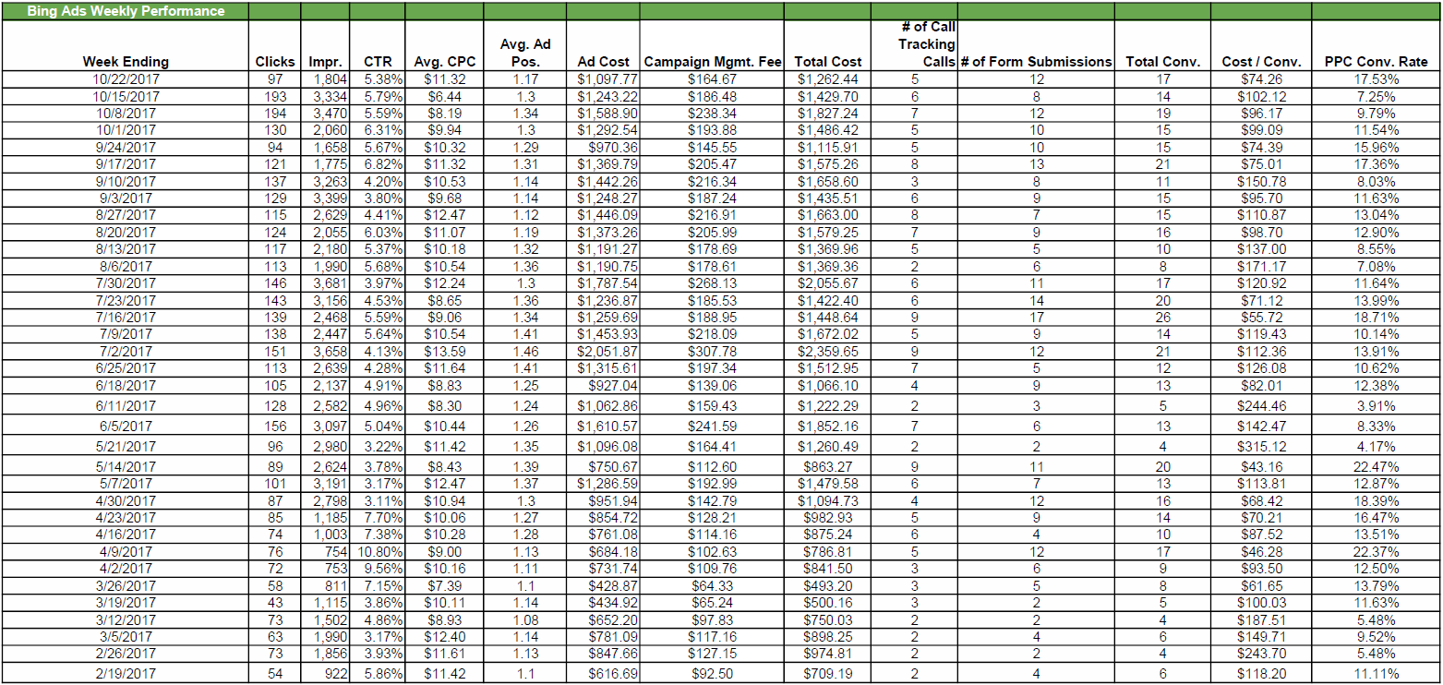
Paid Search Campaign All AdWords Performance
