Assignment 6
This assignment includes 4 calculation questions regarding Chapter 4 Forecasting.
- The following gives the number of pints of type B blood used at Woodlawn Hospital in the past 6 weeks:
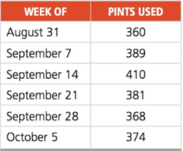
- Forecast the demand for the week of October 12 using a 3-week moving average

- Use a 3-week weighted moving average, with weights of .1, .3, and .6, using .6 for the most recent week. Forecast demand for the week of October 12.

- Compute the forecast for the week of October 12 using exponential smoothing with a forecast for August 31 of 360 and a = .2.

- As you can see in the following table, demand for heart transplant surgery at Washington General Hospital has increased steadily in the past few years:
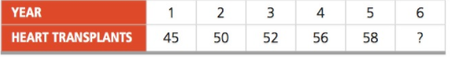
The director of medical services predicted 6 years ago that demand in year 1 would be 41 surgeries.
- Use a 3-year moving average to forecast demand in years 4, 5, and 6.

- Use the trend-projection method to forecast demand in years 1 through 6.

- With MAD as the criterion, which forecasting method is better?

- George Kyparisis owns a company that manufactures sailboats. Actual demand for George’s sailboats during each of the past four seasons was as follows:
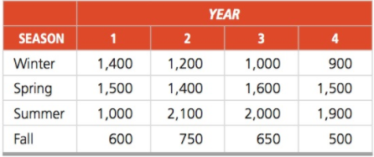
George has forecasted that annual demand for his sailboats in year 5 will equal 5,600 sailboats. Based on this data and the multiplicative seasonal model, what will the demand level be for George’s sailboats in the spring of year 5?

- The number of auto accidents in Athens, Ohio, is related to the regional number of registered automobiles in thou- sands (X1), alcoholic beverage sales in $10,000s (X2), and rainfall in inches (X3). Furthermore, the regression formula has been calculated as:

Y=a+b1X1 +b2X2 +b3X3
Where Y = number of automobile accidents
a = 7.5
b1 = 3.5
b2 = 4.5
b3 = 2.5
Calculate the expected number of automobile accidents under conditions a, b, and c:
